April 1936

CHECK YOUR WIRING
... If You Want Care-Free Motoring
by Martin Bunn
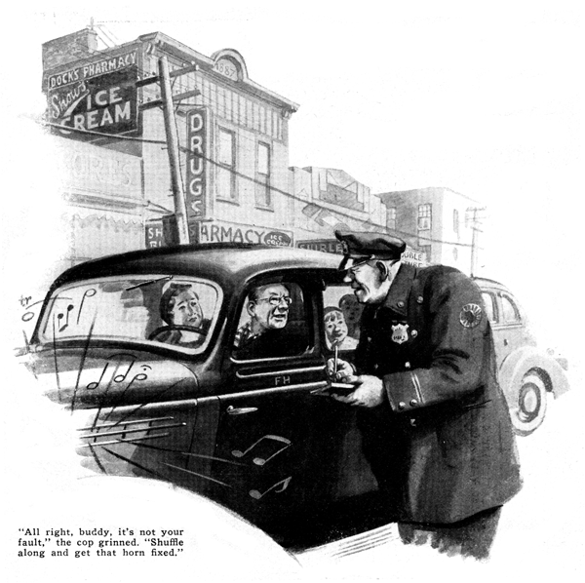
Mrs. Hillon glanced back at the twins smiling like two angels on the back seat and then settled herself contentedly against the cushions.
"For once, Fred," she said "we've started on time. Now, if the car will only behave, we'll get to Aunt Eliza's when we said we would.
"Fred!" she exclaimed, as a car swung out of line and her husband averted a smash only by a quick twist of the wheel. "Why didn't you blow your horn? We almost hit that car."
"Think I don't know it?" Hillon grated. "I pressed the button, but the confounded thing didn't blow. Something must be wrong with it."
"Try it again," she suggested. Hillon obediently pressed the button for a test, and the horn responded instantly. In fact, it responded too well; it kept blowing for nearly a second after he'd taken his hand off.
"There!" she said triumphantly, "You just forgot to blow it, that's all."
Fred merely grunted. Mile after mile passed under the wheels without any further occasion to use the warning signal and then, as they approached the crossing near the Model Garage, the tall, hardboiled cop directing the Sunday traffic at that point majestically held up his hand.
Fred slammed on his brakes and as the car rolled to a stop the horn let go with a long and disconcerting blast.
The cop glared angrily, and deliberately turned his back as he motioned to the traffic flowing in the other direction.
"Whatever did you do that for, Fred?" Mrs. Hillon wailed. "You'll make the officer angry and then he'll give you a ticket or something."
"The blamed horn blew itself," Fred muttered. "I didn't have my hand within a mile of it." The horn punctuated his remarks with three short blasts.
An Ominous frown gathering on his face, the cop held up traffic in both directions and swaggered over to the Hillon's car.
"Say, how do you get that way mister?" he growled. "In a hurry are you? Well I'll show you. Lemme see your license."
Hillon started to protest, shrugged his shoulders hopelessly, and reached for his pocketbook.
While he was fumbling with the buttons of his overcoat and the cop was digging for his summons pad and pencil, the horn let loose upon what promised to be the nonstop record for horn blowing.
"Hey! Shut that blasted thing off!" roared the cop.
"Shut it off yourself, I can't," Hillon shouted despairingly, as he punched and pulled at the horn button.
"So it ain't your fault, eh!" boomed the cop as his gnarled face broke into a twisted grin. "All right, buddy, shuffle along to that garage and have it fixed."
Mrs. Hillon smiled gratefully, and the car drove off with the horn still sounding its raucous blare.
Gus Wilson, veteran auto mechanic of the Model Garage, took in the situation at once as the prolonged honking brought him outside. He fished a screwdriver from a pocket in his overalls and disconnected the wire at the horn.
In the intensified silence that followed, Mrs. Hillon piped up. "Isn't that lucky Fred? Cousin Harriet lives just a little way down the road. I'll take the children and pay her a visit while you get the horn fixed and I'll phone Aunt Eliza that we'll be late - as usual!"
Gus pulled the horn-button assembly apart and found the trouble. The wire had come loose and was resting in such a way that the bare end made contact with the metal of the steering-wheel post at the slightest vibration.
"Gosh!" exclaimed Hilton, as he glared at the loose wire end. "I wish that just once we could start out and get where we're going without some wire giving trouble. Last week it was the headlights. The time before that it was the stoplight. I wonder what it will be the next time?"
"Lots of old cars get that way," Gus observed. "Trouble is, the owners don't realize just what makes a good electrical connection, and they don't know where to look for trouble before it actually breaks.
"Of course, if a car owner always fixed a bad connection right when it did go bad on him, after awhile his troubles would be over because all the bad connections would show up and be fixed for good. But usually, when a light goes dead or something like this horn trouble happens, the wire is put back any old way, and sooner or later the trouble shows up again in the same place.
"Look here," Gus suggested, tapping the horn-button assembly with his screwdriver. "The end of this wire is supposed to be held in place by this spring connection.
That's fine if the spring is strong, but this one is so weak that the vibration gradually worked the end of the wire loose and it dropped out. If I put it back the way it is, you'd have the same trouble again in a few months. I'll tighten the spring first, and then I'll bet it won't happen again while you have the car."
"I can understand that, easy enough." Hillon agreed, "but last time, when one of the headlights went out, I couldn't find any loose wire.
I took the bulb out and put it back, and the light came on again. I guess it was just dirt under the spring contact."
"It was dirt, all right," Gus explained, "but not the kind of dirt that gets in from the outside. The dirt that did that job was corrosion right on the surface of the solder on the bulb contact."
"I always thought a soldered joint was the best of all," protested Hillon.
"It is," Gus agreed. "If you twist two wires together and flow solder into the point, neither time nor any amount of vibration will ever cause that joint to let go.
"But this isn't a soldered joint." Gus went on, pulling open one of the headlights and removing the bulb. "The wire from the filament is soldered to this brass tab on the base of the bulb, but the socket contact presses against a lump of solder instead of against the brass. In time, corrosion on the surface of the solder either breaks the flow of current or puts enough resistance in the current so that the light won't be quite as bright as it ought to be. "Back in the early days of radio, vacuum tube sockets were made just like this the spring contacts pressed against a lump of solder on the end of each prong and if you didn't take the tubes out and sandpaper the prong ends once in a while, the radio got to sounding like a lot of hens scratching on a tin roof.
"You won't find a single radio-tube socket made that way today. The contact is always against the side of the prong, and until the auto lamp makers follow in the radio makers' footsteps, you'll find it a good idea to take every bulb on your car out of its socket at least once every few months and sandpaper the contacts."
"I'll certainly do that hereafter," Hillon decided, "That will eliminate a lot of my troubles."
"A large part of 'em at any rate," Gus agreed, "but not all. Remember, perfect connection won't make current flow if there's a break in the line somewhere else. And it won't flow where it's wanted if there's any shorter path it can take by way of a short circuit.
"Vibration is the enemy of every electrical wire on your car." Gus went on, "I'll bet we can find several places where it'll only be a question of time before a wire will chafe through and either cut off the current or cause a short circuit that may leave you stranded.
"Show me," Hilton ordered, "Aunt Eliza can wait!"
"All right," Gus agreed, pulling up the floorboards. Let's start with the storage battery. Here's one place where you're more likely to have trouble from corrosion than from vibration - unless the battery gets loose in the box, and then you'll have a bad combination of both. Take a look at that ground cable."
"Pretty messy looking, isn't it?" Hillon observed, "I suppose the acid from the battery ate away the strands like that. Still, there seems to be a lot of the cable that is all right."
"It'll do for three or four months, "Gus decided, "but I wouldn't let it go longer. By that time enough of the strands will be eaten away to increase the resistance and cause hard starting, and if you forget about it, you'll likely find yourself stuck on the road some night with no power and no lights either."
"The starter cable looks all right, anyway," remarked Hillon. "I don't see much corrosion there."
"Looks don't mean much," Gus grumbled. Sometimes the corrosion sneaks in under the insulation. We can tell easy enough. If the cable still is in good shape, it will be strong and stiff. If it is badly corroded inside, where you can't see it, it will bend easily at that point. It may even break off in your fingers."
Gus reached down and gave the cable a strong pull, first one way, then the other. No weakness was apparent.
Rapidly they went over all the other connections, one by one. The wire to the stoplight switch had broken loose from its moorings and was dangling is such a way that it was rubbing against the frame and the insulation was slowly wearing away; one of the headlight wires was chafing against the edge of the radiator core, and the wire leading to the generator cut-out was working loose.
"Here's a little point that is worth remembering," Gus pointed out, as he fished out his screwdriver again. "When you find a loose connection like this, don't just tighten it. Remove it and scrape it clean with your knife or a bit of sandpaper, then clamp it down tight and it'll be as good as new. A fellow doesn't need a fancy set of tools to keep the wiring system in dependable shape. With a little sandpaper, a screwdriver, a pair of pliers, and a roll of tape, must anyone can step this sort of trouble before it starts.
"The main thing is to take the time out to give the wiring a thorough check and when you see something slowing signs of wear, fix it right then and there - and fix it right.
"These stitches in time," continued Gus, as he straightened up after replacing the floor boards, "will save your temper because you won't be held up like this and some day it might keep you from running into an expensive repair bill."
"Aren't you nearly ready?" Mrs. Hillon greeted them as she walked in with the twins.
"All finished," Hillon replied. "Hop in and we'll get going.
"I guess this is doomed to be a noisy day," he chuckled in an undertone to the garage man, as he handed him a bill. "We listened to the blamed horn all morning, now we'll have to listen to Aunt Eliza most of the afternoon."
END

