May 1935

HINTS ON QUICK GET-AWAY
by Martin Bunn
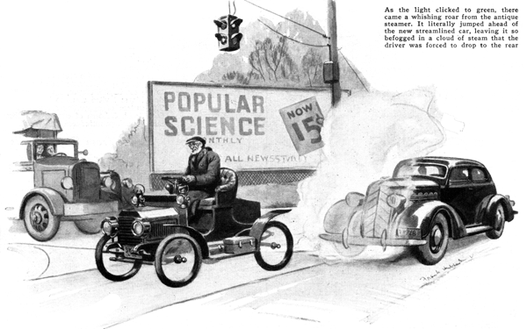
Gus Wilson and Joe Clark, his partner in the operation of the Model Garage, were enjoying the first warm spell of spring during a lull in Saturday afternoon activities.
From where they were sitting in front of the garage, they could see the intersection of two state highways, which presented a scene of more than usual activity. Suddenly, Joe straightened up and stared at the crossroads.
"Say, for the love of Mike!" he exclaimed, "Where'd old Noah and the ark come from?"
Gus looked up and smile broke over his grizzled features as he took in the amazing vehicle waiting for the green light. Spidery wire wheels, and a hood that looked like a cheese box, were the most striking features of an ancient roadster occupied by a shriveled-up little man. Trim gray whiskers edged his chin and old-fashioned gold spectacles framed his eyes.
As if to accentuate the general effect, a streamlined car of the very latest vintage slid to a silent stop beside the oldster.
"Don't you know who that is?" grinned Gus. "Well, now, you just keep your eyes peeled and see what happens!"
The streamlined car had crept ahead several feet and was in motion as the light clicked to green. At that instant, there came a whishing roar from the old vehicle and it literally jumped ahead of the new car, leaving it so be fogged in a cloud of steam that the driver was forced to slow up and drop back.
The antique streamer whizzed up the road past the Model Garage, and the driver of the other car pulled up and stopped by the gas pump.
"What in blazes was that, Gus?" he called as he stared angrily at the spidery car shooting up the steep grade with a comet-like trail of steam vapor trailing out behind.
"Gave you a bit of a start, did he, Mr. Williams?" smile Gus. "That's old Angus Macduff, one of the best steam engineers that ever came out of Scotland. They say he's got that contraption of his so it will stand 1,200 pounds pressure. Some day something will let go and there'll be no more Angus!"
"Humph!" grunted Williams. "Trying to show my tail light to a load of liquid dynamite, was I? And yesterday, another fellow with a car exactly like mine put it all over me on the get-away."
"Maybe the car needs tuning up, but mostly a slow get-away in any modern car is just a matter of poor timing," Gus suggested. "Take old Angus and his steam car, for instance. He doesn't have to know anything about gear-shift timing. All he does is brace himself and give her the gun. There's no gears to shift. A steam throttle does it all."
"A gasoline car is something else again," Gus continued. "The engine has no power at all when it's idling and the power it can pass along to the back wheels to get you going depends on how fast the motor is turning over."
"According to that, you ought to have the motor racing before you let in the clutch if you want to make a quick get-away," Williams interrupted.
"Theoretically, yes," Gus replied. "Trouble is, if you do, you'll either tear the stuffings out of the clutch in no time at all or else you'll snap a shaft or strip a gear. You've got to compromise, and the proper stunt is to have the motor turning over pretty well but not so fast you'll bust something or tear hunks off the tire treads. The best idea is to try starting from a standstill with the motor turning at different speeds till you find the one that gets the car in motion in snappy style."
"I never thought of making any tests like that," Williams commented.
"Try 'em - you'll learn something. The next step is to find at what car speed it's best to shift to second speed. Lots of drivers make the mistake of staying in first too long. First speed in any car always is geared so low that it's a power instead of a speed gear."
"When should you shift to second?" asked Williams.
"That depends a lot on the car, and particularly on the weight of the motor fly-wheel and crankshaft. You see, when you shift from first to second, there's a whale of a change in motor speed because of the big difference in the gear ratio between the two speeds. And the faster you're going when you make the shift, the more difference there'll be in revolutions per minute.
"Another mistake many drivers make is to shift to high gear from second too soon. That's another thing that depends on the type of car."
"It's too bad there isn't some definite rule you can go by," Williams complained.
"Most likely there is," Gus smiled. "The slide-rule sharps probably have figured it all out on paper. Trouble is, they have to assume a set of fixed conditions and when you're on the road the conditions are always changing. The timing of the gear shifting and the pedaling of the accelerator that would give you the fastest pick-up on the level wouldn't be right on an up grade. You'd have to stay in each gear a bit longer. On a down grade you'd shift quicker. A strong wind would have an effect like grade."
"If you really want to learn to make the fastest get-away from a standing start," Gus suggested. "I'd recommend that you take your car out on some nice stretch of road when the traffic is light and keep experimenting with different timing till you find the one that gets you going quickest.
"Mark off a distance on the road of about 200 feet or thereabouts - the exact distance doesn't matter - and get some friend to time you from the word go at the start to the end of the stretch. The clock will soon tell you when you've got the right combination. And I'll bet that if you do practice that way you'll be able to make a monkey out of any ordinary driver handling the same car - and lots of more powerful cars, too!"
"Sounds like good sense to me," Williams agreed. "I think there's an old stop watch kicking around the house somewhere. I'll dig it out and get busy. So long, Gus!"
"Hold on a minute," Gus said, as Williams was about to step on the starter. "What's the use of going out to practice quick starting till you know your car's in shape for it? The least bit of drag on the brakes, or soft tires even, will make the car sluggish."
"Anything else?" Williams asked.
"Sure, plenty," laughed Gus. "Naturally, your carburetor ought to be tuned up a bit. The best mixture for fast starts is a little bit richer in gas than would be right for touring. It wouldn't be a bad idea to check over the ignition system and make sure you haven't any leaky plugs or wiring and that the automatic spark control is working just right."
"There's another thing," Gus continued, warming up to his subject, "and that is the bad effect of leaky valves and piston rings. A bit of leak at a valve or piston doesn't cut much ice in ordinary running, especially at high speed; but when you want every ounce of power you've got for a quick get-away, leaky valves and pistons do count.
"Then there's the matter of carbon. With high-test lead gas you may not hear knocks, but just the same too much carbon doesn't help the motor's power any."
"I was going to bring her in and let you look over the motor next week anyhow, Gus," said Williams, "so I guess I'll postpone my quick-starting practice till after that."
"I'll pay particular attention to the clutch, Mr. Williams," Gus smiled as his customer started the motor. "If your clutch slips a bit, fast starting will wear it out in no time."
"First man in here is a long while that hasn't tried to argue with you," observed Joe Clark as Williams drove off. "There's one man I'll bet will keep at it till he's able to do a snappier start than anybody else around here with the same kind of car."
"Guess you're right, Joe," Gus grunted. "And if he ever catches old Angus with his steam pressure down, he'll throw mud in his eye for sure!"
END

