June 1935

HOW TO ADJUST SHOCK ABSORBERS
by Martin Bunn
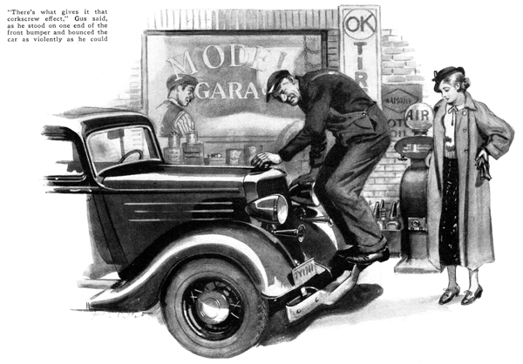
Hey, Gus! There's a lady outside wants to see you," Joe Clark called as he came out of his little office at the Model Garage. Gus Wilson, his partner and the mechanic of the firm was struggling with a recalcitrant clutch.
"Take care of her yourself; you're the Don Juan of his outfit," the veteran automobile man grumbled, reaching for a wrench.
"All right, I will. It's old man Hackett's daughter," said Joe, with a twinkle in his eye.
"Hey! Wait a minute!" Gus snapped.
"Why didn't you say it was Mary Hackett? That's one girl I don't mind talking to. She's got more sense about a car than most of the young fellows that come around here."
"How do you adjust shock absorbers, Gus?" asked Mary Hackett, as Gus appeared. "I've been trying all morning to get them right but the car seems to ride worse than ever. Now it has a sort of a corkscrew motion, like a boat that is taking the waves on the bias."
Gus walked all around the car, examining it critically, and then stood on one end of the rear bumper and bounced the car up and down as violently as he could. He repeated this operation at the other end of the rear bumper and at both ends of the front one.
"There's what gives it that corkscrew effect," he said, as he bounced one end of the front again. "The shock absorber on this side in the rear are a lot too loose, while the others are a bit too tight. And it looks to me as if the tires are unevenly pumped, too. Here you've got a hard tire and loose shock absorber and on the other side a soft tire and a tight absorber."
"Why does that make it pitch and toss so on a rough road?"
"It's this way," Gus explained. "If you're going along a road with a lot of 'thank-you mams,' or cross gullies, in it, the front wheels hit the depression first. They drop and the front of the car starts to drop after 'em, but the front wheels start to climb out of the hole before the car can drop much. On the side where the shock absorber is tight, the friction keeps the spring from pushing the car up so violently. On the other side, the car drops farther and gets kicked back harder. Naturally, the effect is to tip the body sideways. Now, when the rear wheels hit the same hollow in the road, the same thing happens, but in the other direction because the tight shock absorber is on the other side and the body gets a tip the other way."
"Now I see it," exclaimed Mary. "If the car happens to be going at the right speed and the bumps are spaced right along the road, the car'll get to rocking back and forth."
"That's it exactly," Gus smiled. "You've got a mechanical head on your shoulders, Mary. Lots of men drive cars for years without the faintest notion of how shock absorbers work or what is sure to happen if they get out of whack."
"Tell that to Dad next time he comes in," laughed Mary. "He's keen on my knowing things about cars. Now show me how to adjust the shock absorbers so they'll be right."
"It's a pretty big job for a slip of a girl like you. You haven't enough heft to bounce a car up and down the way I did and that's about as good a way as any to tell what the shock absorber is doing."
He stepped to the front of the machine on the side where he had found the loose shock absorber. "Notice how when I bounce it up and down the action seems lively and springy. That's what you don't want. The shock absorber ought to be just tight enough to take the kick-back out of the spring and still not interfere with its up-and-down motion."
"See how it is now," he said, after he had reached under and tightened the adjustment. "No more bounce, but plenty of easy movement. Next thing is to get both front shock absorbers so they act just alike and then match up the rear ones. You don't have to have the rear ones match the front ones, so long as they match each other. In fact, it's usually better to have the back ones stiffer than the front ones."
"Of course," Gus continued, as he changed the adjustment of the rear absorbers and bounced the rear of the car up and down, "the real test of shock-absorber adjustment is the way they act when the going is rough. So if you'll just run me over that rutty piece of road back of the freight yard we'll put the final touches on 'em. Wait till I put some air in the tires so we won't have that to worry about."
The street back of the freight yard was an ideal place to test the effect of shock absorbers. Heavy trucking had reduced the macadam surface to a succession of pot holes, ruts, and broken stones.
"Go over it fast, first," Gus suggested.
"It's lots better - just about right, I should say," Mary decided. Gus made no comment. "Try it again, and go slower this time," he ordered.
"Goodness!" Mary exclaimed as the car bounced along in a most disturbing fashion at the slower speed. "Why should it ride so much worse at this speed than it does when I go faster?" she asked.
'In the first place," Gus explained, "you'll find that with any car and any particular stretch of bumpy road, there'll be on special speed that will make the car ride smoothest. Sometimes it's slow, and sometimes fast. It depends on the number and size of the holes and bumps, and on the kind of car, too. In the second place, all the shock absorbers on this car are a little too loose. Stop while I tighten 'em and we'll try again."
"There," he said, as they went over the stretch for the third time, "that's about right now. You see, young lady, the first step in adjusting shock absorbers is to get 'em equalized by bouncing the car up and down while it's standing still, and then get your final adjustments by testing over a rough road at different speeds."
"What would have happened if you'd set the absorbers too tight before we made this road test?"
"I was wondering if you'd bring that up," Gus grinned. "Well, if we'd tightened them too much the car would have ridden about the same at both speeds, but you'd not have enjoyed it. There'd have been no pitch or bounce. It would have trundled along like a farm wagon and you'd have felt every little bump in the road. The over tight shock absorbers would have kept the springs from doing their job of easing you over the bumps."
"Thanks a lot, Gus, for all the trouble you've taken," said Mary, when they got back to the Model Garage. "Now I know how to fix any car so it will ride as well as this one - just adjust the shock absorbers."
"I wouldn't go so far as to say that," Gus replied. "Remember that riding quality depends on a lot of things beside shock absorber adjustment. Some cars ride easier than others, no matter how you set the absorbers."
"You mean heavy cars ride better than light ones," Mary interrupted. "Of course, I understand that."
"No, I was thinking of cars in the same weight and price class. It isn't so much the weight of the car as it is the way the weight is distributed. They've learned a lot about balance and springing these last few years. For one thing, they are beginning to realize how important it is to put the passengers midway between the front and back wheels so they won't be tossed about."
END

