July 1935

TRICKS THAT ADD

TO DRIVING COMFORT
by Martin Bunn
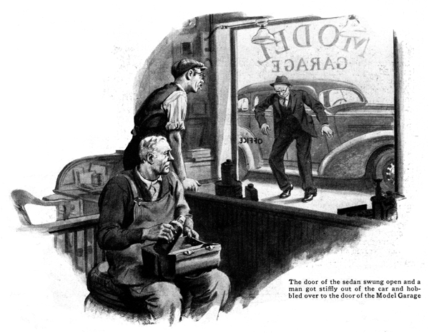
"There's a fellow who's been places and done things," observed Joe Clark to his partner, Gus Wilson, as he watched a dusty mud-spattered sedan pull up in front of the Model Garage. Gus stuffed the last of a ham sandwich into his mouth and fished a vacuum bottle of coffee out of his lunch kit as he strolled over to the window.
"That baby's been traveling off the main routes a long way from here," he said, as he eyed the sedan. "There's no mud just that color anywhere around these parts. And look how it's caked into the spokes. Well, I'll be jiggered, if it isn't O'Hara with a new car!"
"So it is," echoed Joe, as the door of the sedan swung open and a red-headed man got stiffly out of the car and hobbled over to the door of the little office of the Model Garage.
"A bit cramped after a long trip, Mr. O'Hara?" Gus inquired.
"I'll say I am," grunted O'Hara. "Let me sit down and rest a minute."
Gus pushed forward a chair and the red-headed motorist sank into it with a grateful sigh. "What I can't understand," he observed after a moment, "is why this hard chair seems so comfortable. I almost hate to think of getting back in the car. It cramps me just as bad as any of the old ones. I've been on the road all day and I still have one more call to make."
"Driving that new car ought to be like sitting on a sofa," said Gus. "Maybe one of the seat-cushion springs has come loose or the padding has shifted."
"No, it's not that. Everything is fine and comfortable when I start out, but I'm always all cramped and tired by the time I get to the end of a long run. And it's not that the driving position is uncomfortable. That's fine, too. Every car I've had, it's been the same way. Other fellows don't seem to get so tired. Maybe it's just that I'm getting old and can't take it any more!"
"Quit your kidding," snorted O'Hara. "I'm on the road all the time, and I've driven at least a couple of hundred thousand miles."
"Sure you have," Gus agreed, "but you ought to be able to drive without getting tired. Learning how to do any job means learning how to do it easily. It's the easy part you haven't got the hang of, yet."
"You mean I put too much beef into moving the gear shift - things like that?"
"Not a bit of it," said Gus. "You knew all that stuff a hundred thousand miles ago. But, is your driving position really comfortable? You say it is, but are you sure? Have you tried moving the seat back and forth to different distances from the pedals? I'll bet you've done what most drivers do. You adjusted the seat, when you first got the new bus, so that you could reach the pedals without having to stretch. You never thought that the position that seems most comfortable when you just climb in, and try it for a second or two, may not be right for long trips.
"Another thing," Gus continued. "Are you sure that the seat itself fits you? You wouldn't expect every ready-made car seat fit you unless you happen to be exactly average in measurements? Perhaps the back seat cushion is not at the best angle to support your back. Possible the seat-cushion springs are too stiff or too weak for your weight.
"I once knew a tire salesman who spent most of his waking hours pounding the road in a car. He was a skinny, wiry little chap, the kind you'd think would want all the upholstery he could get to take the place of the natural padding he didn't have. And yet, the first thing he did when he got a new car was to rip out the driver's seat-cushion and put in a thin, spring-less leather cushion. He claimed that bouncing around on top of a bunch of springs tired him more than riding on the hard seat."
"I'd prefer springs, "O'Hara commented. "So do I, personally," Gus agreed. "But it does show what I'm driving at. The point is that some change in the regular arrangement may help. Take the cushion that supports your back. Sometimes, building out the padding near the bottom, or perhaps half way up, or even at the top, will make the cushion a better fit for your particular type of anatomy. At any rate it certainly is worth trying. You don't have to tear the cushion all apart to find out, either. You can hang a thin, wafer-edged pad by strings from the coat rail at different heights just to try out the idea."
Sounds reasonable. I'll make some tests when I have the time," said O'Hara, interestedly. "Still, I don't think it will do much good. No matter how comfortable the driving position is, I'm always dog-tired at the end of a long run, and that's pretty often. You know how much I'm on the road."
"All the more reason why you should try out all the possibilities," Gus advised. "But, as you say, a driver can get tired even though the seat cushions and the position are perfect."
"I'll say he can," O'Hara grumbled.
"You and a lot of other drivers get tired on long trips because you don't know how to rest yourself while you're driving. I've watched you, and you always sit in exactly the same position with your hands resting on wheel in exactly the same places, and your feet always just so. Why don't you work out some changes and then keep switching every so often before you've stayed long enough in one position to get all cramped? I don't care how comfortable your first position may be - you ought to change now and then. Staying in one position without any movement, even for half an hour, is harder work and more tiring than ditch digging."
"I don't see how you can get much of a change in driving a car," O'Hara protested. "You've got to have your hands on the wheel and your feet near the pedals, haven't you?"
"You do unless you want to give the insurance adjusters a workout," laughed Gus. "But you can make at least a couple of dozen shifts without risking your neck.
"Look," Gus directed, sitting down in one of the office chairs. "You can sit up straight like this, or you can slump down for a while to move your spine and keep it from 'freezing.' Slumped down in the driver's seat is not the way to drive for long, but it's fine for a short change because it puts so many joints in a new position. Then, you can hold the wheel with both hands up near the top of the rim. That pulls out your arms and changes the strain on a lot of muscles that may be getting tired from holding the rim quite close to you, as you usually do.
"And, there's two variations that help to throw strains first to one side and then to the other side of your body. I mean with one hand up and the other down - like this. You'll see lots of second-hand cars with the wheel worn only in two places. The birds who owned 'em never got wise to shifting their hand positions.
"Of course, you can't move your left foot very far and still keep it handy to the clutch pedal, but it will relieve the stiffness to pull it in close to you every little while to ease your knee joint and your hip joint on that side as well. Don't forget that you can do the same thing with your right foot if the car is fitted with a throttle control on the steering column. You shouldn't try hand control of the throttle when you are in traffic, but it works well when you're out on a long stretch of straight road."
END

