November 1934

WATCH YOUR AMMETER
if you want to spot the start of ignition trouble
and find other hidden ailments
by Martin Bunn
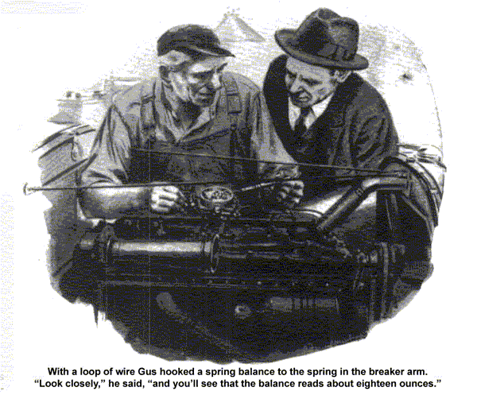
"Some people always want things in a hurry," grumbled Gus Wilson as he hung up the receiver and shoved the telephone away from him. Joe Clark, perched on one corner of the desk, grinned sympathetically.
"What's the trouble now?" he inquired. "Somebody run out of gas?"
Gus shook his head. "It's Ted Cummings again. Something's wrong with his generator and as usual he has to have the car tonight."
Fifteen minutes later, the grizzled garage man had his gray head buried deep under the open hood of Cummings' car.
"Now let's get this straight," he said, fingering the black wires that snaked their way to the distributor. "When you started out this morning everything seemed to be O. K. and the ammeter was charging fifteen or eighteen amps. Then the pointer snapped over to the discharge side and it stayed there until you shut off the ignition."
Cummings nodded. "And it happened again coming over here," he said.
Gus placed his hand on the metal cylinder that housed the generator. "Suppose we try her again and see what happens," he suggested as he walked around to the driver's seat and turned the ignition switch. A glance at the ammeter showed the normal few amperes' discharge.
"So far, so good," commented Gus. "Now to step on the starter."
"Gosh," exclaimed Cummings as Gus opened the throttle and raced the motor. "She doesn't even show charge when you start now. That needle hasn't budged."
With a satisfied grin, Gus shut off the ignition and went back to the side of the motor. A few minutes later he loosened the clip that held a small cover plate to the side of the generator housing. As the plate dropped free and exposed the brushes and commutator, he tapped a small rectangular plate that was also visible.
"See that?" he asked, pointing with the tip of his screw driver. "That's your generator thermostat and unless I've got my signals crossed, that resistance you see mounted on top of it is burned out."
"A thermostat?" questioned Cummings.
"I've heard of a thermostat in the radiator, but a generator thermostat is a new one on me."
"Not every car has one," explained Gus. "But this one does. It's like the gadgets they use to regulate a furnace or an electric iron. You know, a bar of metal that bends under heat and breaks an electric circuit.
"Well, the generator thermostat opens and closes according to the heat of the generator and the surrounding air. When the motor and generator are cold, the electric contact points of the thermostat are closed and full current from the generator goes to the battery.
When the generator warms up, the two contacts spring apart, and instead of flowing to the battery, the current is side-tracked through this resistance and then to the battery. Naturally, the extra resistance cuts down the generator output and reduces the charging rate."
"But what makes you so sure the resistance is burned out?" inquired Cummings.
"From the way your ammeter acts, it's a cinch something is breaking the circuit when your motor warms up. A burned-out resistance would fill the bill pretty nicely wouldn't it?"
"Then, how do you account for the way the ammeter acted a minute ago when you started the motor," asked Cummings.
"It didn't even register charge in the beginning."
"That's easy," replied Gus. "Your generator was still warm from your ride over here. Naturally, the thermostat points were still open and the circuit from the generator to the battery was still broken. As a matter of fact, it was that little test that made me sure it was the resistance."
"Can you put in a new one?" inquired Cummings.
"Sure, but first we'll have to find out what made the resistance blow. Besides controlling the charging rate, that resistance is a generator fuse and when it burns out it's a pretty good sign there's a bum connection somewhere that's been overloading the generator."
Once again, Gus buried his head under the hood and proceeded to tug at the various wires that ran from the generator and the stating motor to the battery.
"One thing certain," he announced at last. "We're going to find that bad connection somewhere in the charging circuit."
Gus soon found that a generator terminal had caused the trouble and a few minutes later he finished replacing the burned-out resistance and announced that the car was as good as new.
"That sure had me guessing," said Cummings. "Sort of mysterious wasn't it, the way that ammeter would jump to discharge?"
"A car's ignition system is chuck full of mysterious troubles," replied Gus. "A fellow came in just the other day. Claimed his car had no pep, was hard to start, and heated up. After spending about two hours going over the ignition, spark plugs, and carburetor, I traced the trouble to the distributor. The spring that operated the breaker arm and points had got weak and wasn't forcing the contacts closed the way it should."
"How did you find that out?" asked Cummings.
Gus walked to his repair bench and picked up a small spring balance. "I borrowed this tool from my fishing kit," he said, holding the scale up so Cummings could see it, "and it comes in mighty handy testing distributor springs and touch springs. Here," he added turning back to Cummings; car, 'I'll show you what I mean."
When he had loosened the fiber distributor cap, Gus indicated a U-shaped spring on the breaker arm and proceeded to slip a loop of wire attached to the lower end of the spring balance over the tip, "Now this spring has good tension," he explained as he pulled the other end of the balance. "If you'll look closely, you'll see that the balance reads just about eighteen ounces. That's just about what it should be.
"The same thing holds true for the springs on starting motor and generator brushes," he continued as he reassembled the distributor, "just hook the balance to the brush arms and pull. The balance ought to show a tension of about twenty ounces."
"Never knew you could use a spring balance round a car," said Cummings with a chuckle. "And I never realized that you could tell so much about the electrical system just by watching the ammeter."
"Or the needle may jiggle back and forth instead of staying steady. That indicates a loose or corroded connection in the lighting system or in the ignition wiring.
"If you're breezing along and your motor suddenly goes dead, a glance of your ammeter will generally help you to find the trouble. The thing to do is turn on your ignition. If the ammeter pointer stays at zero, there's either a break in the primary of your ignition coil or the breaker points have turned away or jammed open. But if the ammeter shows the usual discharge, you can forget about the breaker points and ignition coil primary and concentrate on the condenser, the high-tension winding on the coil, and the high-voltage wiring to the distributor and spark plugs."
"By the way, Gus, speaking of condensers, is there any simple way you can test a condenser when you're stuck miles out on some lonely road."
Gus nodded, "And your ammeter will come in handy there, too. All you've got to do is wedge a piece of cardboard between the breaker points inside your distributor and turn on your ignition. If the ammeter reads discharge, it means current is flowing even though the points are open. The only other route is through the condenser, so it's good proof the plates are short-circuited at some point inside."
"Say, you haven't got a bottle of glass cleaner or window polish around the garage, have you?" asked Cummings with a grin as he climbed into his car and prepared to drive away.
"Glass cleaner?" questioned Gus.
"Sure, I thought I'd clean up the glass on this ammeter so I can watch that confounded pointer a little easier," replied Cummings with a chuckle as he maneuvered his car out of the garage driveway.
END

