May 1934

SAVING DOLLARS ON YOUR CAR
by Martin Bunn
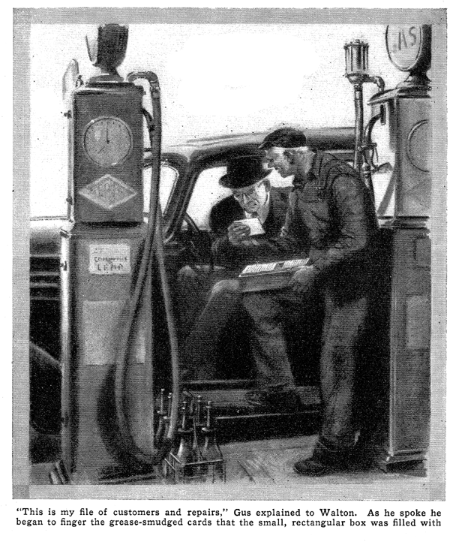
"This buggy sure is harder on the gas than the old one I had," complained the owner of a shiny new sedan that had coasted to a stop beside one of the Model Garage gasoline pumps. "What sort of mileage do you get?" Gus Wilson inquired as he unlimbered the hose and pushed the nozzle into the filler opening.
In answer, the man pulled an envelope from his coat pocket and thrust it at Gus. On the back was a hastily made tabulation of the gasoline used and the mileage.
"About twelve miles to the gallon," the man grumbled. "After thirty years or more of making cars you'd think these automobile engineers could turn out something a little more economical. Now, take those little cars they use over in England -"
"They wouldn't do for you, Mr. Walton," the gray-haired mechanic interrupted. "Ever ride in one?"
"No, but from what I hear they certainly are easy on the gas. Why, I'm told it's nothing for them to give thirty or forty miles to the gallon."
"Sure, but they give less in speed, power, and comfort," said Gus. "They don't use those light, economical cars from choice. They're a necessity. Gasoline is so expensive, they have to sacrifice everything for gas mileage. They don't mind small motors, light bodies, and a four-speed transmission that has to be shifted every time you climb an ant hill. Over here in America, we want speed, comfort and power, and it takes a heap of gas to carry heavy motors, shock absorbers, and trick clutches.
"It's not fair to figure economy by the miles-per-gallon method. Too many things enter into it. Way back in 1904, they had a car that would do twenty miles on a gallon of gas, but I'll bet you wouldn't take it as a trade for the oldest hack on the road today."
"Well, if it's speed that's costing us money, why all the speed?" argued Walton. "Fifty miles an hour is fast enough for me. When I bought this car they told me it would do seventy. But when will I ever need that much speed? If you do over forty-five around here you get a ticket."
"Remember that old open touring car you had back in 1920?" asked Gus with a smile.
"A fine car!" returned Walton proudly. "Had all the speed I wanted. It went forty-five on the straight stretches."
"Sure, and everyone in the car was gritting their teeth and planning which door they'd jump through if the old can left the road. I know, I had one," chuckled Gus. "And that's the answer to your question about speed. The cars of today are made to do seventy and eighty so they'll be able to travel forty-five safely without jarring your fillings loose. There's some difference between forty-five today and forty-five ten years ago.
"And another thing," added Gus. "Remember how you had to coax those old cars up to speed. Why, jumping from ten up to thirty miles an hour is nothing today. And as far as economy goes, I'll bet you'll spend less on this car than you did on the old one."
"Maybe," agreed Walton. "But I'm going to do something about that gas mileage, too. When she gets broken in, I think I'll let you check up on that carburetor."
"That'll help," nodded Gus. "And there are lots other things you can do to save money."
"What?" inquired Walton, interested.
"Well, in the first place, you want to give these tires of yours a little thought," Gus advised. "If you go easy on the speed and easier on your brakes, you can just about double the life of your shoes. They'll be good for all of 20,000 if you're careful, but they won't last 10,000 if you ride them hard. Even figuring on a cheap set of tires, that means about twenty-five or thirty dollars.
"It may sound silly, but engineers claim that even the roads you use have a lot to do with the cost of running your car. They've figured that if you can use concrete instead of macadam, you can save as much as two cents a mile on gas, oil, and wear.
"And while we're on the subject, oil's another thing that can put a crimp in your gas mileage. If it's thicker than it should be, it adds just that much more to the work the motor has to do."
"Oh, I suppose those things mean something," agreed Walton. "But the real costs are gas, oil, and repairs."
"And you can cut down on the repairs too, if you're careful." answered Gus.
"Wait a minute and I'll show you what I mean."
With that Gus disappeared through the door to the garage office. When he reappeared he was carrying a small rectangular box. "This is my file of customers and repairs," he explained as he approached Walton. "It's an illustrated story in itself."
As he spoke, he began fingering the grease-smudged cards.
"We won't bother about names - just figures," he suggested as he lifted out one of the cards.
"For instance, here's a six-cylinder car, a 1930 model. During '31, the only repair was a carbon job. In '32, the brakes were adjusted, the clutch repaired, new exhaust valves installed, and a whole new set of spark plugs was put in. In '33, the car had a rebore job, new rings, new connecting rod bearings, and a new set of tires. So far this year, the car has been in here only once, and that was for a frozen radiator. All in all, the car has cost over two hundred and twenty-four dollars for repairs in four years."
"Phew!" exploded Walton. "Expensive car, I'd say. Glad it isn't mine."
Without answering, Gus fingered through the cards again and selected another.
"Now, here's the same make car, same model, but owned by another man. The mileages are just about the same on bath. In 1931, he had a general check-up of the ignition system, carburetor, valves, and brakes in May and again in October, radiator flushed in April and November, and tires switched to different wheels in December. During '32, chassis inspection two general check-ups in the spring and fall, valves resurfaced and adjusted, bearings tightened, and breaker points adjusted. Under '33 the usual two check-ups in spring and fall, valves resurfaced and adjusted, bearings tightened, and breaker points adjusted, two new tires, and new brake linings. So far in '34 the car hasn't been in." "Gosh," broke in Walton when Gus had finished." That second car was in here more than the first one."
"Right, but it didn't cost as much in the long run," said Gus. "All together, the three year bill for that second car totaled only ninety-three dollars, including the tires. That owner believes in paying for prevention instead of cure. A check-up twice a year doesn't cost much and it keeps the general condition of the car up to par. It's cheaper to adjust bearings than to replace them."
"I've never looked at it that way," Walton admitted. A repair shop has always been something to keep away from unless it was necessary. I don't know, but I've always had an idea that some garagemen take advantage of every chance to make money."
Gus smiled. Some garages are that way," he agreed. "It's been claimed that car owners waste billions of dollars in a year by dealing with gyp garages. That's why it pays to locate some honest service station and give it all your work. You wouldn't trust your life to a quack doctor, so why place your car's health in the hands of some crooked mechanic?"
"Isn't there some way an untrained person can tell if a garage is overcharging him?" inquired Walton.
"It would be pretty hard to make any fast rule on general work," Gus advised. "But with repairs where parts have to be replaced it's safe to figure about a dollar's worth of labor for every sixty cent's worth of parts."
"Well, in about four months I'll bring this car of mine in and let you go over it," said Walton as he climbed into the driver's seat. "Maybe there is something to this business of an ounce of prevention being worth a pound of cure."
"Weren't you just wasting your breath telling that fellow how to take care of his car?"
Joe Clark remarked as Walton drove off. "He never wants to spend any money unless he absolutely has to."
"It may help some," Gus said, and then added with a grin, "The Model Garage would have a tough time making ends meet if every customer on our list treated his car the way he should."
END

