March 1934

Troubles That Turn Cars
into OIL HOGS
by Martin Bunn
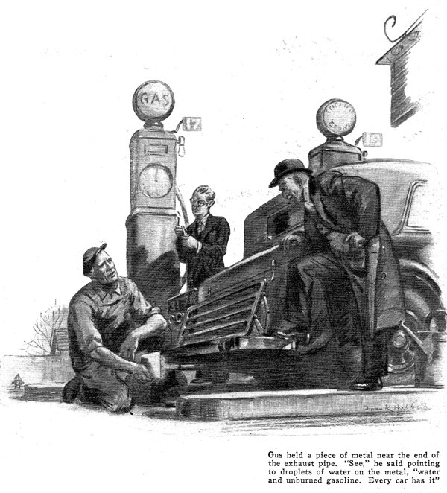
Joe Clark dropped the receiver onto its hook and poked his head through the doorway that led to the Model Garage repair shop.
"Tom Messler was just on the wire, Gus," he called to his gray-haired partner who was half hidden under the head of a motor. "He's stranded out on the York Road and wants you to come and get him."
"What's his trouble?" Gus Wilson asked as he tugged at the end of a wrench. "Out of gas, I suppose."
"Claims he's out of oil," explained Joe with a shrug, "But I just checked it for him the other day and it was right up to the mark."
"Well, I was about to quit for the day, but I don't suppose we can let a friend spend the night on a lonely road," Gus decided as he rubbed his hands on a wad of waste. "Grab one of those six gallon cans of oil and I'll meet you at the wrecker."
In less than twenty minutes, the Model Garage tow car, with Gus at the wheel and Joe perched on the seat beside him, pulled up behind a small sedan. Tom Messler's head was framed in the car window as he greeted the two garage men.
"My crankcase has sprung a leak," he sputtered critically. "She's almost dry. First thing I knew, my pressure gage started to drop as I stopped and took a look at the oil and she's less than one-third full."
While Messler talked, Gus peered under the car and then walking to the rear, followed the general route the car had taken for several hundred feet. When he returned, he was shaking his head.
"Most of your oil is back there on the road," he announced as he slipped his flashlight into his hip pocket. "Been noticing any puddles under your car when it's been parked?"
"Not particularly," Messler replied, "In fact, it was only this morning that I noticed how clean the garage floor was."
"That's funny," mused Gus. "And there's no sign of oil underneath now. The stream ends about three feet back. The means the leak stopped when you stopped your car."
"Do you suppose the drain plug or the crankcase bolts are loose?" put in Messler.
"No such luck," replied Gus. "Chances are it's the rear main bearing. But there's no sense guessing. Let's hoist her up and tow her in. We'll drop you off at your house and you can stop in at the garage tomorrow and I'll go over it with you."
Gus was a little late getting to the garage the next morning and Tom Messler was there waiting for him.
"Well, what's the verdict" the car owner called as the veteran mechanic entered the repair shop.
"There she is," Gus replied, extending a large thumb in the general direction of his bench. "Soon as I can get into my work duds I'll be with you.
"You can blame two things for that little oil leak that left you stranded last night," Gus explained as he joined Messler beside the open hood of the car.
"Burned piston rings and a clogged breather cap on the oil filter pipe. The combination of the two forced the oil through the rear main bearing."
"But what's a breather cap got to do with a bearing?" asked Messler.
"Plenty," Gus asserted. "In the first place, your piston rings are just worn enough to be leaky. Naturally, any gas that blew by collected in the crankcase. Under ordinary conditions that wouldn't be so bad but in some way your breather cap got clogged with dirt and goo. That closed up your crankcase tighter'n a corked bottle and the gas couldn't escape. Something had to give, so the gas just forced the oil out at the bearing.
"I've seen lots of small oil leaks caused by nothing more than a clogged breather. Even without leaky rings, the up and down motion of the pistons will actually pump up enough pressure to force the oil out if it fails to escape through the breather," he explained to Messler.
"Moral: always see that your breather cap is clean when you check the oil," concluded Messler when Gus had finished.
"You know, Gus, I never thought much about my oil until last night when I didn't have any. I never added any between oil changes."
"But that doesn't mean you weren't losing some," put in Gus.
"The oil level stayed pretty much the same," argued Messler.
"That's possible," Gus agreed. "With the blow-by that motor has, enough gasoline probably leaked into the crankcase to make up for any you lost. In every explosion of a cylinder there's a certain portion of the gas that doesn't burn completely. Finally, it's forced by the pistons into the oil. Then, there's the mixture that collects in the cylinders. That ends up in the oil too."
"Moisture," repeated Messler, "where does that come from?"
"It's formed when the gas burns," explained Gus. "It's one of the products of combustion. Let's go out in the driveway, Joe has his car parked out there and with a little experimenting I think I can show you what I mean."
On their way to the car, Gus recruited Joe, who was busy working on some bills in the garage office. As Joe started his car, Gus, sitting on his haunches, held a shiny piece of scrap metal near the end of the exhaust pipe. As the gases struck the metal, a misty coating of water turned out its cold surface.
"You see," Gus said, pointing to the tiny droplets that beaded the metal, "water and unburned gasoline. It's our old enemy dilution. Every car has it, but leaky pistons and rings allow more of it to reach the crankcase."
"Isn't there some way to prevent it?" asked Messler.
"Sure, but you can't eliminate it entirely. The best safeguard is to keep your motor in good condition. As for your driving habits, don't use your choke any more than you have to. You know, Tom, you probably won't believe it, but every time you yank your choke buttons all the way out to start a cold motor, you force several ounces of new gas into your crankcase.
"Fouled spark plugs and a skipping engine help to dilute the oil, too. Some of the unburned gas is bound to find its way past the pistons into the crankcase. And a carburetor that's set too rich will do the same thing."
"How can you tell when your oil is so diluted that it isn't doing its job?" asked Messler.
"There's no way that's particularly accurate," confessed Gus. "Maybe some day automobile manufacturers will equip their cars with some sort of dashboard meter that will measure the viscosity or thickness of the oil in the crankcase. Until then, the safest thing is to change your oil regularly.
"Of course, you can check it to some extent by watching your oil pressure gage. If the reading drops down to about half of what it was when you put in new oil, it's a fairly good sign that the oil is getting thin."
"Aside from dilution, why is it that some cars use more oil than others?" interrupted Messler.
"In most cases," advised Gus, "it's just a little reminder that the motor isn't running as well as it should. Of course every motor is bound to use some oil, but when adding oil get to be a habit, look for trouble. Bad bearings, loose-fitting piston rings, sprung connecting rods, and worn or scared cylinders are just some of the faults that show up in the oil hogs. Then there are leaks of all sorts.
"The way you drive has a lot to do with how much oil a car uses," went on Gus. "A motor that's running at high speed or up long pulls is bound to bust up. Naturally, the oil will get thinner and weaker. Hot, thin oil not only leaks easier but it's bad for the bearings. It pits the Babbitt metal and makes it crumble. That's why some of the new cars are fitted with oil coolers. The oil is water-cooked.
"Then too, the faster you drive, the faster your oil pump will work and the pressure of the oil will increase. High oil pressure will force more oil into your cylinders and possibly through the bearings."
"Say, listen," grinned Messler, "Before you think of any more troubles, what's to be done with my car?"
"Well," Gus drawled, "you could get by with those rings for a while as long as the breather is open and the crankcase is ventilated. But to make a good job of it, I'd suggest new rings and a recondition job on the cylinders."
"Phew!" sighed Messler. "The way you were going at it a few minutes ago I expected nothing less than the advice that I get a new motor. Well, give her the works, Gus. Might as well have it done now as later on when things may get worse. Besides I may be able to save a little on oil."
END

