June 1934

TUNING UP CAR FOR SUMMER USE
by Martin Bunn
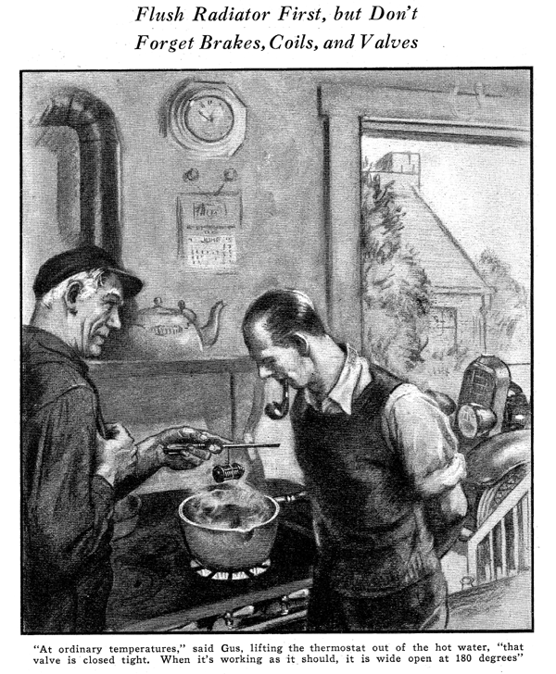
Gus Wilson looked more like a painter than the owner of the Model Garage when Ned Stanton, a neighbor dropped around to see him one holiday afternoon. The gray-haired mechanic had just finished touching up the trim on his neat, two-story house.
"I started some spring cleaning too," Ned said, admiring Gus's handiwork.
"Only I haven't been particularly successful so far."
"Painting?" inquired the garage man.
"Nope, I wish it was. It's that blamed car of mine. I wanted to give it a spring tune-up but all I've managed to do was drain out the anti-freeze and flush the radiator. I didn't know just where to begin."
"Well, you made a start anyway," grinned Gus, wiping spots of paint from his large hands. "Wait until I stick this brush into some turpentine and I'll run over and take a look at it."
"A funny thing," said Ned as they walked to his garage.
"When I was flushing out the radiator during that warm spell a couple of weeks ago, the water didn't seem to run through very fast, I couldn't stop it from gushing out of the top of the radiator where I had the end of the hose."
"Out of the top of the radiator where you had the hose?" repeated Gus.
"Sure, I just stuck the end of my garden hose into the filler opening , opened the drain cock under the radiator, and then turned on the water," Stanton explained. "What's wrong with that?"
Gus's deep chuckle boomed through the driveway. "No wonder your radiator acted like a gusher," he said with a grin. "What did you do about the water thermostat?"
"Thermostat?" echoed Stanton puzzled. "I didn't know the car had one."
"About seven out of every ten cars have one," corrected Gus. "It's a valve controlled by the heat of the cooling water that stops the circulation until the water gets hot. It helps in making cold-morning starts. When the cold water from that garden hose hit your thermostat she just closed up like a clam. It was like trying to force water through a stone wall. And another thing, Ned, you can't clean a radiator by stuffing a hose in the filter hole. Get me a pair of pliers and I'll show you."
With the tool, Gus proceeded to loosen the floor metal clamps that held the radiator hose connections in place. Then he tackled a few screws near the top of the radiator and finally lifted out a cylinder of metal that looked like a stack of large size washers. "This is the thermostat," he said, holding the part up so Stanton could see it. "And one of the first jobs in flushing a radiator is to clean this little heat valve with gasoline and then test it."
"But how the dickens am I going to test a thermostat?" inquired Stanton. "I haven't got any tools for that sort of work."
"You've got everything you need," replied Gus. "Just let me use your kitchen for about ten minutes."
Stanton led the way through the back door of the house to the kitchen. Gus cleaned the thermostat with some gasoline borrowed from the car, then asked Ned for a large pot of water.
"Now," he said as he placed the kettle on the stove, "we're ready for the test. The first thing we'll do is hang the thermostat in the water so it doesn't touch the bottom of the pan where the heat would be too great. We can do that by looping a string around it and supporting the string on this screwdriver placed crosswise on the rim of the pot. Then we'll light the burner and wait for the winter to heat up."
When a faint mist of steam rose from the water, Gus motioned to Stanton to watch the valve at the end of the thermostat. Gradually, as the water got hotter, the tiny valve opened water and wider and wider until at last, when the water was boiling, a space at least a quarter inch in width could be seen all around the head of the circular valve.
"At ordinary temperatures that thermostat valve is closed tight," explained Gus.
"But when it's working as it should, it starts to open up at about 140 degrees Fahrenheit and is wide open at about 180 degrees. Sometimes they get stuck during the winter. If they do, they'll cause all kinds of overheating troubles in the summer. If it doesn't open when the water boils, it's good proof that it's either broken or jammed."
"How do you go about fixing them when they're broken?" asked Stanton with interest.
"There's no sense trying to fix them," replied Gus. "If trouble shows up in the test, the best thing to do is to put in a new unit. Of course, you don't need a thermostat in the summer, but they sure help on cold mornings."
When the two men once again were in the yard standing beside the opened hood of Stanton's car, Gus, proceeded to demonstrate just how a car's cooling system should be flushed.
"To make a good job of it," he began, "the first thing to do it to use some sort of cleaning solution. There are lots of them on the market or, if you want to, you can use a plain washing soda for every gallon of water. Put that in your radiator and run the motor for about ten minutes to force it all through the system.
"Then drain your motor and radiator, pull out the thermostat, test it and clean it, and then remove both hose connections. When that's done, you're ready for the actual flushing.
The best way is to flush the radiator and motor separately; that doesn't force the muck from one into the other. Simply leave the filter cap on the radiator and push the end of your garden hose up into the bottom connection. That will send the water backwards through the core and loosen all the scale.
"To flush the motor, push the hose end into the bottom connection pipe and let the water work its way up through the block and out the top connection. You can tie a length of inner tube to the regular hose pipe to lead the dirty water away from the motor. The main idea in flushing is to force the water backwards through the system.
"Finally," Gus concluded, "you can play your hose on the radiator core from the inside to clean out all the bugs and dirt that clog the honeycombs."
"Gosh, flushing is a regular week-end job in itself," groaned Stanton. "And I suppose there are about a million other things I should do, too?"
"Well," said Gus, "that depends on the condition of the car. But no matter how you figure, the first item on your list should be the radiator flushing and a general overhauling of the cooling system - and that includes fan belt, hose connections, and water pump. Next comes a general check-up of the brakes and front wheels. Shimmy and braking troubles may not be so noticeable in the winter when you're driving slow on slippery streets, but they're bound to show up in the spring.
"Weak coils are another thing that act up in the spring of the year when you start pushing your car for speed and pick-up. You'd better put that down as number three. A weak coil will make the engine misfire and that means overheating.
"Then there's your valves and spark plugs. They always deserve a little attention after a hard winter of over-choking and cold weather starts. You ought to check up on the ignition timing too," added Gus, "it's liable to be a trifle late.
"In other words, check everything that's apt to cause overheating and that includes the oil you're using."
"Say, Gus," put in Stanton as he examined one of the hose connections, "isn't there something you can do to prevent all this muck from forming is a car's cooling systems?"
"Sure. After you get through flushing, you can add some rust preventive to the new water. There are several good brands on the market and they aren't expensive either. At first they form an emulsion with the water but after the car has been driven a few miles they separate out to form a thin film of oil on all the inside surfaces.
"Another good way to keep the cooling system clean is to be careful what kind of water you use. Always try to avoid well water when you're out on trips. It contains all sorts of minerals and salts that form a regular armor plate in the radiator and block."
"Anything else you'd suggest for a thorough job?" asked Stanton.
"Well, you might give the car a good washing and polishing, " returned Gus.
"Pretty soon now you'll be hiking along hot roads under a broiling sun, so you want to replace that skin of dirt with a film of polish.
"And by the way," Gus added as he passed the opened rumble seat on his way through the driveway, "a little time spent cleaning the leather on that rumble seat wouldn't be wasted. Wipe it off with a rag moistened with water, mixed with a few drops of ammonia.
Then, rub it down well with some leather dressing or a homemade concoction of linseed oil and half as much turpentine. There's a lot more kick in driving a clean car."
END

