February 1934

HOW MODERN GAS
ADDS POWER TO YOUR MOTOR
by Martin Bunn
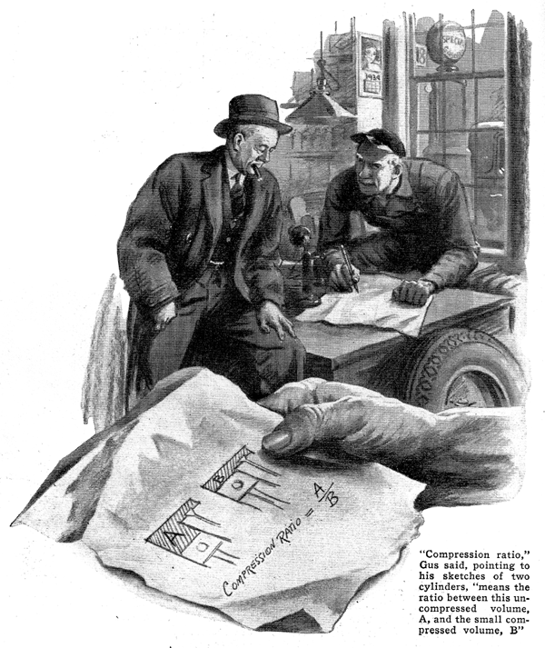
Cliff MacDonald had dropped in at the Model Garage for a noon-hour chat with his old friend Gus Wilson.
"By the way, Gus" he said jerking a thumb toward the gasoline pumps that stood in a line, outside the garage office window, "what's your idea of the perfect gasoline?"
Gus Wilson had just finished his lunch and was poking tufts of black tobacco into the charred bowl of his favorite pipe.
"Your guess is about as good as mine," he replied as he struck a match. "Why do you ask?"
"Well, years ago, gasoline was just gasoline," said MacDonald, "But now every brand advertises some new feature that's supposed to make it better than all the rest. Why, they've even gone so far as to put the stuff out in different colors."
Gus chuckled as he found himself a seat on a corner of the office desk.
"You're getting more for your gasoline dollar today than you ever got before," he pointed out, "Gasoline had to change to keep up with the times. You know, automobiles aren't as simple as they used to be either."
"Well, the bodies may have changed but I don't see where the motors are much different," MacDonald maintained. "They may be a trifle faster and more powerful but - "
"And that's the answer," interrupted Gus, "It's that extra power and added speed that's back of the whole business. Car horsepowers have increased over seventy-five percent in the last eight years."
"Sure, but that's a question of motor design and not gasoline," MacDonald argued.
"Not entirely," Gus corrected. "It's true that one way to get more power is to build a larger engine and feed it more gasoline. But when the public started its howl for more power and speed, it didn't want a heavier engine. In fact, they wanted a smaller one that would use less gasoline. So automobile engineers had to compromise.
"First of all, they knew that by putting the air and gas mixture in the cylinders under more pressure they could get more power with the same amount of gas so they worked along those lines and developed the high-compression motor. By making the space in the cylinder head smaller, they increased the compression."
"So that's what they mean when they say that the modern motor has a higher compression ratio than the older ones?"
Exactly," agreed Gus as he picked up a scrap of wrapping paper and proceeded to make rough sketches of two cylinders; one with the piston at the top of its stroke and the other with the piston at the bottom.
"Compression ratio," he explained pointing to his sketches, "simply means the ratio between this large uncompressed volume (A) and this small compressed volume (B). In other words, it tells the number of times that the mixture of air and gas is compressed by the up stroke of the piston. Ten years ago plenty of cars had compression ratios as low as three to one. Today, some go higher than six to one. In 1923 only about four percent of cars had a cylinder pressure over one hundred pounds. Now, ninety-three percent of the cars operate at that pressure."
"How about gas mileage?" put in MacDonald. "I should think a high-compression motor would use more fuel."
Gus shook his head, "As a matter of fact," he pointed out," a good high-compression engine will deliver more power for less gas. But the engineers ran into a snag with their high-compression motors and that's where the new gasolines come in.
"Years ago, gasoline used to be obtained from the crude oil by a simple method of distillation. You know, like moonshine whiskey; simply boiled and then condensed. That kind of gasoline worked fine in the older motors but when they put it in a high-compression motor, it made all kinds of noises and wouldn't give any power."
"What caused that?" MacDonald asked.
"The increased pressure in the cylinders. Instead of burning slowly and pushing the piston steadily, it exploded. That gave the piston a sudden punch that lacked power and caused a 'pinging' knock.
"Naturally, if high-compression motors were to be a success, something had to be done about it, so the gasoline chemists tinkered around until they made a discovery. They found that if instead of distilling the crude oil they placed it in a closed container under pressure and heated it, like the vegetables in a pressure cooker, they obtained an entirely different gasoline. They called this process 'cracking' and its product was found to burn quietly in a high-compression motor. After a little more fussing around, they finally brought out the modern anti-knock gasoline. Some chemists even added a chemical, tetra-ethyl lead, to make it burn still more evenly."
"But what's this octane rating you see and hear as much about these days?" MacDonald asked. "Sounds like the name of a gas or something."
Gus smiled. "It's not, though. It's simply a number, like degrees of temperature that designates anti-knocking qualities. They got it by comparing the running qualities of the gasoline with some known gasoline. A gasoline with a high octane rating will run under high pressure without knocking."
As Gus talked, he ambled toward the repair shop door and beckoned to MacDonald to follow him. "I've got something in here along this same line," he said as he led the way to one corner of the shop.
"You know Dave Clemons? Well, this is his car. Brought it in here the other day to let me give the radiator the once over. During the conversation he happened to mention that his favorite brand of gas wasn't giving him the service it used to. Claimed it knocked.
"I suggested carbon. But he told me that he'd just had it cleaned. That gave me a hunch and I examined the gasket between the cylinder head and the block.
"My guess was right. The serviceman who did the job had substituted a gasket that was thinner than the one that was originally in the car. Naturally that reduced the cylinder head volume slightly. But even that small difference - and it wasn't over a tenth of an inch at the most - increased the compression enough to make 'regular' gas knock. With the 'premium' stuff, it works fine."
"Something like the mistake I made a couple of years ago," commented MacDonald as the two men strolled back to the garage office. "In putting in a new gas line, I got it too close to the exhaust and every hot day the motor would die. Had me puzzled until someone told me about vapor lock and I realized that when the motor reached a certain temperature, the gas boiled and the bubbles choked off the supply."
"Gasoline companies have licked that problem and they've licked winter starting, too," explained Gus. "Now they regulate their gasolines so they perform well under almost any natural temperatures. Sometimes they speak of this feature as 'climatic control.' Of course, the automobile companies have done their share, too, by designing the fuel supply more carefully."
"Well, the thing that gets me," confessed MacDonald, "is how the average car owner is supposed to know just what brand of gasoline is best for his car?"
"He doesn't have to know," concluded Gus. "Knock and gas mileage will soon tell him which is the best. Obviously, no one gasoline will meet the needs of all cars under all conditions. Be your own experimenter. Try several tanks of each of the good grade gasolines, both the regular and the premium. If you'll continue to use the one that gives you the smoothest, quietest, and peppiest performance, you can forget about octane ratings and compression ratios."
END

