August 1934

ARE YOUR HEADLIGHTS SAFE?
by Martin Bunn
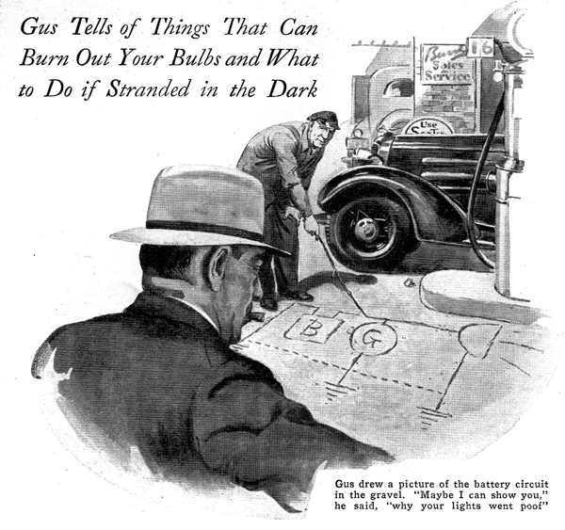
"Who's the mechanic around here?" The gruffness of the voice brought Gus Wilson's head around with a snap. A large sedan had rolled to a stop in the Model Garage driveway, "I am," he replied walking toward it.
"I hope you're better than the rest of them around here," grumbled the driver as he stepped to the ground. "I'll bet I've had this car to four garages in the last two weeks."
"What seems to be the trouble?" inquired Gus courteously.
"If I knew I wouldn't be here," replied the driver. "But I do know that my headlight bulbs and tail light burn out as fast as I put them in."
Gus walked around to the front of the car and patted the headlamps. "Burn out while you're driving?" he asked casually.
"Yeah, that's what makes it bad. I'll be breezing along when all of a sudden they'll flare up and go out. The thing that gets me is that new bulbs always light when I put them in. That doesn't seem right."
Gus slid into the driver's seat and ran his hand over the rear of the instrument panel. Evidently satisfied with what he found, he pulled up the seat cushion and centered his attention on the battery.
The owner ventured a suggestion. "Do you suppose the generator has anything to do with it?"
"I'll say it has," was Gus's abrupt reply, "But not the way you think. Take a look at this."
He held up the frayed end of one of the battery cables. "Your battery ground wire," he announced. "Your battery looks like it's been loose for some time and in joggling around it's gradually broken the wire in two."
"Then, how come the car started?" demanded the man.
"That's the funny thing about it," said Gus. "As long as the battery stayed still, the two ends of the wire most likely rested against each other and closed the circuit. But every time you hit a big bump, the rebound of the springs tossed the battery up in the air, pulled the two wires apart, and opened the circuit. When she settled back in place again the two wires came together and closed the circuit but if you had the lights on at the time, the damage was done."
The customer looked puzzled. "But I still don't see how a broken battery wire can blow out lights," he argued.
"Maybe I can show you" Gus said as he picked up a short twig and drew a rough picture of the battery circuit in the gravel that bordered the driveway.
"In the first place the generator is connected to the battery, and as long as it stays connected, its voltage can't get any greater than the battery voltage. The current flowing through the battery won't let it. Now, suppose we break the ground connection to the battery," Gus suggested as he smoothed over the gravel to form a break in the line. "That cuts the battery out of the circuit, the generator voltage skyrockets and poof go your lights.
"As a matter of fact, a loose, dirty connection or a partly broken wire will cause the same trouble. Anything that puts a lot of resistance into the charging circuit will let the generator voltage build up too high. Then, if your lights are on they'll blow out.
"I had a case last winter that showed me what a little resistance in the battery circuit can do. I had just put new headlights bulbs in a customer's car. The next day he came in and said that the new bulbs had burned out the night before. Since I had regulated the generator earlier in the winter, I knew that the charging rate wasn't too high so I had to look somewhere else for the trouble.
"It almost had me stumped until I thought of the battery. It turned out that because of the cold weather, the internal resistance of the battery got a little higher than usual and added just enough resistance to the circuit to shoot the generator voltage up and blow the lights."
As the gray-haired mechanic worked over the battery, replacing the broken wire with a new one, his customer, less grumpy than when he arrived watched with interest.
"It seems to me," he said, "that manufacturers should supply their cars with some sort of emergency light that could be used when your driving lights burn out. I was in a tight spot the other night. A pitch black road, no lights, and no room to get off the road. I expected to be smashed into any minute."
"Why didn't you turn on the dome light?" asked Gus as he grasped a connecting lug firmly between the jaws of his pliers. "There's no reason why that should have burned out. It wasn't on when your headlights blew."
"Gosh, I never thought of it," the man replied sheepishly.
"There are three things you should do if your lights blow while you're driving," Gus said. "First, jam on your brakes and guide yourself by watching the sky line or the edge of the road until you come to a stop. Second, get as far off the road as you can. And third, switch on your dome light for a danger signal to the rest of the drivers on the road."
"By the way," interrupted the man. "Before I forget it, when you put new bulbs in those headlights will you see if you can do anything to them to make them brighter. Even with new lamps, they seem to be awfully dull."
"It's no wonder," said Gus when he had lifted off the headlight lenses. "Look at those reflectors. They're so dirty it's just luck that you got any light. Why don't you clean them now and then?"
"Thought you weren't supposed to touch them," replied the man.
"You're not supposed to touch them with your fingers," agreed Gus. "But that doesn't stop you from using a piece of cotton or a soft cloth. A trick that I find works well to dip an old handkerchief in alcohol and then in lamp black. The combination makes a swell cleaner and polish. Don't rub the reflectors too hard, just enough to bring back some of the original silver finish. Of course, if they're too far gone, you can have them re-silvered in almost any large city.
"And while we're on the subject," added Gus, holding up one of the lens holders, "polishing won't do much good unless you renew these lens gaskets in the rims. They're pretty badly rotted and aren't much help in keeping out the dirt and moisture."
"How about focusing the lights? Would that do any good?"
"Not these headlights. They're focused already - pre focused they call them. All the newer cars have them. The only adjustment they'll ever need is a little aiming.
"You can test that by drawing a chalk line on the back wall of your garage, making it parallel to the floor and on a level with the centers of your headlights. Then, back your car out on the driveway so that the headlights are about twenty-five feet from the wall and turn on your driving lights. The upper edge of the bright beam shouldn't go much above the line. If it does, shield first one light and then the other to find out which one is out of whack and then re-aim it by adjusting the aiming screw or clamp under the headlight.
"If you will point some sort of guide line on your driveway to tell you when your headlights are just about twenty-five feet from the wall, you can test your lights every time you drive into the garage. Just stop a minute at that spot, turn on your driving lights, and watch where the beam comes."
"I wouldn't mind night driving at all," remarked the car owner, "if it wasn't for the terrific glare you get from about nine tenths of the cars on the road. My headlights don't seem to push past the other lights al all. It's just like driving blind."
"They're going to try out a tricky way of eliminating glare on the roads in Germany," replied Gus. "In the centers of the high speed roads, they're planting a long series of hedges crossways to make a lane. Being sort of planted across the road like the leaves of a shutter, they won't cut off the view but will cut off the glare.
"Speaking of glare," continued Gus as he fastened the lenses back into place, "reminds me of old man Curtis. About a year ago, Mr. Curtis had to make a lot of long trips in his car. On each trip, he took a small bottle of water and a soft cloth. Every night as soon as it got dark, he'd stop his car, wet the cloth with the water, and wash off the headlights lenses."
"Is there anything that the average driver can do to improve his lighting equipment?" the man asked when Gus had finished.
"Well, besides perhaps adding a spotlight to light up the edge of the road and a couple of fender lights, I'd say that a pilot light mounted on the instrument board and wired into the tall-light circuit would be the most helpful. The tail lamp is one important light the car owner can't see. A pilot, wired in series with the tail light, will let him know the minute the tail-light bulb fails."
END

