April 1934

HUNTING YOUR CAR'S CASTER
by Martin Bunn
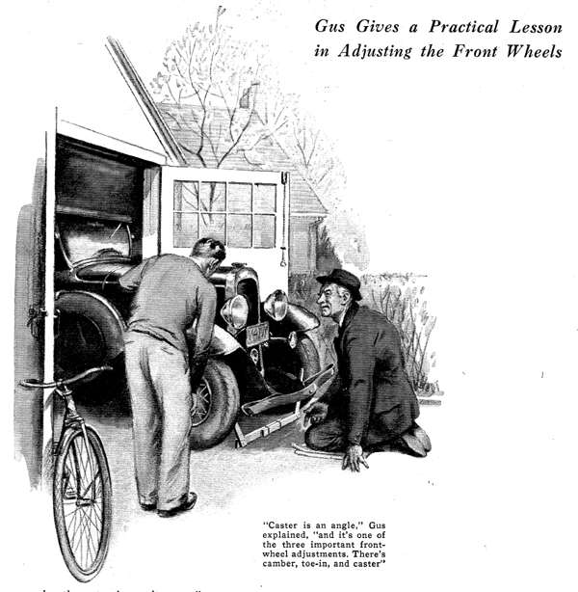
Gus Wilson's annual visit to his upstate relatives had a way of developing into a busman's holiday.
On this particular trip, his hopes for a workless vacation were shattered the second morning of his stay. This time it was Bill, his eldest nephew, who upset his plans for a week of rest.
"Uncle Gus," the young man began timidly as the gray-haired auto mechanic propped his morning paper against the sugar bowl and leisurely poured himself a second cup of coffee, "will you show me how to check the steering gear on my car while you're here?"
"What seems to be wrong?" asked Gus good-naturedly.
"The car keeps running to the right," explained Bill. "I have to wrestle with the steering wheel to keep it on the road."
A grunt was Gus's only answer as he followed his nephew to the front curb where the car was parked.
"First of all, we'll have to find a good place to work," said Gus after a hasty inspection. "How about running the front wheels onto the driveway outside your garage? While I move the car around there, you go to your Dad's workshop and see if you can hunt up a couple of lengths of wood lathing, a hammer, a saw, some nails, and a large steel square. And, say, if you can find one of those adjustable spirit levels bring that along too."
Gus finished parking the car just as Bill, his arms laden, emerged from the cellar door.
"What are you going to do with all this stuff, Uncle Gus?" asked Bill as he piled the tools and lumber on the car's running board. "All I want to know is how to check the steering gear."
"I don't think the steering gear has much to do with your trouble," replied Gus as he picked up the two long sticks and sighted along the first one and then the other. "Sounds like unequal caster."
"Unequal what?" asked Bill.
"Caster," repeated Gus. "Don't you know what that is?"
"No relation to the oil, is it?" grinned Bill.
Gus shook his head. "Nope, it's an angle and it's one of three important front-wheel adjustments. There's camber, toe-in, and caster."
The puzzled look on Bill's face told Gus that the subject needed some tall explaining.
"Here, take a look at this," said Gus as he wheeled out a bicycle that had been leaning against the garage wall. "Do you notice how the steering pivot for that front wheel is back of the wheel's center. Well, that's caster. It's just like the arrangement of the casters on furniture legs. The front wheels at an automobile are pivoted in just the same way. The king pin on each wheel is tilted by the axle to give the caster angle.
"Now, if this bicycle wheel is tilted a little off the vertical," Gus continued as he held the bicycle at an angle, "that illustrates camber. The front wheels of a car are tilted just like that. They're mounted to be closer together at the bottom than they are at the top.
"As for toe-in, that's just what you'd expect from the name," continued Gus.
"The front wheels are pigeon-toed; their front edges are closer together than their rear edges."
"How the dickens can two wheels be like that all at once? Seems like they'd get all mixed up," argued Bill. "As far as I can see, camber and toe-in are pretty much the same thing, except one is horizontal and other is vertical."
"Right," agreed Gus, "and if either the caster or the camber are wrong, they'll upset the toe-in. That's why toe-in is a check on them all. If the toe-in measures O.K., you can be pretty sure that the camber and caster are right."
"Sounds like an awful lot of measuring to me," observed Bill. "How would you check all those angles?"
"Well, the best way is to use regular measuring instruments that are made for the work. All good repair shops and service stations have them. Of course, in a case like this, you can put together some tools that will do a good enough job.
"For instance, camber tilts the front wheels out at the top, like this," Gus explained, indicating the angle with his hands. "Well, we can check that by placing a large steel square flush against the hub and measuring the distances between the rim and the vertical edge of the square at the top and at the bottom of the wheel. If the wheel has camber, the distance at the top should be less than the bottom distance.
"If the car is an old model, two long laths, pointed at the ends and fastened together one on top of the other with four or five heavy rubber bands will do to space off the measurements. Of course, on new cars you'll have to add arms at the ends to get around the motor pan.
"As for caster, you can use an adjustable spirit level to check that. The caster angle generally is obtained by the twist of the axle. So by placing the spirit level crosswise on the axle, first at one end and then at the other, and adjusting it, you can measure each angle.
"Suppose some of these adjustments are wrong," interrupted Bill, "how do you make them right?"
"Well, if the caster, for example, is wrong, it generally means that the axle has been bent in an accident. Naturally the only way to fix it is to bend it back."
"Do you have to heat it" asked Bill.
"That's the one thing you shouldn't do," declared Gus positively. "Heat would spoil the original heat treatment that's responsible for the strength. If you have to bend it, do it with the metal cold. It's a tough job, though, and I wouldn't advise trying it unless you have experience and the right tools. Of course, if the caster is out only a little, you can correct it by loosening the spring saddles and driving wedge-shaped shims in between the spring and the spring seat. That will tip the axle.
"Camber can be changed by bending the portion of the axle between the springs and the wheels. As for toe-in, that's the easiest to adjust. All you've got to do is lengthen or shorten the front axle tie rod."
As Gus talked, Bill was inspecting each of the front wheels on his car. "But what makes you think my trouble is unequal caster?" he inquired at last.
"I'm just like a doctor," chuckled Gus. "I diagnose from symptoms. You complain of hard steering to the left and a tendency to pull to the right if you don't keep your hands on the wheel. My diagnosis from these symptoms is that each wheel has a different caster angle. The car turns to the right; that means that the right-hand wheel has less caster than the left.
"It's the same with camber, only you have to look in a different place for the symptoms. If you have too much camber, the outer edges of your tires will wear faster than the rest of your tread."
"What are we going to do about my car?" asked Bill impatiently. "There's no sense checking the caster, if I can't fix it."
"Well, drawled Gus, "I'd suggest that you check all three adjustments just for the practice. You can learn a heap about your car that way. Then, when you find out just how much the caster is out, perhaps we can fix it with wedges.
"And, by the way, before you do any checking be sure that the car is absolutely level and that the tires are properly pumped."
With that, Gus turned and ambled toward the house. As he reached the front steps, he glanced back and grinned. Bill was hard at work, and Gus knew that doing was the best way of learning, and besides - now he could get back in that morning paper.
END

