November 1933

SPEEDOMETERS
SOMETIMES TELL LIES
by Martin Bunn
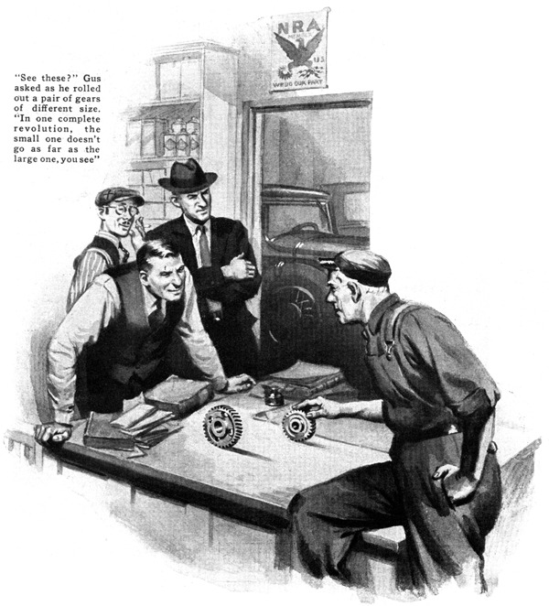
Loud voices were coming from the Model Garage when Gus Wilson arrived one morning. Two customers were in the midst of a heated argument.
"Hey, you guys," the gray-haired mechanic shouted as his car rolled to a stop in the driveway, "Pipe down. You're waking up the neighborhood." Then he asked Joe Clark, his partner, who was busy unlocking the gasoline pumps. "What's it all about?"
"Got me," the younger garage man said with a gesture of disgust. "All I know is, they've been arguing steady for the last half hour."
"It's about speedometers," one of the men offered excitedly, "Otis, here, says his is right and mine's wrong."
"I'll do more than say it, Al. "the other broke in. "I'll prove it."
"Hold on there," Gus bellowed. "Two people talking at once never settled an argument. One of you keep quiet and let the other fellow talk."
Al Taylor caught his breath first.
"It all started about two weeks ago." He began, "when Frank Otis and I decided we'd treat our families to a trip to the Chicago Fair. To make a party of it we planned to stick close together.
"It worked out fine. I'd trail him one day and he'd trail me the next. We kept together every inch of the way, but when we got to Chicago, my speedometer read 970 miles while his read 930. Coming back it was the same way."
"Maybe they're both wrong," Gus suggested.
Both men sputtered indignant replies as Gus walked to the front curb where the two cars were parked.
"Mine's a newer car than his," put in Otis. "My speedometer ought to be nearer right."
"I looked up the mileage according to the roads we took and it checks nearer mine than yours," retorted Taylor.
Gus calmly walked around one car and then the other.
"Say, if you fellows will can the chatter for about five minutes I'll tell you something interesting." He said finally.
"In the first place, now matter how good a speedometer is, it rarely clocks the exact mileage after a car's been driven five or six thousand miles."
"Humph!" grunted Otis. "If they go bad that soon, what's the sense of having one?"
"The speedometers don't wear out," Gus corrected. "But your tires do."
"What have tires got to do with it?" asked Taylor.
Gus walked into the garage office and beckoned the others to follow.
"See these?" he asked, picking up a pair of gears that served as paper weights on Joe Clark's desk.
One is larger than the other, isn't it?" The two men nodded.
"Suppose we roll them along this desk top for one complete revolution," suggested Gus, demonstrating as he spoke. "The small one doesn't go quite as far as the large one, does it?
"Now, let's apply that to the wheels on a car. To start with speedometers tick off the miles according to the revolutions of the wheels and each one is designed to be used with a certain size wheel. Naturally, if the wheels are larger or smaller than they're supposed to be, the speedometer reading will be wrong."
"How can a wheel be smaller or larger than it's supposed to be"" demanded Frank Otis.
"Easy enough," Gus said with a smile. "Tires have a bad habit of wearing out and car owners often forget to keep the air pressure up. In both cases, the tires will be smaller than they should be. If you fit your car with oversize shoes as you've done, Otis, the wheels will be larger."
"I can see how it might make a difference on an old automobile that has the speedometer geared to the front wheel." Chris replied. "but what about the cars that have it geared to the drive shaft?"
"Makes no difference where it's geared." Gus insisted. "It still gets its movement from the wheels and if the tires don't pace off the distance they're supposed to, the reading will be wrong."
"Gosh! The size of your wheels will make a difference, won't it," exclaimed Taylor, "But forty miles is a big error in a trip to Chicago."
"Let's figure it out in black and white just for the fun of it," Gus suggested as he picked up a scrap of paper and fished for his favorite pencil stub. "Just to make it easy, let's take a car with thirty-inch tires.
"Normally, a thirty-inch tire, with a circumference of about seven feet, nine inches, will make about six hundred and seventy-five complete revolutions every mile. Since that's the normal condition, the speedometer will be set to tick off a mile every time the wheels turn that number of times.
"Now, let's suppose the tires are worn down a half inch or underinflated the same amount. That'll bring the diameter down to twenty-nine inches and the tire will pace off three additional inches for every revolution. In a mile the error is three times six hundred and seventy five or approximately two thousand inches.
"Changing that into miles," Gus continued to calculate, "will mean that every time the speedometer clicks a mile the car will have traveled one hundred and seventy feet less than a mile. In a trip of one thousand miles, that amounts to about thirty-five miles error.
"And the same thing happens if the tires are larger than they should be," Gus added.
"Only the error will be in the other direction. The speedometer will read low."
"How can we check them?" asked Otis.
"Simple enough," explained Gus. "Make sure your tires have the right amount of air in them and then go out on the Mount River highway where the automobile club has that measured mile. Just run the length of it several times and see what your speedometer reads.
"Of course, if you want to make a larger test, take a trip some place where you're sure of the mileage. Then, when you've found out the error, if there is any, you can figure it in percentage."
"By the way, Gus, how about the miles-per-hour reading on a speedometer?" asked Otis, "Wasn't the size of the wheels affect that also?"
"Sure, said Gus, "The speed reading depends on the revolutions of the wheels just like the mileage. Naturally, if the wheels are smaller than they should be, the speedometer will show a higher speed than it should. On the other hand, if the wheels are larger, it will read lower."
"Oh, so that's it, Al," Otis grinned with satisfaction. "No wonder you got that bunch of junk you call a car up to seventy when the best I've been able to do is sixty-seven. Your tires are worn and mine are oversize."
"Aw, go on," Taylor snapped back, "you couldn't get that crate of yours up to seventy if you used spokes for wheels."
Gus shoved his pencil stub back in his pocket and walked out of the office.
Soon the door opened with a bang and the two men, still arguing loudly, appeared.
"What's up now?" Gus asked as they rushed toward their cars.
"We're going out to that measured mile," said Frank. "Maybe we can settle two arguments at once."
"You didn't do so well with them," Joe grinned as the two cars disappeared up the street. "They came here with one argument and left with two."
"Oh, well," growled Gus, "I started them thinking anyway. And, if you don't think that's something, you don't know these two birds as well as I do."
END

