March 1933

DON'T STARVE YOUR CAR'S BATTERY
by Martin Bunn

Gus Wilson Describes Easy Way to Test Ignition System

and Keep It in Good Shape.

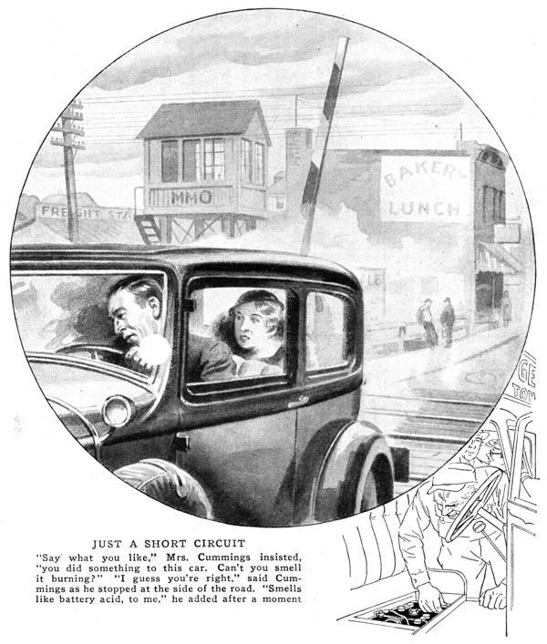
Rabbit-like, the Cummings car bounded over the bumpy railroad crossing. Then - blump! A hollow thud resounded above the rattles, Harry Cummings jammed on his brakes. His wife shrieked.
"What have you done now?" she demanded.
"Aw, say!" protested Harry. "What's the idea of blaming me for everything? Can I help it if we hit a loose stone and it bounces up against the floor boards?"
"Well, you could be more careful," snapped Mrs. Cummings. She sniffed once or twice. "Say what you like," she insisted, "you did do something to this car! Can't you smell it burning?"
"Gosh, I guess you're right!" exclaimed Harry. He steered the car over to the side of the road and stopped. "Smells like battery acid to me," he muttered after a moment. Quickly he lifted the front seat and raised the cover to the storage battery compartment.
Some minutes later, Gus Wilson and Joe Clark, the owners of the Model Garage were listening to Harry Cummings strange tale of woe.
"Look at that, will you," Harry directed, pointing down at his uncovered battery. "The compound on top of that left cell is split right across the middle where the filler cap goes. When I first looked at it, the filler cap had entirely disappeared and the top of the cell was bulged up like a broken stick where that crack is.
"I hunted around and finally located the missing cap at the bottom of the battery compartment. I pushed the top of the cell back in place, screwed in the filler cap, and then drove here."
Gus Wilson leaned over to inspect the battery, Joe Clark peering inquisitively over his shoulder, while Mrs. Cummings fidgeted impatiently in the back seat.
"Joe suppose you take my car and drive Mrs. Cummings home," Gus suggested after glancing at the back seat and recognizing the warnings of an impending verbal storm. "There's no need for you to wait around until we've found the trouble, Mrs. Cummings."
When they were gone, Gus busied himself with the leads from the battery. The battery compartment was metal and the heavy cables that led from the battery passed through holes in the metal sides.
As Gus pulled and jiggled the cable leading to the starting motor, long yellow sparks zigzagged in all directions.
"Here's your trouble," Gus announced triumphantly. "The insulation on this cable has worn through right where it leaves the battery compartment. Every time you went over a bump, the bare wire came in contact with the metal sides of the compartment and caused a short circuit."
"That's a short circuit all right," Cummings agreed, "and a bad one too. But what split the top of the battery open?"
Gus scratched his head. "Well, you can bet your hat the short circuit had something to do with it" he decided at last. "My guess is that you've been doing a lot of daytime driving. That charged up your battery and it began to gas. By that I mean that it bubbled off hydrogen gas.
"Hydrogen is an explosive gas when it's mixed with air and your battery compartment, being closed over, confined the gas that was given off. When you went over those bumps at the railroad crossing, the bare wire on that worn battery lead came in contact with the metal sides of the compartment and caused a short circuit.
"The sparks from the short ignited the gas mixture and blew the top off that left hand cell. The thud you heard was the rubber filer cap hitting the cover on the battery compartment. You should inspect your battery leads now and then," he finished.
"Isn't there some way you can reduce the charging rate of the generator when you're going on a long trip," Harry asked, after instructing Gus to put in a rental battery and a new set of battery cables.
"Sure, you can reduce the charging rate in most cases," Gus agreed. "But the easiest way is to burn your lights when you go on a long drive. The additional drain will prevent over charging."
"But I though every car generator had a cut-out that switched the generator out of the circuit when the battery was charged," Cummings objected.
"Generators have cut-outs, but they don't work that way," replied Gus, "Cut-outs are automatic switches that cut the generator out of the circuit when the car is running so slowly that the generated voltage is less than the battery voltage. On most cars, the generator begins charging at twelve miles an hour and decreases at twenty-five miles an hour."
"Well how can a punk mechanic like me tell when his electrical system is working as it should?" Harry inquired as he watched Gus lift the rental battery into place. "If most of the drivers in the world are as dumb as I am, they never think twice about the battery, much less the generator."
"That's that way with most car owners," Gus chuckled. "It's a case of out of sight, out of mind.
"It's a cinch to check upon your generator. All you've got to do is make use of that ammeter on your dashboard. With the motor off and your lights on, jot down the reading of the ammeter. Of course, it will show on the discharge side of the dial.
"Then with your car running at fifteen miles an hour and your lights off, take a second reading. This should show on the charge side of the meter. When you compare both readings, the second one should be a little more than the first. Most generators are adjusted to give their greatest output of fifteen or twenty miles an hour so by making the test at that speed you get the greatest value."
"Sounds easy enough," Harry agreed, "but what I want to know is how I could have located that short before anything happened."
"Well, in the first place," explained Gus, "you ought to take better care of your battery. A battery coming from the manufacturer is as perfect as it can be made and if it gives up before its usual span of life you can charge it up to neglect on your part.
"A battery is just like a human being. If it doesn't get enough food, it gets weak; and if it get too much, it gets sick. Most battery troubles can be traced to neglect - lack of water, undercharging, or overcharging."
By this time, Joe Clark had returned and was helping Gus connect the new battery cables.
"The best way to take care of a battery," Gus continued as he took the wrench Joe handed him and tightened one of the battery terminals, "is to do it periodically. Test your battery every two weeks with a hydrometer. In order to make it a habit, do it on the first and fifteenth of every month. If a cell reads much below 1,250 on two successive testing dates, get the battery tested at a service station.
"Always test all the cells to make sure each one is healthy, and most important of all, don't add anything but distilled water."
"But, Gus," Cummings interrupted, "the solution in a battery is made up of water and acid, isn't it? How come you don't have to add some acid now and then?"
"If the battery is in good condition," Gus replied, "the only reason for losing any solution is evaporation, and the acid doesn't evaporate. All you've got to do is replace the distilled water to keep the solution at the proper strength. Of course, if you lose some of the solution through a leak, you'll have to add acid and water accordingly.
"Speaking of leaks," continued Gus, "any leaks in your electrical system will drain your battery too and make it weak. So besides testing the battery periodically you should test your wiring as well."
"Isn't there some quick way to test the whole system for short circuits?" Harry asked.
"There is, and it's almost as simple as checking the air in your tires," said Gus as he reached for a file. "Joe and I can show you how in a jiffy."
The two garage men busied themselves with the headlights and cowl lamps as Harry Cummings looked on.
"The first step is to turn on all your lamps and remove the bulbs," explained Gus as he worked. "Then disconnect one of the battery cables and hold one end of a coarse file against the free terminal post on the battery, like this. Next, rub the unconnected cable end along the file. If sparks are noticed there's a ground in the wiring. From the looks of this," Gus said indicating the absence of sparks on the surface of the file he was holding in his left hand, "I'd say that those new battery cables fixed up the only short you had. You know, every short won't be as easy to find as the one that caused your trouble, but nine-tenths of the shorts, that are found in cars, are caused by worn-out battery cables.
"And there's one more thing," Gus added. "If you do much driving in real cold weather always start the motor before adding the distilled water.
"Water floats on acid, you know. So if you pour it in and let it stand, it may freeze. Running the motor fast enough to charge the battery, however makes the solution circulate around. Once the water has mixed with the acid there isn't much danger of freezing. Of course, in very cold weather, it's sometimes wise to keep the specific gravity of the solution up to 1.275."
"There's more to this battery business than I suspected," Cummings confessed as he waited for Joe to slide back the doors of the garage.
"Just remember one thing," Gus called. "Your battery is probably all right when you buy it and you can keep it that way for quite a few months if you'll only take moderately good care of it."
END

