July 1933

AUTO GLASS THAT'S CRASH PROOF
by Martin Bunn
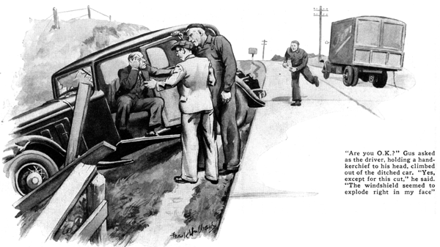
Brakes screeched and horns sounded as a blue sedan whizzed past the Model Garage tow car, cut in sharply to avoid a truck and crashed through the white fence bordering the well-paved highway.
For a moment, Gus Wilson and his partner, Joe Clark, were speechless. Then Gus slid the garage car to a stop and both men hurried back to the wreck.
The driver of the truck trotted toward them from the opposite direction.
"Are you O. K.?" Gus asked as a small man, holding a red-stained handkerchief to his face, climbed out of the ditched car and stood grinning sheepishly.
"Except for this cut," said the man, uncovering a gash over one eye. "The blamed windshield seemed to explode right in my face when I hit that fence.
Guess I lost control. I didn't see that truck when I started to pass you."
"We'd better get you to a doctor," the truck driver put in. "Cuts like that are nothing to fool with."
"Aw, the cuts all right. How about the car?" he asked as he surveyed the wrecked machine in the ditch.
Aside from a shattered windshield and a badly crumpled fender and headlight, nothing vital appeared to be damaged.
Gus Wilson bent the mangled mudguard clear of the wheel and climbed into the driver's seat.
"A busted windshield sure contains a heap of glass," remarked Gus as he carefully brushed the glass splinters from the seat. "The whole car's sprayed with it."
"You're telling me?" said the injured driver. "When I hit, that windshield just disintegrated. I'll be picking it out of my hair for months."
Gus carefully backed the car onto the road. "Joe," he said, "suppose you drive Mr. - er - "
"Kennedy," supplied the man. "Live just a few blocks from your garage."
"Suppose you drive, Mr. Kennedy home in his car and I’ll follow in the wrecker,” continued Gus. “And if I were you Mr. Kennedy, I’d see a doctor, first thing.”
The car can wait. Bring it around tomorrow and I'll look it over. Probably all its needs is a new windshield and a little ironing out on that fender."
Gus was standing in the garage office doorway the next morning when Kennedy patched and bandaged, arrived.
"Well, here I am," he called in answer to Gus's greeting. "Now that I'm all mended, I guess I'll treat the car to a few repairs."
"How's the cut?" Gus asked, indicating the bandage over Kennedy's eye.
"Fine, Doc says I'll have a scar, though. Had to take four stitches to close it up."
Gus drove the car into the repair shop and started a systematic inspection of the wheels, brakes, and steering gear.
"Looks like your car got off easier than you did," he said as he tested the wheel bearings. "Outside of that busted windshield and folded fender, she's O. K. If that windshield had been as up-to-date as the rest of the car, you'd have escaped without a scratch."
"How come?" Kennedy asked.
Gus said nothing as he ambled across the repair shop and disappeared through the storeroom door. When he reappeared, he was holding two squares of glass.
"See any difference between these?" he asked holding out the two glass sheets.
Kennedy held the two samples to the light, looking first through one and than the other. "They look alike to me," he said, "excepting for the black strip along the edge of this one."
Gus propped the two sections of glass on the repair bench picked up a heavy wrench, and stepped back about four paces. "Now watch," he said.
Swinging his arm in a wide arc, he flung the heavy wrench at one of the glass squares. Kennedy ducked as glass showered down on the repair bench.
"What did you expect it to do, bounce?" Kennedy said, obviously puzzled by the strange performance.
Without answering, the gray-haired mechanic tossed the wrench at the second square of glass. Cracks darted from the point where the tool hit, but the glass did not shatter. Instead it held its shape as the wrench rebounded.
"Say!" exclaimed Kennedy, "I've seen shatter-proof glass before, but it was always brown and cloudy-looking. I thought those two pieces of glass were cut from the same sheet."
"If you'd had a windshield made of that stuff," said Gus, "you'd have saved a doctor's bill and a mean gash over your eye to boot."
"What's the secret of the stuff?" inquired Kennedy as he examined the cracked surface of the safe glass.
"It's no secret," replied Gus. "Safe glass is made of two polished pieces of plate glass cemented to a center sheet of transparent plastic material like celluloid. This center sheet is tough yet pliable and holds the outer and inner glass in place when it cracks.
"This black edging," Gus continued, "is a waterproof cement that seals over the edge of the plastic filler. After the two sheets of plate glass and the center sheet are bonded together under pressure and heat, the sheet of safety glass is dipped in acid. The acid gets away the plastic filler and forms a shallow groove around the sheet.
When cement is forced in this groove, the plastic center is sealed in airtight. Moisture and air can't get at it."
Joe Clark, standing in the garage door-way, listened intently as his partner explained the process. "Do you know how they discovered the stuff?" he called when Gus had finished.
"About thirty years ago some French scientist was using a sort of liquid celluloid in his work. One day he forgot to cork the bottle. Of course the liquid evaporated and left a thin layer of celluloid, or something like it, on the inside of the glass bottle. He put the bottle aside and forgot about it until one day he accidentally knocked it from the shelf. It crashed to the ground, but instead of smashing to bits, it shattered, holding its shape. The hardened liquid held the cracked bits of glass in place. That gave him an idea and shortly after shatterproof glass was developed."
"But doesn't all glass of that kind get discolored after a time?" Kennedy inquired.
"Nope," Gus told him. "The seal I just told you about stops discoloration to a great extent and a new type of transparent filler sheet has been developed that's not affected by the sun's rays. Good shatter-proof glass will stay clear as long as it's intact."
"I don't doubt that safe glass is a wonderful thing," Kennedy agreed, "but it costs a lot of dough."
Gus shook his head. "But it's an investment, a safety investment," he pointed out.
"Fifty percent of all the injuries in automobile accidents come from flying glass.
Twenty or thirty bucks isn't much to spend to make your car fifty percent safer to ride in, is it? One good smash-up, when you have a car full of people, will cost you a lot more than that in doctor's bills alone.
"You're paying a doctor right now and accidents like yours can happen any time. Generally it won't be your fault, either."
"I guess you're right," said Kennedy after a pause. "Suppose you fix my car up with it. With children in the family, safety means something."
"Just the windshield?" Gus asked glancing at Kennedy.
"Not on your life!" Kennedy replied, "If I do it at all, I'll do it right. Put in safe glass all round."
"Fine!" said Gus as he wrote out the order. "Safety isn't something to buy in parts. Put it in front, back and sides and driving a car will be less of a worry to you."
END

