January 1933

HOW TO LOCATE MOTOR KNOCKS
by Martin Bunn
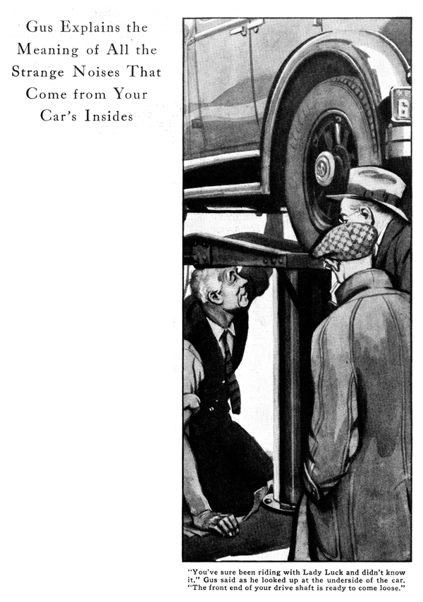
Gus Wilson put down his paper and glanced out of the living room window just as his next door neighbors, the Benton's returned from their weekly travels with Sunday afternoon traffic.
"Dan seems to be taking it slower than usual," thought Gus as the car passed at a snail's pace and came to a stop outside the Benton's house "The missus must be back seat driving. Fifteen miles an hour isn't that lad's speed."
When his wife, four children and pet dog were safely inside the house, Dan Benson climbed the steps to Gus's porch and held a finger impatiently and insistently on the doorbell button.
"Sorry to bother you, Gus, especially on your day off," Benson apologized when Gus opened the door, "but something's wrong with that car of mine and I'm scared to drive it as far as my garage. On the way home, it acted like the engine was falling apart. All of a sudden the steering wheel began to wobble and the further I drove the worse it got. Every time I'd start up in traffic, the whole car would shake and the motor sounded like the "anvil chorus'."
"So that's why you drove by as though you were going to a funeral," Gus chuckled as he took down his hat and coat.
When they reached Benson's car, Gus slid into the driver's seat and motioned to Dan to sit beside him. "Let's take a ride around the block," he suggested as he pressed the starter.
"Doesn't sound so bad when it's idling," muttered Gus as he leaned forward to get his ear nearer the motor. "It seems to run fine at high speed too."
Gus shifted into low gear and cautiously released the clutch pedal. The whole car began to vibrate as the motor groaned and the car jerked unsteadily ahead. Gus again tilted his head and listened.
"I don't think it's your motor," he bellowed over the clatter. "It must be your clutch or drive shaft. Let's go down to the garage so I can run it up on the greasing rack and give it the once over from underneath. Joe Clark, my partner, is down there trying to catch up on the unpaid bills. He'll be glad to see us."
Wasting little time, Gus soon had the car raised on the rack and was busily rolling up the sleeves of his Sunday shirt.
"Holy smokes," he grunted as he glanced up at the underside of the car. "You've sure been riding with Lady Luck and didn't know it."
Joe Clark and Benson looked in the direction he indicated. "The front end of your driveshaft's just about ready to come loose. That connection between the transmission and the front universal should have six bolts holding it together. Four have dropped out and the two that are left are on the same side of the flanges and about ready to drop out too. If that drive shaft had dropped when you were going fast, the front end would have dug into the road sure as shooting and lifted the rear of your car into a front somersault." "But, Gus, "Benson asked bluntly when the gray-haired mechanic had replaced the missing belts, "what made all the noise? I could have sworn it was in the motor."
"Being loose, the connection buckled every time you gave it the gas. You see," Gus explained, using his hands to demonstrate, "the universal was connected to the transmission shaft only at one point where the loose bolts were. Naturally there was a lot of play and every time your motor putted, the two connecting flanges twisted and hit against the two loose bolts. Being connected off center, the shaft vibrated and the whole car rattled as though falling apart."
"It certainly sounded as if a main bearing was falling to pieces," Benson insisted. "That's the trouble with most car owners," Gus said jokingly as he wiped his large, greasy hands on a convenient piece of waste. "Every time you hear a rattle or a noise you think it's the bearings. Nine times out of ten, it isn't."
"Motor knocks generally occur in cycles. The majority of knocks people hear are nothing but valve noises. You've got a valve tap in that motor of yours, but I wouldn't advise tightening the tappets, because tight tappets wear faster. "Most times, a motor knock comes from nothing more than carbon, advanced spark or a poorly adjusted carburetor. It's best to look for the common troubles before you blame the bearings or pistons. I've had people come in here with great tales about bearing knocks and lots of those have turned out to be motors caused by loose motor fittings or bolts."
"But how can you tell one knock from the other?" asked Benson, intent on learning all he could. "The best way is to take the car out on the road and drive it along about fifteen miles and hour; ordinary motor noises don't speak up so loudly at that speed. I generally include a few hills in the ride too.
"If I hear a light knock that gets louder when the car climbs, loose piston rings, or a loose piston. If the knock has a muffled sound I mark it up against a worn connecting rod. A pounding engine sometimes means a worn crank-shaft bearing. In your case, is meant that something was loose inside the motor."
"But that's all guesswork," Benson objected, "Isn't there some way you can tell for sure just what the trouble is?"
"An auto mechanic," smiled Gus, "is like a detective. He doesn't make any accusations until he's pretty sure. A little brain work in the beginning will save a lot of expensive ton of work later on. You've got to go about things systematically and find the trouble by eliminating one possibility after the other.
"After a good mechanic gets some hunch by using his ears, he can generally run down the actual trouble by making common sense tests. For instance," Gus led the way to a car parked by the repair bench at the back of the garage, "I took this car out for a test run yesterday and from the noise it made I decided a connecting rod was loose. "Now I'm going to test the bearings by running the motor at idling speed and short-circuiting the spark plugs one at a time."
He picked up a rubber-handled screwdriver and shorted the cylinders in turn.
"Nothing's happened so far," he said, placing the shock of the tool on the third plug, "but listen to this one."
When the engine was running with all cylinders, a definite metallic knock could be heard, but when Gus cut out one cylinder by shorting the spark plug, the noise got fainter and changed to a double knock instead of a single rap.
"That's the cylinder," announced Gus. "Now I won't have to bother about the rest. You can always locate bearing or piston trouble by cutting out the explosion on the cylinders one at a time. A difference is the sound of the knock will generally tell you that the short-circuited cylinder is the one causing the trouble. Of course, two or more cylinders may be at fault, but you can generally sort them out by repeating the test several times."
"What do mechanics mean when they speak of 'piston slap'?" Benson asked when Gus had closed the hood on the car. "That's a knock caused by a worn piston hitting against the side of the cylinder at the beginning of each power strike," Gus explained. "You can generally spot the right cylinder by short-circuiting. If the knock stops when a particular cylinder is cut out, that cylinder contains the worn piston. "Piston slap is a funny thing, though. A cold motor will often have a piston slap that'll disappear when the motor heats up and the parts expand. If it's a real case of piston slap, all you can do is pull down the motor and fit oversize pistons and see that the connecting rods are properly aligned."
When Benson had dropped Gus off in front of his house, the old mechanic looked over his shoulder and smiled. "I wouldn't worry too much about all the squeaks and rattles you hear when you're driving a car," he said. "A motor's bound to make some noise when it gets old. But it's only the queer thumps and knocks that mean real trouble."
END

