August 1933

WHY YOUR CAR'S MOTOR GETS HOT
by Martin Bunn
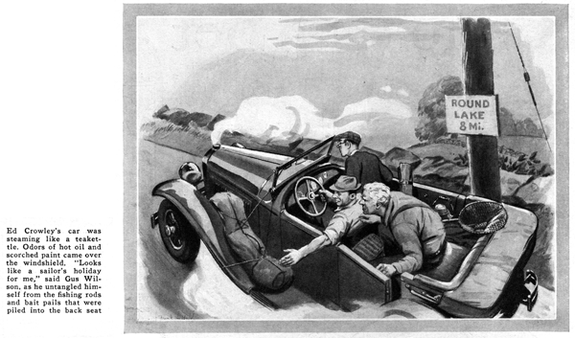
Snake Hill was proving too much for Ed Crowley's car. It was steaming like a teakettle and mingled odors of hot oil and scorched paint came over the windshield.
"A swell fishing trip we're gonna have," groaned Joe Clark as Crowley drew over to the side of the road and set the hand brake. "Might've known this crate of yours would never get us to Round Lake."
Gus Wilson sitting in the rear seat untangled himself from fishing rods, bait pails, and landing nets. Ed Crowley had convinced the two owners of the Model Garage that a day's vacation spent fishing would do them a world of good.
"Looks like a sailor's holiday for me," the grizzled garageman grumbled as he climbed to the ground.
"What did you do, Ed - forget to water the radiator this morning?" asked Joe.
"Not on your life," Ed protested as he loosened the radiator cap and squinted down the filter hole, "filled her up just before we left. First time anything like this has happened in all my experience."
Gus walked to the front of the car and ran the palm of his hand over the radiator from top to bottom. "Hmm, waters not circulating at all," he muttered. "Pump must be on the blink or else the system is completely clogged."
Lifting the hood, he examined the motor carefully. "Here's a funny one," he exclaimed. Ed and Joe, drawing near, peered down at the motor over Gus's broad shoulders. He was pointing at the lower hose connection. The sides of the rubber tube were drawn in like the checks of a boy sucking a straw.
Gus poked the short tube with his thumb. "That hose is so old it's collapsed. Let's drain off the rest of the water and have a look."
Joe pulled a bait pail from the pile of fishing tackle and placed it under the radiator. Soon a muddy mixture of rust and water dribbled from the opened drain cock. Pliers in hand, Gus worked at the metal clamps that held the lower hose connection is place.
"There, what did I tell you," he boomed triumphantly as he pulled the short rubber tube loose and held it up for inspection. "The inside's so rotten it's falling apart." A layer of the fabric is wedged right across the opening like a flap valve. I guess the suction of the pump pulled it closed every time you stepped on the gas. If we cut this loose piece out I think your cooling troubles will be over - for a while, anyway."
"By the way, how's the fan belt," he asked, after he had completed the job and Joe had filled the radiator with water from a near-by farm pump.
Ed Crowley tested the tension with his fingers. "Seems O. K.," he announced.
"Fine, Now, Ed suppose you start her up and let's see how she runs," suggested Gus.
One touch of the starter button spun the motor into action. Gus removed the radiator cap again and peered down the filter hole.
"She's circulating all right now," he reported. "Give her more gas, Ed...O. K. that's enough, now step on her again and slow down gradually."
"Say, what is this, a game?" Crowley protested as he opened and closed the throttle. "Why all the tests? If it works, it works."
"Just wanted to make sure the fan belt wasn't slipping," Gus replied as he fastened the side catches on the hood. It turned the fan at low speed all right, but I wanted to make sure it didn't slip at road speed."
"How could it do one without the other?" Crowley asked, obviously puzzled.
"Ever hear of centrifugal force?"
"Sure. That's the force that makes the balls on a steam governor fly out when the engine speeds up," replied Crowley.
"But what's that got to do with it?"
"Plenty," explained Gus. "A belt that doesn't slip at low speed may be lifted clear off the fan pulley by centrifugal force at high speed. A belt can be pretty loose and still drive the fan when the motor's idling."
"It certainly beats all, how you can root out trouble on a car," Crowley said admiringly to Gus when the trip to Round Lake was resumed. "How'd you know the cooling system was clogged up. All you did was pat the radiator here and there."
Gus checked. "You're right that's all I did but it told the story. And that's the simplest way to find out what's the matter when a car overheats. Your radiator was cooler at the bottom than at the top. That showed me the water wasn't circulating. If it had been hot all over, I'd have known the water was circulating but not as fast as it should.
"It never fails. If the radiator's hot all over, look for a loose fan belt, a clogged radiator, too rich a mixture, or punk ignition. If it's cool at the bottom, something's completely shutting off the water."
"Yeah, and fan belts cause most of the trouble," Joe added. "Nine-tenths of the cars that are brought to the Model Garage need new fan belts, don't they, Gus?"
The mechanic agreed with a nod. "And the tough part of it is, loose fan belts causes a lot of other troubles especially when the fan belt runs the generator as well as the fan. If it slips, the generator slows down. That means the generator doesn't charge the battery as fast as it should."
"Gosh!" exclaimed Crowley shifting into second gear for the long pull up Round Mountain. "I never thought of that. At that rate you ought to check the fan belt every time you use the car."
"That wouldn't be a bad idea," Gus agreed. "But it's simpler than that. The fact that the fan belt drives the generator makes it easy. All you've got to do is check the ammeter reading now and then when all the lights are off. If it reads lower than usual, the first thing to look for is a loose belt. Then about once every month let a service man look at the belt just to make sure it's O. K.
"And another thing," Gus went on. "Loose fan belts and clogged radiators aren't the only things that'll make an engine overheat. A weak ignition coil can cause a lot of trouble too. If the coil is breaking down, the engine misses fire and overheats.
"Lots of times a high compression motor will overheat because the engine gasket has blown internally. The cooling water leaks into the motor and the exhaust fumes escape through the radiator."
"Motors must be like people. As soon as they get sick they run a temperature," Crowley grinned.
"Right, and that's why it pays to go over your car now and then and get it in shape," said Gus. "After a hard winter, a car a needs some attention. flush the radiator, clean the honeycombs by squirting a hose at them from the inside, change to summer oil, go over the ignition system, check the carburetor, and clean up the motor generally.”
"In other words," he concluded, "give your car's spring cleaning if you want your summer trips to be free of trouble."
END

