September 1932

HOW TO KEEP
YOUR CAR LOOKING NEW
by Martin Bunn
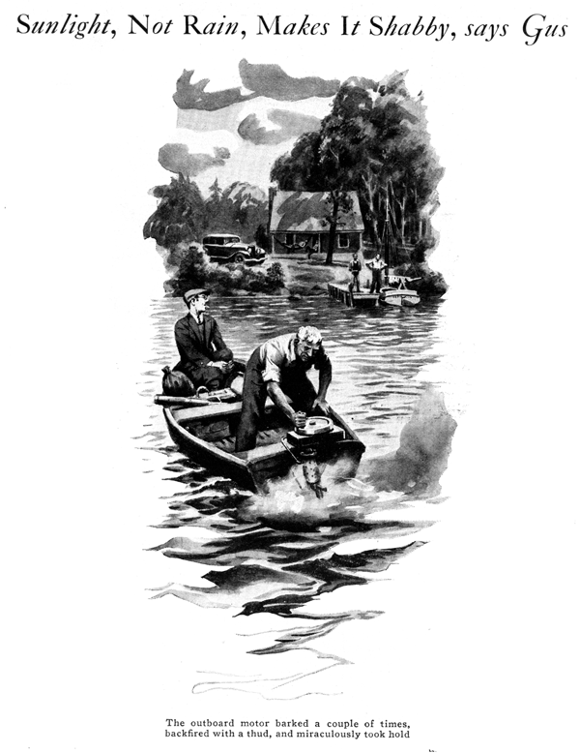
"What in blazes is it now?" grumbled Joe Clark from his perch in the bow of the boat the two garage men had hired to get down the lake for a few days' fishing at Whitey's camp.
"Ask me what isn't the matter with it," his partner Gus Wilson panted as he grabbed the handle and gave the flywheel another vicious twirl. The outboard motor barked a couple of times, backfired with a thud, and then miraculously took hold.
Whitey, who had been standing on his deck watching their progress, called a greeting as Gus shut off the ignition and they drifted in.
"I'll have to hand it to you, Gus," their host smiled as he grabbed the pointer and made it fast. "Nobody else can make one of Brandt's hired boats go that far without using the oars."
"Good reason why," Gus grunted. "He leaves them outdoors all the time with no protection whatever. That's no way to treat machinery. Watch out you don't get in Brandt's class Whitey."
"No fear," Whitey chuckled. "Take a look at my new car and you'll see how I keep machinery."
"Nice bus now," Gus commented as he gazed at the shiny car standing beside the cabin. "Take care that it doesn't look and run like this outboard motor after a while."
"Where do you get that stuff?" Whitey exclaimed indignantly.
"Here I've been busting my back dragging water up from the lake to give it a wash and polish every two or three days. How is it going bad if it's kept that way?"
"That's just what I thought," replied Gus. "Too much washing and none of the care it ought to have. Trouble is, Whitey, you don't understand the difference between keeping a car in the garage and keeping it out in the open. What makes a car grow old, anyhow?"
"Why, I never stopped to think much about it," said Whitey after a pause. "Wear does most of it, I suppose, and dirt getting ground into the finish does the rest."
"You're only partly right," Gus maintained. "Of course the number of miles you drive determines the wear on the engine and running gear, assuming that you take care of changing the oil and so on. But the kind of wear that makes a car look old and shabby depends as much on how the car is kept when it's not in use as it does on the number of miles it travels.
"Suppose, Whitey," Gus continued, "you took two brand-new cars and you put one of 'em inside a glass case sealed air-tight and covered to keep out all the light and you kept it always at the same temperature. Then you put the other one out in the open where the sun could blaze on it, the rainfall on it, and the temperature was constantly changing. How long do you figure those two cars would keep looking like new? At the end of a year the car that was left outdoors would look several years old. The other car would keep on looking new till you had long white whiskers.
"The difference between a new-looking car and a shabby one it's mighty little when you stop to figure it. The coating of lacquer on your car is a few thousandths of an inch thick measuring from the bare metal to the shiny outside surface. Yet the whole job looks like something the cat dragged in if a mere ten-thousandth of an inch of the outer layer gets grimy and discolored, same way with the running gear. Let a hole form in the enamel or lacquer so small it'd take a microscope to see it, and right away moisture gets in and you've got a coat of rust."
"Well," Whitey interrupted, "what am I to do about it - go around with a microscope looking for holes in the finish?"
"Not exactly," Gus replied, "but you can keep the pin holes from starting and you can fix things so nothing will happen if they do.
"Rain, wind dirt, and changing temperatures all put together don't do half the damage to your car's finish that strong light does. Direct sunlight is the worst because it always has quite a lot of ultra-violet rays in it and it's the ultra-violet that does the most damage. Even the light on cloudy days is harmful. You can get a bad sunburn on a cloudy day, you know, and that proves there's ultra-violet light eating away at the finish of your car.
"As a matter of fact, the more you wash your car the worse it is for the finish if you keep it outdoors all the time. At the end of a couple of years, the finish would be a lot better if you hadn't washed it at all. A thick layer of dust won't do the finish any good, but it will shield it from the light. Of course that doesn't apply if the car gets covered with wet mud. There's a lot of ammonia in some mud and that's bad medicine for auto finishes."
"Humph!" Whitey snorted. "Looks like the finish'll go to the dogs no matter what I do. I can't make the sun stop shining and I'll be danged if I'll ride around in a filthy car!"
"I was just showing you the troubles you're up against." Gus smiled. "Now I'll show you how to lick 'em.
"First off, why keep the car in the sunniest spot in the place? You could just as well put it an the north side of the shack under the trees where it will be in the shade at least a part of the time. Next, it certainly will pay to sew up a canvas cover you can throw over it when it's not in use. Dark colored canvas will be best. Olive drab is all right. You don't have to get heavyweight stuff; the lightweight, close-woven tent cloth will do, and it isn't necessary to have it waterproofed because it's light and not rain you're trying to keep off the car.
"Speaking of light," Gus added, "there's many a fellow who has wondered why the finish on one side of his car or on one particular mudguard has gone had before the rest of it. Nine times out of ten, the sun coming in a garage window fell on that particular part of the finish several hours every bright day. Home garage windows ought to be fitted with black shades and the shades ought to be kept drawn except when you need the light in order to work by."
"By George!" exclaimed Whitey. "That explains why the right front mudguard on every car I've owned always gets shabby looking before the rest of the car. There's a window in my garage at home right opposite that mudguard."
"Put a black shade over it," Gus advised. "Now to get back to this outdoor storage problem: Instead of washing your car every few days, give it one thorough wash and then polish it with wax type auto polish. The wax forms a protective coating over the lacquer and to some extent saves it from the sun. Also it makes the body easy to clean because dust doesn't stick to the wax and a gentle wipe with a rag every few days will keep it looking fine. Of course you can't expect the wax to last forever, so give it another treatment before it begins to wear away.
"If the car is going to be outdoors all the time it's a good idea to go over the bright work and the running gear with a slightly oily rag every so often. That's not so easy for the brake rods and the parts underneath that are hard to get at. For those places, give 'em a wipe once in a while with a rag smeared with a bit of gun grease. That will protect them for a long time although it will pick up plenty of dust."
"What do you do about road tar?" Whitey asked, "you can't get that off with body polish."
"Use kerosene on a rag with gentle rubbing," Gus advised, "and get at it as soon as possible, the same day you pick up the car if you can. If you let it set for a week or two it's much harder to remove. Don't scrape it off the underside of the mudguards, either. If you do, you are sure to scratch the enamel and in time rust will eat holes through the sheet steel."
"So that's it, eh," Whitey commented. "And would that keep a car in good shape at the seashore?"
"Listen, mister," Gus granted, "if you ever dope out any way to keep a car looking like new when you keep it outdoors within a few hundred feet of salt water, then believe me, old-timer, I'll take off my hat to you!"
END

