March 1932

YOUR NEXT CAR...NEW OR USED
by Martin Bunn
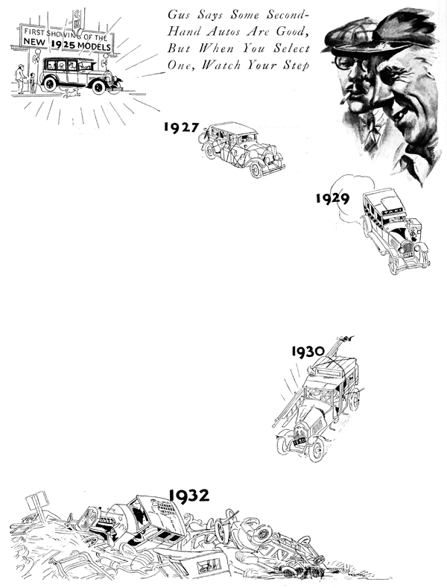
"Take a real good look at her, Gus. This is the last time you'll set eyes on the old machine," Sam Foskett said regretfully.
Gus Wilson half owner of the Model Garage and expert auto mechanic, smiled.
"I was kind of wondering how much longer you were going to keep it, "he observed, as his keen glance wandered over the traffic-scarred veteran of thousands of motoring miles. The paint job, once Foskett's pride, had faded to a dingy gray where it was not completely missing. The top was streaked and patched. The holes rusted through the fenders tinted at approaching dissolution.
"Yeah," Foskett grumbled. "I've got to get a new bus. The missus put her foot down. She swears she won't ride another mile in this one. It's a shame, too, the motor still runs pretty well."
"You mean it still runs?" Gus grinned. "You're so used to it you don't realize how bad it is."
"Maybe so," Foskett agreed. "But what I want to know is, should I buy a new car or a good secondhand one? I've taken demonstrations in most of the new ones and some of them are mighty sweet running jobs. On the other hand, with things the way they are, secondhand prices are down and I've seen some almost new cars that look like real bargains. What do you think, Gus?"
"Even King Solomon couldn't answer that one," laughed Gus, "Ask a couple of dozen experts that question and you'll get a couple of dozen different answers - each one of them right, but not necessarily for you. It all depends on how you look at it.
"Some engineering institute checked up on a lot of cars and found that the average life of a car is fifty thousand miles before it goes to the scrap pile. On that basis, this car," Gus continued, "is due to be scrapped because you've exceeded that mileage already.
"They also worked out fancy curves to prove what everybody know, which is that the secondhand value of a car is determined by how long it is since it left the factory, whereas the life of a car, speaking mechanically, depends not on years but on mileage."
"That's what style does, I suppose," Foskett interrupted. "The same thing makes clothing dealers put bargain prices on clothes rather than hold them over for another year, when they'd have to sell them cheap anyhow because by then they'd be out of style."
"Exactly," Gus replied. "And that's why advice is no good. It all depends on what you expect to get when you buy the car. Of course, if it's just a matter of buying so much transportation for so many dollars, then there's no doubt but what you get the most for your money on the average by buying a secondhand car about one year old."
"Why do you say 'on the average?" Foskett wanted to know. "If they've actually gone to the trouble of figuring on average, then it must be so."
"Listen," said Gus, "you're not buying an average, you're buying an automobile; and the two aren't the same. The average height of a man is five feet six or seven inches, but I'll bet you couldn't go down the street and find a single man on it that is exactly the average height. The point is, while an average car would be a good buy, that doesn't prove the one you buy is going to turn out right. You may get a much better bargain than you hoped for, or you may pick some lemon that's had the life driven out of it by an inexperienced owner."
"Humph!" Foskett snorted. "New cars sometimes turn out to be lemons too. Remember Lambert's car, the one he bought two years ago? Nothing but trouble from the time he got it till he got rid of it."
"That's right." Gus nodded. "There never was a factory turning out any product that didn't make a bad one now and then. But the percentage of Jonah cars is very small nowadays. Ninety-nine times out of a hundred you can bank on a new car being right if you treat it right."
"You said a minute ago," Foskett reminded him. "that the most economical buy is a one-year-old secondhand car. How do you figure that out?"
"That's easy, if you're figuring only on cost per mile without taking style, looks or anything else into consideration. The market value of a car - that is, the price at which you can buy it - is about forty percent less by the end of the first year. Yet that car will have at least seventy or eighty percent of its useful mileage still in it.
"Suppose you take a car that costs a thousand dollars and assume it's good for fifty thousand miles. If you drive that car for the full distance, your depreciation is going to cost you two cents a mile less whatever you can get for the car from the junkie. Now if you buy a one-year-old car that has been driven, say, ten thousand miles, and you pay six hundred for it, and you drive it till the speedometer shows fifty thousand miles, it's only going to cost you a cent and a half a mile for depreciation, and that figure is also run by what you get at the auto graveyard."
"But the saving won't make enough of a hit with the wife to offset the fact that she'll be driving in an older car." Foskett grumbled.
"I didn't say it will," Gus grinned. "All I'm giving you is the facts. It's up to you and your wife to decide how those facts fit your case."
"Maybe I could get around that trouble by going in for a higher priced secondhand car. It would have more useful miles in it and that would cut the cost.
"It used to be that way," Gus explained, "but not any more. Fifty or sixty thousand miles marks the end of the economical life of any car today no matter what its price. The only difference between a low priced car and a more expensive one now is that the more you pay the more car you get in size, looks, and riding qualities."
"Anyhow you've cleared up some points that were a bit hazy," Foskett admitted.
"Now, can you tell me just how much difference there is in the cost of operating a big car as compared with a little one?"
"It all depends on how many miles you drive a year," said Gus.
"Assuming you drive five thousand miles a year, your cost per mile will be about five to seven cents for a medium six or a light eight, and around eighteen cents for a big, heavy eight."
"All right. Now tell me how to be sure of getting a good secondhand car, if the decision goes that way," requested Foskett.
"The only sure way I know of," Gus suggested, "is to buy a car only when you know its complete history - how many miles it's been driven and who owned it.
"Of course," Gus went on, "most times you can't get all that done, but you can at least make sure that you're buying the car from an established sales agency for some well-known make of car."
END

