April 1932

WHY CLEANLINESS PAYS ON CHASSIS AND MOTOR
by Martin Bunn
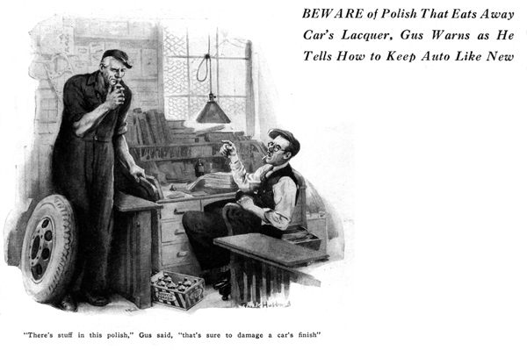
"Where'd you get this stuff?" Gus Wilson asked as he picked up a gaudily decorated can that was resting on the edge of his partner's desk in the office of the Model Garage.
"That's a marvelous new auto polish, Gus," Joe Clark replied as he pushed aside the pile of bills in front of him. "A couple of swipes with that'll put a shine on the dingiest old crock you ever saw. We ought to be able to sell a lot of it."
Gus shook the can, then unscrewed the cap and moved it in front of his nose as he cautiously sniffed.
"Marvelous polish eh!" he growled, "A couple of swipes give you a grand shine do they?" Well, I'll be another couple of swipes or we'll take the finish off altogether. That would be grand stuff to sell if the Model Garage was in the repainting business. How much of it did the salesman stick you for, Joe?"
"Only a dozen cans," Joe replied. "He said it wouldn't hurt any auto lacquer. Are you sure it's no good?"
"My nose tells me there's stuff in it that's sure to damage the finish if you use it much," said Gus. "If you don't believe it, polish a spot on the fender of the service car every day for a week and see what happens."
At the end of the week, Joe called Gus over and pointed to a spot a few inches square in an inconspicuous place on the service car's rear fender. Although the finish glowed with a fine shine at that point, there was a small streak in the middle where the gleam of bare metal showed through.
"You win, Gus," Joe admitted, as Gus examined the spot. "Guess we'd better throw the rest of the stuff in the ash can."
"That's the place for it," Gus smiled, "only I hope it doesn't eat holes through the ash can!"
"What I want to know is how does that fellow you call 'polishing Pete' get by with all the polishing he does without taking the finish off? He spends nine tenths of his time polishing his car and the other tenth riding around town to show people how swell it looks."
"In the first place," Gus said, "Pete knows a thing or two about polishing a car. He uses one of those hard wax finishes that takes a bit of elbow grease to apply, but which actually forms a protective coating over the lacquer. Then, instead of letting the car go till it's all covered with mud and grime, he goes over it with a duster when he gets home and then gives it a light rubbing with a clean soft rag. Road dirt and scum never have a chance to harden on the surface of his car and so he doesn't have to dig away a lot of the lacquer itself to get a polish."
"But that can't go on forever," said Joe. "No matter how careful he is there'll come a time when the finish gets shabby and nothing but a polish with a bit of bite in it will restore it. What does he do then?"
"What every one else does," Gus explained. "He uses a good cleaner or one of the good combination cleaners and polishers.
"That's one of the things that people don't seem to understand about lacquer finishes. They don't check or crack and they don't peel or take off as the old paint finishes did. But time takes its toll on lacquer just as it does on most everything else. After a while, depending mainly on how much ultra-violet light from the sun actually reaches the finish and also on changing temperatures, moisture, atmospheric gases, and so on, the extreme outside skin of the lacquer coating gets rotten and discolored. The only way you can bring back the finish then is to strip off this skin of broken-down lacquer so as to get down to good lacquer again.
"That's why even the really good lacquer cleaners and polishers seem to make the color of the finish run onto the rag. It isn't color you see, it's the particles of dead lacquer being rubbed off that color the rag. If you let the finish go long enough without any cleaning at all, you can rub your dry finger over it and it will show the color of the dead lacquer particles."
"Then no matter what you do, the finish is bound to go in time, isn't it?" Joe broke in.
"Of course it is," Gus replied, "But if you take care of the lacquer finish on any car made today, it'll look fine as long as the car lasts. Of course, that doesn't apply to a car that is garaged in the street or back yard without shelter.
"Another thing lots of car owners don't know yet if how important it is to dry a car right after washing. Most fellows, after they get through washing off the mud and grime with soap and water, just let the car stand till it's dry. If you could rinse the car with distilled water, that would be fine, but any ordinary water contains chemicals, and every drop leaves a spot when it dries.
"The proper trick is to wipe off all the water drops with a piece of chamois leather. What's more important is to see that the chamois is clean. Unless you frequently wash the chamois with soap and water, it'll pick up grit and scratch the finish."
"Seems to me," Joe grinned, "most fellows don't want to go to all that bother."
"Humph!" Gus grunted. "I'm a bachelor, and nobody cares whether I keep my car clean or not, but I should think you married birds would take the trouble to keep your cars clean just to keep your wives from frowning.
"After traveling through rain and mud, suppose you let the hose flow on your car gently to flush all the loose, wet mud, and then give a quick wipe with the chamois. Isn't that better than letting it dry and cake on so you have to give the car a regular wash?"
"It would be less work in the end, I suppose," Joe agreed, "once you get the habit."
Joe glanced toward the corner of the garage where the veteran auto mechanic's own car stood in its accustomed place.
"Yes," he nodded as he observed with renewed interest the spotless condition of Gus's two-year-old bus. "I think I'll treat my boat to a thorough cleaning and then try to follow your method."
Gus walked over to his car and lifted the hood. "Take a squint at that," he suggested as he swung a drop light around so that its light fell on the motor.
"Gosh!" Joe exclaimed as he gazed at the motor, which looked as though it had been dolled up for an exhibition chassis. "You could eat your dinner off any part of that motor. What's the use of keeping the motor so clean when nobody sees it anyhow?"
"I wouldn't argue that point with you." Gus smiled. "But there are mechanical reasons why it's a good idea to keep the motor clean. In the first place a clean motor is easy to work on. Even so simple a thing as changing a spark plug is a filthy, disagreeable job if the motor is covered with road dust and oil. Also, it's a lot easier to see what you're doing on a clean motor. On top of that, a clean motor runs better because when you clean the motor, you just naturally clean the distributor head and the spark plug cable. Then, if you get caught in a driving rain, all their juice won't flow out through the damp muck that coats them."
"What's the easiest way to clean a motor?"
"If you haven't air pressure as we have here, the best way is to fill a gasoline torch with kerosene and just chase the dirt off the motor with a fine stream of the liquid."
"Funny I never heard you suggest cleaning a motor to any customer," said Joe.
Gus laughed, "Sure I do," he protested.
"If I think a fellow has gumption enough to appreciate the value of taking good care of a fine place of machinery like an auto motor, I get him started right. Of course when I run into the kind of bird who only has the front of his house painted because the back doesn't show, it'd be a waste of time!"
END

