September 1931

PILLS WON'T GIVE

YOUR GAS MORE POWER
by Martin Bunn
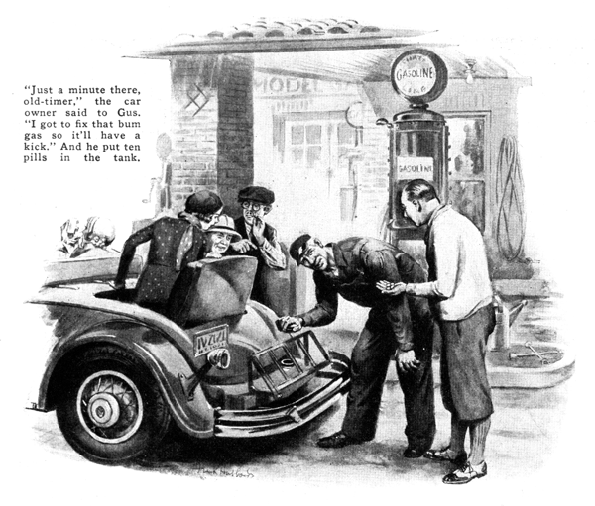
"Gimme ten gallons of plain gas!" the owner of a smart roadster called out as he pulled up in front of the Model Garage.
Gus Wilson, half owner of the garage and mechanical mainstay of the establishment, unlimbered the hose and turned the crank for the required ten gallons.
As he was about to replace the cap on the tank, the owner pushed him aside. "Just a minute, there, old-timer," he commanded. "I've got to fix that bum gas so it'll have a real kick to it."
He fished a bottle out of the car's door pocket and counted out ten small pills which he dropped into the gasoline tank.
"There," he said, replacing the cork. "This dope makes cheap gas work better then the high-priced stuff you sell out of the other pump."
"Smart lad that, eh, Gus?" Joe Clark grinned to his partner after the customer had gone. "What are those pills he put in the tank?"
"Oh, they're probably harmless," returned Gus noncommittally.
"But he said they made the motor run better," Joe persisted.
"A sap like that's likely to say almost anything," Gus growled.
"That stuff he put in his tank is only one of about a hundred different dopes for gasoline. And not one of 'em adds one fly-power to an auto engine."
"But how about that doped gasoline we sell from the high-priced pump?" Joe asked.
"That's a different matter," Gus replied.
"That gas is doped with tetra-ethyl lead, which you can't buy separately. Leaded gas is all right. It increases the power by stopping the knocking, but those pills, powders, and such don't do anything."
"Why didn't you tell that bird his pills were no good?" Joe asked.
Gus smiled. "Why should I? In the first place he didn't ask me. In the second place he probably gets a lot of fun out of thinking how smart he is. Besides the directions with most of those dopes tell you to cut down the gas at the carburetor, which is good advice. Any driver that wants economy usually can get it by cutting down on the gas. The motor will start harder and take longer to warm up and maybe not have quite as much power on the hills or on the getaway, but the owner will save money and he won't have so much trouble with carbon. Most carburetors are set for too rich a mixture anyway."
"I saw one of those dopes advertised with a guarantee of fifty percent more power." Joe commented. "How much increase do you suppose you'd actually get with that stuff?"
"If you want to read fairy stories go down to the library!" Gus exclaimed.
"Those pills would give you just exactly no increase in power and you'll find that the U.S. Bureau of Standards after testing dozens of 'em, says the same thing.
"Just suppose," he went on, "you really could drop a few pills in the gas tank and increase the power of the motor fifty percent. What would happen? If you opened the throttle wide, you'd rip the rear end to pieces or maybe smash the crankshaft.
"Speaking of what happens when you boost the power with dope," Gus added with a reminiscent smile. "Years ago there was a bird - I'm not mentioning any names, because he's a prominent aviator now - who figured out a way to dope the gasoline he put in the tank of his motorcycle. He entered an economy contest and actually covered almost two hundred miles with just one gallon of his concoction. Of course he won the event.
"Later on he entered a couple of hill-climbing contests and then the fun started. In a tryout he flew up the hill like a shot out of a gun, but when he started up for the real test, one of the cylinder heads blew off and he almost passed on to the happy hunting grounds."
"What on earth did he use?" Joe exclaimed. "I thought you said there wasn't any kind of a dope that would do that."
"There isn't," Gus explained. "No one would dare sell such a dangerous explosive for auto use. He dissolved picric acid - they use it in making explosives and it's about as safe to experiment with as dynamite - in ether, and dumped the solution into his gasoline. Besides being dangerous, the stuff is so corrosive it chews the stuffings out of the motor."
"But those gasoline dopes are supposed to remove carbon," said Joe. "Is that bunk, too?"
"Anybody who know what the carbon deposit in a cylinder really is, knows there isn't any chemical that would actually dissolve the carbon itself, and the gummy, tar-like, broken-down oil that holds it stuck to the cylinder head and piston can be dissolved only by a powerful solvent.
"As a matter of fact," Gus went on, "a long hard run in hot weather with the carburetor set for a real thin mixture will burn away a lot of the carbon deposit in any modern motor. That's how some gasoline dopes got their reputation for removing carbon. A thin mixture and a hard run did it and the pills got the credit.
"It all boils down to just this, Joe," Gus concluded, "the power you get out of gasoline comes from the heat that develops when the hydrogen and carbon of the gas burns in the oxygen of the air that goes in through the carburetor. Putting pills in the gas tank isn't going to increase the oxygen in the air going through the carburetor and it isn't going to increase the amount of hydrogen or carbon in the gasoline - gasoline is all carbon and hydrogen anyhow."
"But aren't some of the dopes good as antiknocks?" Joe asked.
"Not one is nearly as good as tetra-ethyl lead," replied Gus. "Gasoline dopes sell to the suckers, the fellows who buy phony stock and fake medicine - the fellows who would rather believe a lie than go to the trouble of finding out the truth!"
END

