October 1931

CONCEIT MAKES GOOD DRIVERS BAD
by Martin Bunn
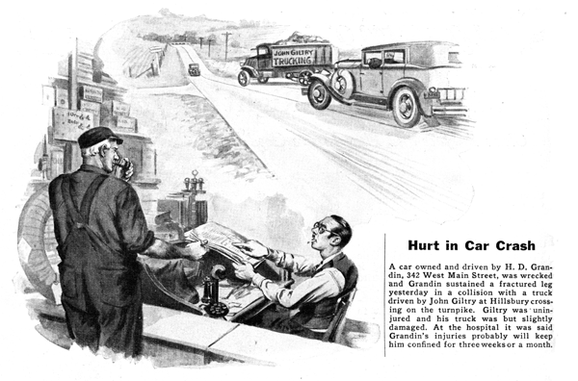
"Sorry, Mr. Grandin," Gus Wilson apologized to the owner of an expensive sedan that had stopped at the Model Garage, "I'd be glad to go out with you and see if I can locate that funny noise but, you see, I'm expecting a phone call any minute now. Bring the car around tomorrow or the next day when you have time to leave it so I can give it a good going over."
Grandin started his car and drove off with the effortless ease of the expert driver. Joe Clark eyed his partner speculatively. It wasn't like him to pass up jobs. But Gus went back to the car on which he was working without offering any explanation. He finished it a few minutes before the owner walked in.
"All ready, Mr. Meekins," he said. "Drive me around a bit so I can see if everything is in good shape."
Meekins smiled diffidently. "I'm not so very good as a driver, Gus, but if you don't mind hearing the gears grind once in a while, I'd be delighted to try it out that way."
By the time they returned Joe's curiosity was working.
"Tell me, Gus," he asked. "Why you hand Grandin a phoney excuse to get out of driving with him and then invite yourself for a ride with a dub like Meekins? Anybody with half an eye can see Grandin is a far better driver."
Gus grunted. "Did you ever try to drive a horse over a bridge that looked all right but wasn't really safe, and then have the horse kind of snort and refuse to put a foot on the bridge? That's how Grandin affects me, except of course the horse only has his instinct to go by while I've got reasons for acting as I did,"
"What are they?" Joe argued. "Grandin can drive rings around Meekins any day in the week. You don't mean to tell me an expert driver is not as safe to ride with as a dub, do you?"
"Sometimes he is and sometimes he isn't," Gus said noncommittally. "Have you talked with Grandin enough to know him?"
"Sure I have," Joe asserted, He's about the most conceited bird I've every met. The world revolves around Grandin - according to him. But what's that got to do with driving a car? There's nobody around here handles a car say better than he does."
"I'll admit that," agreed Gus, "But the point is, a conceited egotistical man, or woman, is mighty likely to be a dangerous driver no matter how expert he is at handling the gear shift and steering wheel. Why? Because the conceited bird always has it at the back of his skull that he's better and more important than the fellows he meets on the road. Whenever it's a question of who is to give way, the swelled-headed guy instinctively expects the other fellow to back water. When he blows his horn he just naturally expects other people to get out of his way.
"A bird like that is a bad risk for the accident insurance companies because sooner or later he is going to get into a mix-up with some one who either don't know how to handle a car or else has a swelled head too - then there's a smash."
"And if he comes out of it alive," Joe interrupted, "at least the swelled head shrinks a couple of sizes."
"Not if his bump of conceit is a big one, like Grandin's," said Gus. "He just naturally figures that the other fellow is entirely to blame and he goes barging along, letting the rest of the world watch out for itself."
"Maybe so," said Joe, "but if you took all the conceited drivers off the road there'd hardly be any motorists left!"
"G'wan!" Gus grinned. "You can't laugh it off that way. It's too serious. I'm not talking about just ordinary conceit. Every fellow ought to take a little pride in his own accomplishments. It's good for him. It makes him self-confident. I mean the bird that's so swelled up with conceit that he's lost all sense of values. He forgets that the other fellow has as many rights as he has.
"That," Gus continued, "is the real meat of this safe driving business - remembering all the time that the other fellow has as many rights as you have. It isn't a question of brains. A dim - wit who can't read or understand anything beyond a tabloid newspaper may be a better and safer driver than a mechanical genius with a whole head full of gray matter. The dim--wit may not know much but if he has the right idea about what he does know, I'll drive with him any day.
"Of course conceit is only one of the three main causes of accidents. Carelessness comes first, swelled-headedness next, and third place goes to those unfortunate people with nerves and muscles that never learned how to work together - people who turn the wheel the wrong way or step on the accelerator instead of the brake when they get into a jam. The fancy name for that is lack of muscular coordination, but it really is an extra severe case of plain clumsiness just as self-headedness is too much development of the ordinary pride everyone should have."
"Seems to me Meekins is in that class," Joe again interrupted. "He's clumsy."
"He's clumsy only because he hasn't driven very long," Gus replied. "There's nothing the matter with his muscles and nerves, they just need training. The fellows I mean are so clumsy they won't ever learn no matter how long they try. In factories where they have a lot of machinery, they call the hopelessly clumsy or conceited workmen repeaters because they keep on having one accident after another as long as they are on the job.
"Meekins already has got to the point where his foot slams on the brake without his having to think about it - I watched him the other day when he was driving out and a car came around the corner unexpectedly. And he seems to go out of his way to give the other fellow a break. Some day he may have a smash, but if he does it'll either be the other fellow's fault or else it'll be one of those unavoidable freaks that do happen once in a while where nobody's to blame."
"Well," said Joe as he pulled out his ledger and prepared to make out the monthly bills, "it all sounds fine the way you say it, but I think you're getting a bit too theoretical like some of those psychology sharps with their subconscious reactions and all the rest of that piffle."
Joes voice trailed off into a grunt of displeasure as he became absorbed in an account that was several months overdue.
Some weeks later, Joe arrived at the Model Garage at opening time with a sheepish expression on his face. He thrust a copy of the local paper under Gus's nose. "I guess you win," he muttered.
Gus took the paper and began to read the following item:

Hurt in Car Crash
A car owned and driven by H. D. Grandin, 342 West Main Street, was wrecked and Grandin sustained a fractured leg in a collision with a truck driven by John Giltry, at the Hillsbury crossing on the turnpike yesterday afternoon. Giltry was uninjured and his truck was but slightly damaged. Grandin was rushed to the hospital where it was said his injuries were not serious but will keep him confined for three weeks or a month. Grandin blames Giltry for the accident, saying that, as he came to the crossing, he blew his horn in time for the truck to get out of the way. Giltry asked, "Why didn't Grandin stop?" Turnpike police have started an investigation
END

