March 1931

STARTING TRICKS FOR COLD WEATHER
by Martin Bunn
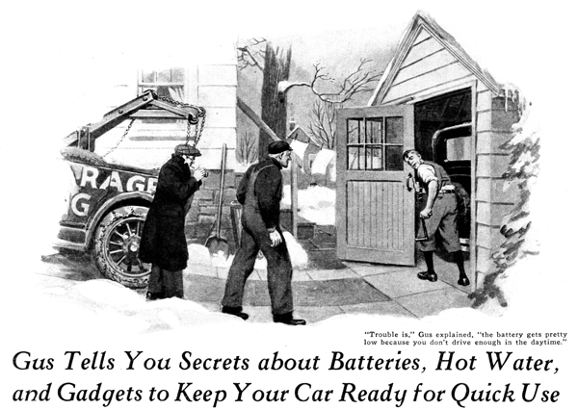
John Whipton, who lives out on the edge of town, was a steady patron of the Model Garage. He came regularly to have Gus Wilson, veteran auto mechanic and half owner of the establishment, inspect the car and check its condition.
Whipton was a funny customer. He wanted things to be just right. And in spite of the fact that he had an absorbing interest in mechanical matters, he was himself, possessed of no skill with tools.
Gus was not surprised when Joe Clark, his partner, came out of the office one winter morning to announce that Whipton was calling for help.
Whipton's appearance as he swung over his garage door after Gus had backed the service car down the driveway graphically suggested the trouble. He was coatless. Beads of perspiration stood on his forehead and a starting crank dangled from his hand.
"You're a fine auto mechanic. I don't think!" Whipton exclaimed. "Only two weeks ago I had the car at your place and you said it was in perfect condition. Now look at the darn thing - won't even start with the crank!"
"Where were you last night and the night before?" Gus asked.
"What's that got to do with it?" snapped Whipton. "Last night we drove over to the other side of town to visit friends and night before that was lodge night."
"Hum-m!" said Gus, "I'll bet you left the car standing with the headlights going, didn't you?"
"Sure I did," Whipton admitted. "But that shouldn't run the battery down."
"It wouldn't if you'd been doing any amount of driving in the daytime," Gus explained. "Trouble is, the battery gets partly low because you don't drive enough in the daytime. Then the extra load of standing two nights brings it down to the point where it hasn't any amp left."
"It had amp enough to turn over the motor for quite a while," Whipton protested."
"After it wouldn't turn any more I got out the crank. I spun it till I thought it would start playing phonograph music and still nothing happened. What ought I to have done?"
"Maybe if you'd cranked it by hand after the first couple of shots at the starter, it would have started. As it is," said Gus, "you ran the battery down so far with the starter you haven't enough juice to make a spark enough to start a cold motor." Simplest thing now is to try the old reliable hot water method! Bring out a pail of real hot water and we'll get going."
Whipton came out with a pail of steaming hot water and after Gus had slowly poured it over the intake manifold, the motor started almost with the first effort.
"I should have had sense enough to think of that," Whipton grumbled disgustedly, "I'll chalk it on the wall so I won't forget it next time."
"What would you do if you couldn't get any hot water?" Gus inquired with a smile. Whipton thought a moment, "I'll bite," he finally said. "What would I do?"
"Well," said Gus, "there's a lot of ways t get a cold motor started. Hot water is the simplest. But if you haven't any and there's a drug store handy, buy yourself a small can of ether. Pour a little in the air intake of the carburetor and crank by hand. The motor will start on the second or third quarter turn. You don't have to spin it. Of course if the motor is too stiff to turn by hand, pull out the choke and let the starter grind it over two or three times so the raw gas will cut the frozen oil on the cylinder wall. Wait a minute or two till the gas has had time to set, then give it the ether. If there's anybody with you have the party hold out the clutch pedal while you crank. That cuts out the resistance of the stiff lubricant in the gear case, which holds back the engine like so much molasses."
"Suppose you can't get any ether, then what?" Whipton asked.
"You'd still have a couple of tricks left up your sleeve," said Gus. "One of 'em would be to short-circuit the resistance unit on the ignition coil while you get started. More current would flow and make a better spark, hot enough to ignite high-grade gas at zero. And by the way, if your motor is hard to start in winter, don't fool around with cheap gas. It always makes a motor harder to start than the 'premium' stuff.
"Closing up the spark plug gaps," Gus continued, "is another way to make winter starting easier. Cut the gap down to about half the regulation opening. Lots of cars are hard to start in winter for no other reason than that their owners forget the points burn away after thousands of miles of running. That makes the gap wider than it ought to be even for best summer going.
That isn't the trouble with this motor, though, because I looked at the points the last time you had it in."
"Those tricks sound all right for an emergency," said Whipton, "but isn't there anything you can do to a car that will just naturally make it easier to start without having to try tricks?"
"Sure," Gus replied. "There's a primer you can fit on the deck. Working the standard gas in the manifold. If you add a little tank to hold extra high-test gas such as they use in airplanes, or even ether if the weather is exceptionally cold, that gadget will start you instantly.
"Thus there's another type of primer that works electrically. It takes a minute or two to heat up the manifold. It's fine if you give your battery an extra charge now and then with a radio battery charger or if you do plenty of daylight driving.
"Of course," Gus continued, "a lot depends on how you use your car. If you keep it in a heated garage and don't have it standing in the streets more than an hour at a time, hard starting won't bother you. But if you keep It in a cold garage, the first start in the morning is going to be tough, make sure you do something about it.
"Some people put an electric grill or a heater or even a big electric bulb under the hood right near the carburetor. Trouble is, if you have the current turned on all the time, it runs into a lot of money, and there's always a chance of a fire if the carburetor should leak. The red-hot wires would ignite the gas. Of course the electric light bulb is safe enough, but you have to use a big bulb, not less than a hundred watts.
"One fellow I know sticks a drop light with a hundred-and-fifty-watt bulb in it under the hood when he puts the car away for the night, and then he throws a blanket over the radiator. The next morning, about an hour before he wants to start out, he turns on the current. His garage light is wired to a switch in the house."
END

