June 1931

WHY YOUR CAR NEEDS INSURANCE
by Martin Bunn
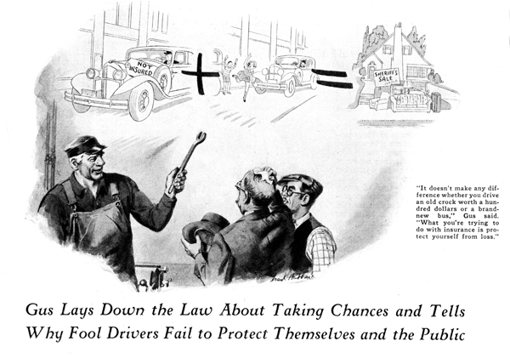
Gus Wilson fingered the crumpled fender while he gazed appraisingly at the other damaged parts on the front end of the car. "Lemme see," he mumbled, counting on his large fingers. "First there's the mud-guard. That's a total loss - beyond fixing. Then there's the end of that bumper. Maybe I can save that, but the lamp is a wreck. The radiator's sprung a leak. I guess it will cost you about thirty-five dollars, Mr. Cardon."
The motorist, who had driven his damaged car into the Model Garage a few minutes before whistled.
"Here's where the old bank roll gets another sock, "he grumbled. "But I guess you're not sticking me at that, I can see there's a lot of work to be done. For once I'm sorry I didn't have collision insurance so I could let the company hold the sack."
"You'd never have collected a nickel on this accident," Gus asserted as he got out his tool kit and set to work. "Why wouldn't I?" asked Cardon. "That's what insurance is for, isn't it?" "You forgot about that fifty-dollar clause all the insurance companies put in their collision policies," Gus explained. "You always have to pay the first fifty dollars yourself. The company only pays costs over that."
"Well, I'll be jiggered!" Cardon exclaimed, "They insure you and then make you pay! I always suspected this auto insurance business was a racket. I've saved a lot of money by not carrying any." "Do you figure that way about fire insurance on your house, Mr. Cardon?" asked Gus mildly.
"Oh that's different," Cardon replied. "You never can tell when your house is going to burn down, and if it did, and you didn't have insurance, you'd be wiped out, at least I would. Auto insurance isn't the same thing at all."
"That's just the trouble," Gus growled, "You think about auto insurance as if it didn't apply to anything but your car, and that's where you're dead wrong. Suppose tomorrow you drive down the street and some kid steps out in front of you and you smash him. Suppose you make him a cripple for life. "Then comes an expensive court trial and the jury slaps a fifty-thousand dollar judgment on you. They'd take away your house and your car and everything else you own that the sheriff could lay hands on, right down to the clothes on your back. You could keep your clothes, and that's about all."
"Rats!" Cardon scuffed, "I've never run over anybody yet and I don't intend to start now." "Maybe so," said Gus. "I guess nobody ever smashes anybody intentionally, but the best drivers have accidents now and then." "Besides," Cardon argued, "what good would it do if I had a policy for say, five thousand dollars and I got nicked for fifty thousand? They'd grab everything I owned anyhow." "That would be like having a two thousand-dollar fire insurance policy on a twelve-thousand-dollar house. There's nothing to stop you from carrying a bigger liability policy," Gus suggested.
"That would be a good joke." Cardon scuffed. "Carrying a fifty-thousand-dollar policy on this old car that I couldn't sell for six hundred bucks!" "There you go figuring cars again," said Gus. "Auto liability isn't to protect your car. It's to protect everything else you own. It doesn't make any difference whether you drive some old crock worth less than a hundred dollars or a brand-new one in the two-thousand-dollar class. What you're trying to do with liability insurance is protect yourself, not your car. Even if you only own a house worth five thousand dollars or less or a little private business you need plenty of protection. No matter how little you've got, you'll lose it if you get into an accident and the judgment is bigger than your policy.
"I was talking to Sharples, the insurance agent the other day," Gus went on, "and he showed me that even a policy that covers you for one hundred thousand dollars for a single person injured in an accident or up to three hundred thousand for several people only costs about a third more than the five-thousand, ten-thousand protection. "If you want to take a chance on going without fire and theft protection on your car, that's not so bad. If the car is stolen or burns up, you can't lose more than the value of the car." "I'd like to see anyone swipe my car," Cardon bragged. "No theft insurance for me. Any crook that can solve the secret locks on this bus is welcome to take it."
Gus smiled. "There's something in that. Really locked cars aren't often swiped. By the way, how'd you get smashed this way?" "One of these big five-ton trucks cut me off," replied Cardone. "Didn't do him any damage at all." "That's lucky for you, else you'd have had to pay for fixing the truck, too," Gus commented. "Maybe next time you'll bust the rear end off one of those ten-thousand dollar limousines, then you'll be in for it."
"Well, what of it?" Cardon growled, "You just said these insurance birds let you pay most of the bill before they ante up a few blue chips." "Wrong again!" Gus grinned. "Property damage insurance isn't like collision insurance. There's no low limit on property damage. You're protected right down to a dime's worth of busted parts on the other fellow's car. Of course ordinarily you aren't likely to do more than a thousand dollars worth of damage if you hit a car, because the majority of cars on the road today aren't worth much more than that. But there's other ways you can bust things. "Fellow I know had something go wrong with his steering gear and the car swerved off the road, swerved across the sidewalk, crashed through a plate glass window, and knocked the stuffin's out of a fancy automatic printing press that was running in the window. Cost this bird seventeen hundred dollars to square it, besides the hundred bucks he spent for a lawyer."
"If he'd been careful like I am," Carbon said, "he wouldn't have had his steering gear fall apart that way. Well, I guess I'll run down the street and do some errands while you're finishing the job - er- did I hear you say that one hundred thousand liability only cost a little more than ten thousand?" "About a third, I think," Gus replied, winking slyly at Joe Clark, his partner. "Joe, he observed, after Cardon had gone, "I'll bet you a dollar against a busted spark plug, that know-it-all comes back in an hour with the biggest policy they'll write!"
END

