July 1931

GUS GIVES YOU FACTS

ABOUT CAR BEARINGS
by Martin Bunn
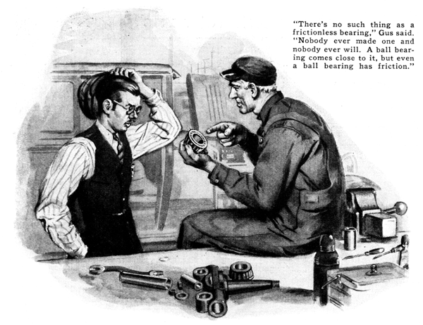
"Take a look at that, Joe," Gus Wilson said, pointing to the main bearing surfaces of a motor on which he was working. "That's about as nice a job of bearing scraping as I've done in many moons."
Joe Clark, his partner in the Model Garage, glanced at the journals of the crankshaft resting on blocks beside the engine and noted the Prussian blue that coated them. Then he saw how the blue that rubbed off from each journal covered nearly the entire surface of each bearing and its cap.
"Golly!" he exclaimed. "That's fitting 'em close. I'll bet you couldn't squeeze a hair from a fly's eyebrow anywhere into those bearings. They ought to run without any friction at all."
"There's no such thing as a frictionless bearing," Gus retorted. "Nobody ever made one and nobody ever will. A ball bearing, if its just right, comes pretty close to it, but even a ball bearing has friction. These bearings will have more friction for a while now than they did when they were loose."
"If that's so," Joe asked, "why waste so much time getting them perfect? Why didn't you just file off each bearing cap so it would fit closer in the crankshaft? That would have taken out the play and got rid of the thumping."
The veteran auto mechanic grinned as he polished off the blue with a piece of clean water. "I'm ashamed of you, Joe, for suggesting a bum job like that. Don't you know that a bearing that really fits lasts about six times as long as a sloppy job? Trouble is, you don't understand how a bearing really works.
"Take this crankshaft. It'll run tight for a while, then a tiny bit of wear will make it really perfect. After that the oil will form a film over the whole surface of each bearing, and being the same thickness, the pressure won't break it down in spots. It'll be almost like a ball bearing, then, only instead of steel balls, the shaft will roll on particles of oil."
Joe settled himself comfortably on the workbench and opened his lunch kit. "Seems to me," he observed, "that they ought to fix ball bearings all through an automobile motor. That would save all the trouble of fitting plain bearings. You say ball bearings have less friction."
"If they could make ball bearings out of rubber," Gus grumbled as he dragged out his own lunch kit, "that would be a swell idea - maybe. How are you going to slip the ball bearings around the corners of a crankshaft to get them in place? Of course you could make the races in two pieces but there'd be extra wear at the joints.
"No," he continued, "I don't look for ball bearings for quite a while yet. To begin with ball bearings are always noisy at high speed. They make a sort of steady roaring noise. Imagine what a modern eight would sound like when you go whizzing along with nine ball bearings on the crank shaft and eight more on the connecting rod big ends. You'd think a hurricane was blowing.
"Another thing: one of the biggest advantages of ball bearings is that you don't have to be putting oil on them all the time. That doesn't mean anything in the crankcase of an auto motor because as long as you've got pistons sliding up and down you've got to have a steady supply of oil. Besides, the main friction in an auto motor is caused by the pistons and you can't make them ball bearing!"
"How about roller bearings? Do they make a noise too?" Joe asked.
"At high speed they do," Gus replied. "Someday we'll get a ball bearing salesman and a roller bearing salesman together and let 'em argue it out. Far as I can see there isn't an awful lot of difference between ball and roller bearings any place in a car if they're made big enough to stand the job. Point is, each type of bearing - plain, roller, or ball - is good if it's used in the right place.
"Take the generator , for instance. A lot of 'em are made now with a plain bearing at the drive end and a ball bearing at the commutator end. That's because the drive end gets oil all the time from the timing chain case and the car makers know that most motorists won't bother to oil the other bearing; so they put in a half bearing that will run for along time with almost no oil. On cars that drive the generator with a belt, they usually put ball bearings at both ends because they know that neither will get the attention it should.
"Of course," he continued, "all wheel bearings now are either ball or roller bearing. Even the wheel bearings were plain. Whenever we drove by a swampy place at night, we never could tell whether the squeaking was frogs or a wheel bearing gone dry. Hardly a trip went by that we didn't have to get out, take a wheel off, and smear cap grease on the axle.
"Speaking of bearings and lubrication," Gus went on with a reminiscent chuckle, "that old bus had a lubricating system that was at least twenty-five years ahead of its time. On the dash was a big brass cylinder - an enormous grease gun - with copper pipes radiating all over the car. By turning the lever you could send grease to any one of a number of bearings and, believe me, you had to do that quite frequently if you didn't want to hear a squeak and smell a hot bearing! That old system was the grandpa of all the centralized lubricating systems they use today."
"Even if ball bearings don't seem practical for crank shafts," Joe suggested, "there ought to be some way to get around all that scraping."
"Get around it!" echoed Gus, "Why in another few years scraping bearings will be a lost art even in the finest auto repair shops. That motor is a few years old, as you know. Lots of cars are built today so that you couldn't scrape the bearings if you wanted to. The idea is to machine the halves of the bearing shaft as accurately that you can simply slip in new bearings."
"You have no idea how much time and development is going into that bearing problem. Do you know that some of the makers are going as far as to finish the bearing surfaces of connecting red big ends with a cutting tool made out of genuine diamond? The result is a surface that is true round, of exactly the right diameter down to less than the hair out of that fly's eyebrow you mentioned and with a surface so smooth as glass. When you stop to think that many of the cars now have lapped crank shaft journals, you can see we are getting bearings, even in popular priced cars, that are better than the most expensive cars had a few years ago."
"What is a lapped bearing?" Joe inquired. "I know what a lap joint is - one that's laid one edge over the other - but how do you lap a bearing?"
Gus reached for his warm bottle of coffee. "Lapping a bearing," he explained, "merely means polishing it with a fine abrasive to give even a smoother surface than grinding. It use to be an expensive process but now they have machines that will lap all the journals on a crank shaft at the same time, using a crocus cloth or something similar."
"I still don't se why it makes so much difference whether the bearing is absolutely smooth or not," said Joe.
"That's because you don't understand how oil works on a bearing," Gus stated. "Oil has two qualities that really count in lubrication. One is its ability to stick to steel and form a coating that the steel can ride on. The other is the amount of friction the oil particles develop when they slide over each other. They call that viscosity, or thickness.
"The two features are related because this all generally doesn't stick to the steel quite as well and being thin the pressure squashes it out of the bearing - if it's too high for that oil. You notice that most of the good brands of oil are marked with numbers now. Those numbers really tell how thick as oil is, both cold and hot.
"People are beginning to call for oil by number instead of asking for light, medium, or heavy. That's a good sign, because all oils marked S. A. E. 30, for example, are of the right thickness for a motor that uses that thickness of oil.
"When you get the right oil into a bearing," Gus went on, "it forms the proper coating and the bearing works right. If the oil is too heavy it may not get in or if it does, the body of the oil will cause more friction moving the particles over each other. On the other hand if the motor maker specifies S. A. E. 30 oil for summer and you use S. A. E. 20, the oil will get so thin when it gets hot that the pressure may force it out of the bearing. When that happens, the steel rubs on the bearing metal itself and that's the end of the bearing."
END

