January 1931

LATEST TRANSMISSION TRICKS -

What they do for you
by Martin Bunn
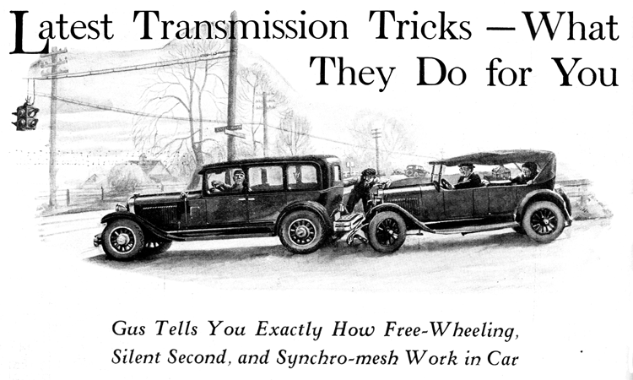
"Aarrk! Go slower! Go slower!" the big green parrot croaked.
Professor Donaldson, who knew a lot about literature but very little about cars, glanced angrily at the bird as it sat solemnly swaying in his cage in the back of his automobile.
"You've said that so often even the bird is imitating you, Matilda," he protested to his wife.
At that moment the car rounded a curve and Donaldson smiled in anticipation as they approached the top of a long down grade.
"Here is a chance to try out free-wheeling," he whispered to himself as he threw the gear lever into neutral, took, his foot off the clutch pedal and settled back to enjoy the smooth floating sensation. He did not notice that the motor accidentally stalled owing to an exceptionally close idling adjustment.
The car attained sufficient speed to coast a considerable distance along the level stretch at the foot of the hill and then as it slowed down, the professor attempted to shift into gear. There was a terrific clashing, but the gears would not mesh. He pressed the clutch pedal clear down to the floor boards and tried again with no better result.
By this time Professor Donaldson was so flustered that he did not notice that he was coasting into the rear of a car ahead that had stopped at a traffic light.
There was a clang, followed by a squawk from the parrot, a shriek from Matilda, and a grunt from the professor, who had been forcibly propelled against the steering wheel.
A grizzled head poked out of the window on the driver's side of the car the professor had bumped and a dapper little chap with large glasses popped out of the other side.
"Nothing busted, Gus," the latter reported after inspecting the damage. "Our car's all right. This boob's bumper's fell off, that's all."
"I'd better take a look," the other grumbled as he, too, got out and looked things over.
"You can't run with your bumper that way, mister," he observed to the professor who had not yet recovered his breath,
"Want us to fix it for you?"
Professor Donaldson looked at him wonderingly. "Most amazing!" he exclaimed. "I ran into you and you offer to fix my car for me!"
"Nothing generous about it," said Gus. "You're going to pay for the work if you want us to do it. My name's Wilson. This is my partner, Joe Clark. We run the Model Garage in the next town."
"Excellent!" said the professor, beaming. "Fasten it temporarily and I'll follow you to your shop."
"Well, mister," said Gus as the two cars drew up in front of the Model Garage a little later, "I'm kind of curious to know how you happened to slam into us that way in broad daylight."
The professor grinned sheepishly. "I was attempting to free-wheel down that hill and I was unable to operate the gear lever when we reached the bottom."
"Free-wheel?" repeated Gus in puzzlement. "Oh, I see. You were coasting in neutral, and the motor stalled. That's why you couldn't get into gear again. That's coasting, not free-wheeling."
"Isn't it?" exclaimed the professor. "I thought free-wheeling was merely disengaging the gears so the wheels could turn freely. I'm afraid I fail to grasp the meaning of many of the terms used to describe transmission features. What, for example does 'synchromesh' mean? Or 'silent second?' Could you explain what those terms actually mean in ordinary language?"
"I can try," Gus smiled as he squinted along the bumper to see if he had succeeded in removing the kink.
"Did you ever ride a bike, one with a coaster brake?" the veteran auto mechanic asked.
"I should say so!" replied Donaldson. "But what has that to do with free-wheeling?"
"A whole lot," Gus stated. "Free-wheeling is really going back to the old bicycle days. Your legs could make the wheel go round but when you got tired pedaling or you wanted to coast down a hill you just stopped your feet. As quick as a wink the mechanism in the rear wheel disconnected the back sprocket so the motion of the wheel couldn't make your feet go round.
"Free-wheeling really is as old as the hills," Gus continued. "A free-wheeling auto is just like any other auto with one extra gadget added. That gadget is a one-way clutch, not a whole lot different from the coaster brakes they've been fitting to bikes for thirty years or more. And a one-way clutch, which is what a coaster brake really is, has been used in various machine applications for a great many more years than that.
"The winding stem of your watch, for instance, is one of the oldest types. It uses a ratchet that slips over the teeth one way for the free motion and hooks into them to wind the spring when you turn it the other way. The film-winding key on a camera has the same kind of mechanism to prevent the key from turning the wrong way.
"The trouble with the ratchet arrangement is that it is noisy and has a lot of lost motion, so the really good one-way clutches have a number of balls or rollers so fitted that they jam and lock the shafts when the force is in one direction and start to slide when the force is applied from the other end."
"That seems clear enough," Donaldson observed. "But if the idea is so old why hasn't some one used it before?"
"How should I know?" Gus countered. "There's hundreds of ideas that might be used in a car. Only time will tell which ones will prove worth while. Free-wheeling certainly should save gas and wear on the motor in average driving, but sure as shooting it's going to wear out the brake linings faster. You'd get the most benefit out of free-wheeling in rolling country same as you would out of a coaster brake on a bicycle. On steady, level going it wouldn't mean anything. The cars that have it are fixed so you can lock the free-wheel gadget and not use it while the going isn't the kind where free-wheeling is worth while - coming down a mountain for instance, when you want to use the drag of the motor to save the brakes."
"Now I see why my idea of free-wheeling was wide of the mark," Donaldson nodded. "Coasting in neutral isn't the same, is it?"
"Not by a long shot," said Gus emphatically. "Besides, coasting in neutral is against the law in some states because too many people got into trouble that way. They couldn't get back into gear and got rattled same as you did. You forgot that gears have to be turning over at somewhere near the same speed before you can mesh 'em. Of course if you had a synchromesh transmission you couldn't have had that trouble."
"How would that have helped?"
"Simply because the synchromesh transmission," Gus explained, "has an extra little clutch for each speed that goes into action when you move the gear lever. The clutch takes hold just before the gears go together and force 'em to run at the same speed. Clashing gears isn't possible because clashing means gear teeth grating past each other and when two gears are turning at the same speed their teeth can't pass each other."
"I hope Mrs. Donaldson doesn't become familiar with the fact that gears should not be clashed," the professor observed, "at least until I can shift with less noise otherwise I should be compelled, in self-defense, to purchase a car with that feature. Is a transmission with a silent second speed constructed in the same manner?"
"No," said Gus, "that's something else again. Transmissions with silent second speeds really are offshoots of another kind of development. Maybe you remember there was a lot of talk about four-speed transmissions a couple of years ago? The silent second speed transmission really is a relative of the fancy four-speed outfit.
"Four-speed transmissions were made just like the regular three-speed outfit only with an extra gear for economical level driving. The extra fourth speed had internal gears, which are not so noisy because the teeth kind of slide together instead of bumping. The idea worked grand. Fourth speed was almost as quiet as third. Then along came some engineers and said: 'why not use those nice, quiet internal fourth-speed gears for second speed in a regular three speed job? Then people wouldn't mind using second speed and we could gear up the rear axle a bit to get more economy'."
"H'mm" said Professor Donaldson, "I imagine what I require is a transmission that includes them all."
Gus grinned. "That's an order I'm afraid no car manufacturer can fill - just yet."
END

