April 1931

GUS GIVES POINTERS ON CAR BUYING
by Martin Bunn
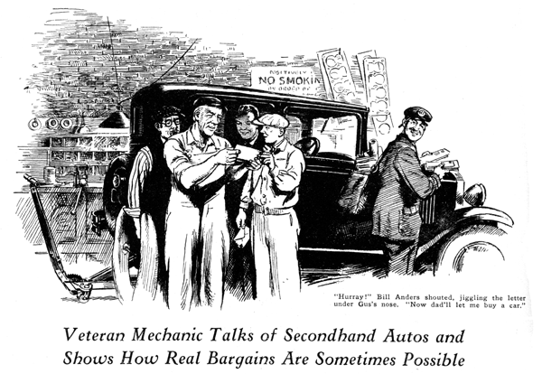
Gee whiz!" exclaimed young Bill Anders as he gazed longingly at the shiny new automobile. "I just wish I had a car like that!"
"It'd suit me right down to the ground, too," echoed Ted Anders, Bill's younger brother.
Gus Wilson, veteran auto mechanic and half owner of the Model Garage, looked at them critically.
"You young scalawags'll never get a car like this just by wishing," he grumbled as he lowered the hood and snapped the catches. "Instead of hanging around here under my feet all the time, why don't you earn some money so you can buy one?"
"I do earn money," young Bill indignantly protested. "I've got enough saved up already to pay my way through college next year."
At that moment the postman poked his head in the door and handed several letters to Gus.
"You might as well take this and save me stopping at your house," he said, thrusting a letter into Bill Anders' hand.
Joe Clark, Gus's partner, stepped out of his little office to get the mail just in time to hear Bill let out an excited yell.
"Hurray!" he shouted jiggling the letter under Gus's nose. "I've won the scholarship! Now dad'll let me use that money to buy a car! What kind of a car shall I get, Gus?"
"Well," Gus grinningly observed, "if you're like the rest of these collegiate birds I see wound here, you'll collect a rattling heap of tin."
"Now, for," said Bill firmly. "I want a real car and then I want to keep it in tip-top conditions. Do you think I'd do better to buy a good secondhand car instead of a new one?"
Gus threw up his hands. "Solomon himself couldn't give the right answer to that one," he said. "It depends on a whole lot of things. How much money have you? What type of car do you want? What do you expect out of a car? How much do you expect to use it? Even with all those questions answered there's still plenty of room for argument. About all I can do is to line up some of the things you'll have to figure on and let you decide for yourself."
"Fair enough," said Bill. "Just tell me the arguments both ways. That'll give me something to go on."
"To begin with," said Gus, "the main difference between buying a new car and a secondhand bus is that the new one is pretty much of a sure thing while the secondhand outfit is, most times, just a gamble.
"When you buy a new car there is always the chance that some part may prove defective, but you can be dead sure that there aren't any worn parts. If you take the trouble to cover at least a couple of thousand miles before the guarantee runs out, you're almost certain to smoke out anything really defective so you can get it replaced free.
"Another thing about a new car is the tires. You start out with new rubber on every wheel, and in the ordinary course of events you needn't expect any tire trouble at all for a couple of years, except maybe a couple of punctures.
"The rubber on a secondhand car may be pretty rotten without looking so awful bad. I've seen lots of secondhand cars need new shoes all around before the year was out.
"The same thing applies to batteries. They're like tires - only good for so long anyhow. A battery that'll start the secondhand car in fine style when you get a demonstration may go all to pieces in six months. Sometimes a new car battery does that too, but not if you take care of it."
"Why couldn't you take care of the secondhand car battery the same way and get the same results?" Bill broke in.
"Because," Gus explained, "taking care of a battery isn't going to put back the material that's fallen off the plates or patch up the holes in the separators that are going to cause short circuits. Babying along a bum battery after it starts to go bad is a waste of time.
"That's two items," Gus continued, "and there's a lot more. You can't tell how much carbon there is in the cylinders or even how many miles it'll be before the valves will need regrinding just by lifting the hood and looking at the motor. How long will it be before the starter motor itself is going to need attention? Or the generator? You can't tell from the outside. That's where the gamble comes in. Maybe not one of these parts'll give you a bit of trouble for years. Then again they may all go on the blink the first month and that's just your hard luck.
"There's another thing," he went on. "When you buy a secondhand car, it's already out of date. Suppose it's three years old when you get it. Look around and see how the cars that are five years old look to you today. Kind of ancient, don't they? Your three-year-old car is going to look just as ancient to you and everybody else in only two years.
"Don't get the idea that a secondhand car is always a lemon," Gus cautioned. "It may be a much better buy than a new car. When a man buys a new car he pays the factory price plus the freight charge and also a 'service' charge, so what he pays is a lot more than the advertised price. Then if he drives it for a couple of months and tries to sell it, he has to take a big loss even if the car looks just like new and is in mechanically perfect condition. It may be even better than new if he's broken it in real careful. If he keeps it over a year and then tries to sell it, he has to take two years' depreciation instead of one.
"Maybe he has kept it in fine shape and only driven it three or four thousand miles. Figured on a dollars per mile basis, the fellow that buys that car is getting a real bargain. It's only a tenth worn out any way you figure it, and he gets it for half or maybe a third of what it cost."
"Sure sounds like a bargain the way you put it," said Bill. "But why does the fellow that bought the car in the first place sell it so cheap?"
"That's just human nature again," Gus maintained. "He's like the woman who throws away a perfectly good pair of shoes or a dress and buys a new dress or shoes just because the ones she had weren't exactly like what every other woman happened to be wearing that particular month. Keeping up with the styles is fine, son, if you can afford it."
"Then," said Bill, "you think I'd be taking less chance on buying a new car but I might get a much better bargain in a secondhand one?"
"That's about the way it sizes up," Gus grinned. "Like a lot of other propositions it al depends on how you look at it!"
END

