October 1930

GREASE AND STAY CLEAN,
SAYS GUS
by Martin Bunn
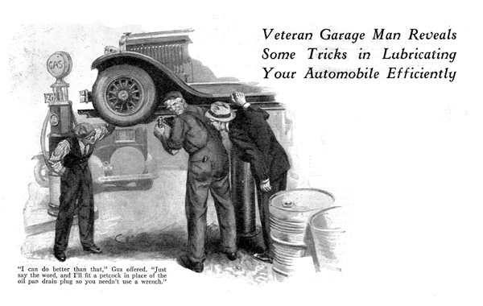
"See the beautiful country by motor!" Madison muttered jeeringly to himself as a fresh gust of wind dashed a torrent of rain against the windshield. "Three days out and three days of rain. See the beautiful country! I've seen about as much as you could see out of a submarine! Now all I need is a real good break-down or a first class smash-up to make this vacation a perfect flop - and if I don't get this steering gear fixed pretty soon that's just what'll happen to me."
Madison swore gently to himself as he yanked the wheel to round a curve in the road. A mile or two farther on, the rain stopped and he caught sight of the Model Garage.
"Steering gear's on the bum. It's almost impossible to turn the wheel," he growled as he pulled in.
Gus Wilson veteran auto mechanic and half owner of the Model Garage, twisted the wheel back and forth a couple of times. It groaned protestingly.
"Dry as a bone," he commented. "Run it over here where I can shoot it up in the air and give it a good greasing."
"Say listen, mister," Madison snapped disgustedly, "I had it greased last night at the garage where I stopped over. Can't you see the grease smeared all over the fittings? Guess again!"
Gus chuckled. "That's an old one. They knew you were just passing through so they spent two minutes dabbing grease on the fittings that show and let it go."
"Stung again!" exclaimed Madison.
"The tourist hasn't much chance these days has he?"
"It isn't as bad as that," Gus replied, as he turned the valve and the car rose from the ground. "Most of 'em wouldn't do a trick like that."
"Well if I've got to watch 'em to make sure," said Madison, "I might just as well do the job myself. I started to when I first got the car but the grease gun busted. It's awful messy, though. I got grease all over everything the last time I tried it."
"Why get all smeared?" Gus continued, "Take more time and do it right."
"In the first place," Gus continued, "you want a grease gun that shoots grease or oil out where it is supposed to come out and not out around the handle and every joint. Next, squander two bits on a pair of leather-faced canvas gloves with gauntlets - the kind they sell to truck drivers. Then make a raid on the rag bag and get a good wad of clean rags. Put on the gloves and keep 'em on till you get through."
"But I can't work with gloves on." Madison objected.
"Sure you can," Gus asserted. "After you've done the job a few times with gloves on you'll get the habit and when the gloves get so greasy it starts to work through on your hands, throw 'em away and get a new pair."
"Here's another point where you win out by doing the job yourself," Gus added as he reached for a clean piece of waste. "You'll notice that I clean off every bit of dirt from each fitting before I shot in the grease. Lots of service stations are mighty sloppy about that. They just shoot the grease in and the dirt along with it and believe me, that grit doesn't do the bearing surfaces any good. If you do the job yourself, you can take the time to get the dirt off."
"How often ought I to do the job?" Madison asked.
"Stick to the oiling chart that came with the car," Gus suggested. "Of course if you're running a lot through mud in summer or slush in winter oil the bearings that get splashed about twice as often. That will keep the water out of 'em."
"When you get through there," said Madison, "you can sell me a good grease gun. And can you sell me a wrench that will really fit that plug in the oil pan so I can drain the crankcase myself? I nearly ruined a couple of knuckles the last time I tried it with a regular wrench."
"I can do better than that," Gus offered. "Just say the word and I'll fit a petcock in place of the plug so you won't have to use a wrench at all."
"Sounds like a swell idea," said Madison enthusiastically. "I always wondered why they don't fit all cars with some way to get the oil out of the crankcase that isn't so much trouble as taking out a plug. I've had a lot of trouble with plugs. Twice dumbbells at service stations have chewed all the corners off the plug so I had to get a new one and once a bonehead stripped the threads so I had to have him plug the hole with a wooden plug so I could get to a service station. Cost me ten dollars that time!"
"Well," Gus explained, "a good bronze petcock costs more than a plug. Besides, the oil runs so slow out of a petcock that the service stations don't like 'em. Then there's always the chance that an extra big rock will fly up from the road and knock it off."
"Not much chance of that the way roads are today," Madison scoffed. "I'll take a chance on that, and the time it takes the oil to run out makes no difference to me. Will it be much of a job to fit one?"
"Takes only a couple of minutes," said Gus. "I just run a regular pipe tap into the hole. It cuts out the old threads and makes a new thread that will take a regular petcock. Then I screw in a good bronze petcock that has a spring to keep it tight. Of course you want one that is in the off position when the lever is straight down so it won't jar open."
"How do you figure out what size pipe tap to use?" Madison inquired interestedly.
"That's easy," Gus replied. "Use the biggest pipe tap that will fit in the hole in the oil pan that is just right for the regular quarter-inch pipe tap."
"All right, go to it!" Madison ordered as Gus shot lubricant into the last fitting.
"By the way," he added, "how can you tell whether grease or transmission oil is better to lubricate the chassis bearings?"
"There isn't much choice," Gus replied, "I kind of favor heavy transmission oil in place of ordinary cap grease. Grease, you know, is just oil with something added to make it solid. If the bearing is built so that a bit of flow is needed to get real lubrication, grease doesn't do much good till the friction has made the bearing hot enough to melt the grease. Of course, grease stays in better and if the job isn't done often enough, you make out better with grease."
"But if you lubricate often enough so there's no chance of the bearing running dry, you'd recommend transmission oil?" Madison suggested.
"That's my idea of it," Gus replied. "These automatic lubricating outfits that are fitted to some makes of cars all use oil and it's not so easy to push the plunger or step on the pedal of the automatic outfits that you can do it every hundred miles or so."
"The next car I get is going to have automatic chassis lubrication." Madison stated. "Then I won't have to monkey with a grease gun at all."
Gus smiled. "Sure you will," he said. "None of the automatic systems shoot the oil to every bearing. You have to lubricate some of the important bearings on the steering gear by hand anyhow. Of course the automatic outfits do save a lot of time and they're fine if you don't forget the hand lubricated bearings."
A short time later Madison was spinning down the road under a bright and cheerful sun.
"I kind of wish I lived in that town," Madison murmured to himself. "Never mind, old bus," he added patting the steering wheel affectionately, "you won't be bothered with any more dry bearings. I'll see to that myself!"
END

