June 1930

TRICKS THAT ADD TO A CAR'S SPEED
by Martin Bunn
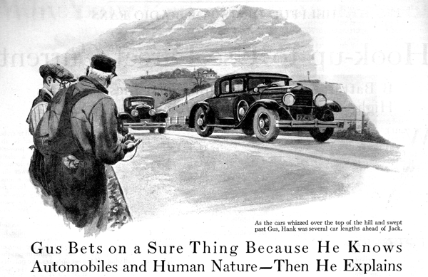
Joe Clark stepped out of his little office, slammed the door, and walked disgustedly back to the rear of the Model Garage where Gus Wilson, his partner in the auto business, was working.
"Something's just got to be done about it, Gus, "he complained, "Hank Witherbee and that young Jack Landrith've been wrangling with each other in the office till I'm nearly crazy. Go in and shoo 'em out for me, will you?"
"Shoo 'em yourself. I've got troubles of my own," the veteran auto mechanic growled as he "miked" a new piston pin and found it way out of round.
"Another one of them darn 'eggs,' "he grated, snapping the offending pin into the scrap pile under the bench. "What're they arguing about, anyhow?"
"Some old thing," Joe replied. "Each one claims his car is faster and better on hills than the other fellow's."
Gus reached for a clean piece of waste and headed for the office.
Young Landrith was pounding on the desk in his excitement as Gus strode into the office. "Is that so!" he shouted. "You know darn well that my car can beat yours anytime, anywhere. Every time we've had a brush I've licked you!"
"G'wan," Hank scoffed. "I didn't even know you were racing me."
"You fellows have exactly the same car," Joe interrupted. "What's the sense of arguing that way when both can have the same speed?"
"They haven't anything of the kind," put in Gus emphatically. "Jack, you think your car is faster. I'll bet you twenty bucks Hank can beat you on a hill or on the level."
"You're on!" Jack snapped angrily. "Just give me a chance and I'll find good use for that twenty."
"All right," said Gus, "Joe and I'll meet you fellows at the foot of Shonk's Mountain at six tomorrow morning when there won't be any traffic. You can race up the mountain and then try out again on that level piece this side of it. "How about it Hank?"
"I'm willing," Hank agreed.
"Don't forget to bring the twenty with you," Jack called as he left the Garage.
"What makes you so sure Hank will win?" Joe asked after the two had gone.
"Well, I know Hank and I know Jack," smiled Gus mysteriously.
"I'm glad it's your twenty you're risking," Joe grunted.
It so happens that the road beyond the stiff grade up Shonk's Mountain curves away at a gentle slope so that a person standing at the top can see the road for nearly two miles. Also the top of the hill is visible from the bottom. Consequently Gus, by waving, could signal the contestants when the road was clear.
The two cars had drawn up side by side at the foot of the hill and as Gus waved, they started with a roar. For about a quarter of a mile they stuck together like a team of horses, and then Hank began to pull ahead so that as they whizzed over the top of the hill, and swept past Gus, he was several car lengths ahead.
The result was the same on the level road race.
"Here's your twenty," said Jack as he fished out of twenty-dollar bill and looked at it dolefully as he offered it to Gus. "He beat me fair enough," he added, "but I'm blamed if I see how he did it. I can drive just as well as he does."
Gus pocketed the money, "Come back to the garage with us," he said, "and I'll tell you how he beat you."
"Now, "said Gus, when they were all in Joe's little office
"In the first place here's your money. You're a good sport, kid, you didn't try to pull any alibis. That Hank would beat you was a sure thing and I wouldn't bet on a sure thing. You were licked before you started. The two cars are the same make and model and you're a good driver, but that had nothing to do with it. What did mean something is that Hank has been playing with auto motors long enough to know some of the tricks of getting the most out of them. For instance, what did you do to your carburetor before the race?"
"Nothing," Jack replied. "Why should I? It was all right."
"Not for racing or hill-climbing tests," Gus explained. "Hank set his for a good rich mixture that would give him plenty of kick on the hill and the last mile of speed on the level. What did you do to the ignition?"
"I checked that, all right," said Jack. "Looked over the spark plugs to make sure that there weren't any fouled ones and I looked at the breaker points to make sure they weren't getting pitted."
"All right for ordinary use," admitted Gus, "bet Hank came here last night and got himself a whole new set of spark plugs and also a new set of spark plug cables. You two have had those cars nearly a year, and while the spark plugs and ignition cable are plenty good enough for any ordinary service, if you want to get the last ounce of pep out of the motor, new plugs and new cable will help a trifle - and it only takes a couple of trifles to make a difference between two cars of the same make."
"Gosh," young Landrith exclaimed. "Anything else?"
"Sure," Gus smiled. "Hank spent nearly an hour here last night just making sure his brakes didn't drag the tiniest bit. You know how fussy he is about draining the crankcase every little while and grinding the valves every few thousand miles. He even went over the wheel bearings and made sure they were set just loose enough."
"I'll bet he put one over on us by taking his muffler off, too," Jack suggested.
"I know he didn't do that, "Gus asserted, "bet he did get busy with the generator and moved the third break over as far as he could to get the charging rate way down so that the generator didn't drag on the motor so much.
"There's another point where you missed out, "Gus continued. "I never could get you to believe that it paid to use real good gas. Hank knows better. He buys the best he can get. And the same goes for oil, too. Another thing; "you jam your transmission case and rear end full of cheap grease." "It doesn't lubricate as well and makes a lot more friction than good transmission oil."
"Well, anyhow, I had sense enough to pump up my tires," Jack maintained.
"Yes, and how did you do it?" inquired Gus. "You probably put just as much air in as the makers recommend. That's right for regular use, but if you want to cut down the rolling friction on good roads, shoot in an extra five pounds or so."
"Good night!" said young Landrith disgustedly. "The next time I'll try to know a little more before I start shooting off my face!"
"That's a real good idea, too," Gus agreed.
END

