August 1930

GUS AND JOE ARE REAL LIVE MEN
by Martin Bunn
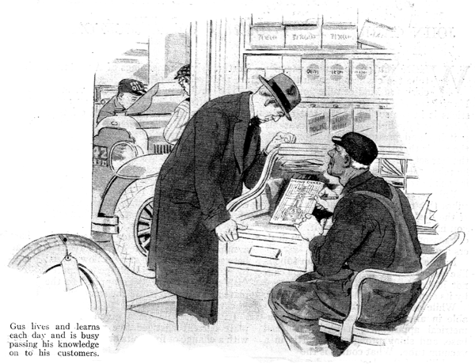
Many readers of POPULAR SCIENCE MONTHLY have asked me if Gus Wilson is a real, live man and if the Model Garage actually exists. The answer to both questions is yes. The Model Garage is located in a town not far from New York City. It is owned and operated by two men whom I have named in my stories Gus Wilson and Joe Clark. These are not their real names, nor is their place of business called the Model Garage. But don't ask me to tell you what their real names are or where the garage actually is located. I can't do it because years ago when this series of stories first started, I promised never to reveal these facts.
I can assure you, however, that I have done my best to describe "Gus Wilson" as he really is. Even the drawings of Gus which illustrate each story look like the real man because they are made by an artist who knew him.
The incidents in the stories are taken directly from the veteran auto mechanic's own experience.
While I cannot reveal "Gus's" real name or where he lives and works, I can without any breach of confidence tell you a little about his past history.
"Gus Wilson" grew up with the automobile industry. When Duryea was experimenting with his first gasoline buggy "Gus Wilson," then a young man, was investigating and incidentally overhauling one of those funny little steam vehicles that had to stop at every horse trough while the driver sucked into the tank, with a length of hose and a hand pump, gallons and gallons of water.
When the first electric hansom cab hummed and groaned its snail-like course over the streets of New York, Gus was adding water to the batteries sandpapering the commutators of the motor, and otherwise mothering these clumsy vehicles.
His wrist still is a little stiff because years ago the huge one-cylinder engine of a Northern runabout (a competitor of original Oldsmobile) kicked back and broke several wrist bones.
He has worked on almost every kind of an automobile ever made, and yet with all his experience he remarked, a while ago: "I'm learning some new queer kink about a gasoline motor every day!"
Like many exceptionally generous and kind-hearted men, "Gus Wilson" hides his friendliness under a gruff and growling manner. His bark, however, is much worse than his bite, and he is always willing to give all the information at his command to any motorist who is honestly striving to get better results from his car.
I feel safe in saying that motorists in general would be a lot better off if all auto mechanics had as much skill and knowledge of automobiles and took as much genuine pride in fine workmanship as does "Gus Wilson."
END

