November 1929

DANGERS IN DRIVING WITH BAD EYES
by Martin Bunn

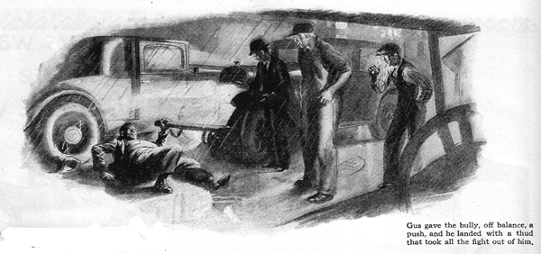
"Joe," growled Gus Wilson to his partner, Joe Clark, as the two clattered down the road in their old service car. "I'm about fed up on this auto business. For two pins I'd sell you my share in the Model Garage!"
"G'wan!" Joe scoffed, grinning. "You're fed up on 'hot dogs' - not autos, I told you three was too many."
"Maybe so," Gus agreed. "I do feel as though they're snapping at each other." The veteran automobile mechanic relapsed into a gloomy silence as the car sloshed on through the rain. They were rounding a curve, when the headlights revealed two cars jammed together at the side of the road.
"Speaking of fights," Joe whispered as Gus stepped the car, "looks like we're going to see one right now!"
The owner of one of the cars, a big, red faced chap, appeared to be on the point of hitting the under sized bespectacled driver of the other car.
"Of course it's your fault!" the big fellow yelled angrily. "Anybody that wears glasses as thick as yours must be half blind anyway. It's a good thing you've got 'em on or I'd sock you into the middle of next week. I've a good mind to do it anyhow!"
"What's the idea of picking on the little guy, you big stiff?" snapped Gus grimly as he stepped up to the speaker, who was almost a head taller than himself, "I'll bet you're to blame, at that."
"Say! Who asked you to butt in?" grated the big fellow. "Somebody's going to get a clout for this and it might just as well be you!"
With that, he aimed a furious swing at Gus's jaw. The veteran ducked and the force of the swing threw the bully off his balance. Gus gave him a gentle push and he landed on the ground with a jarring thud that took all the fight out of him.
"Now let's get the straight of this," said Gus, turning to the little chap, "How did it happen?"
"I was coming down Mapes Avenue," he explained, nervously dabbing rain drops from the thick lenses of his spectacles, "and this man was approaching the crossing on my left, so I had the right of way. When I saw he wasn't going to stop I put on the brakes, but it was too late."
"Kind of near-sighted, aren't you," observed Gus as he noted the thick lenses with their deeply concaved inner surfaces. "But I'm fully corrected," said the little fellow hastily.
"He's half blind, I tell you," argued the bully, who, by this time, had crawled painfully to his feet and seeing that Gus had no intention of renewing hostilities, wanted to uphold his end of the argument.
"How about your own eyes?" Gus asked. "Why didn't you see this man's car approaching the intersection? There's no signboards or anything in the way."
"My eyes are perfect and I can prove it."
"All right, prove it then," snapped Gus. "Stand right where you are and describe the radiator ornament on my car."
The big fellow laughed sneeringly.
"What are you trying to do, kid me?" he growled, staring intently at the metal object. "That's no test. It's just one of those metal bulldogs. One of the front legs is busted off."
Gus, who was standing in front of the big chap but slightly to one side of his direct line of vision, did a peculiar thing while the big fellow was gazing at the radiator ornament. He crouched into a pugilistic attitude and started a swing that would have landed square on the point of the jaw if he had not stopped it a foot short of the mark.
Joe and the other accident victim gasped in amazement, for the big fellow seemed totally unaware of Gus's threatening move.
I guess that settles it," Gus growled at him as the big man finished describing that bulldog. "If you'll take my advice, you won't ever try to drive again. You have what is called 'tunnel vision'. You only see what is directly in front of your eyes - no side vision at all. A normal man can see a moving object, that's almost ninety degrees off to one side. You didn't see my fist move toward your jaw just then, and the chances are you never saw this fellow's car at all until it was right in front of you."
"I passed the license examination," said the big fellow uneasily. "That gives me the right to drive, doesn't it?
"Sorry, big boy," said Gus sympathetically. "People with tunnel vision are scarce. There's no cure and no way to correct it with glasses. I heard of a fire engine driver who had it without realizing it. He managed to drive the engine for several years, and then he got into a bad smash and the investigation showed his eyes were to blame."
"That's a new one on me," the big fellow muttered." "Still it would account for most of the accidents I've had." It's cost me plenty of jack fixing up other people's cars after I busted into 'em." Can't even get insurance any more." Guess I'd better get me a chauffeur before I land under the daisies!"
"And if I were you," Gus grinned, "I'd make durned sure that the chauffeur doesn't have the same trouble."
Both of the men's cars were so badly smashed that they had to be towed in. "How about the little fellow?" Joe asked as they rattled down the road with the first car on the end of the wrecker's crane. "Should a man be allowed to drive a car who is as near-sighted as he is?"
"Sure", replied Gus, "if he's got enough common sense to know his own limitations." In the daytime, with his glasses on, he can see just about as well as anybody" A night, especially when it's raining, he won't be quite sure what he sees through the rain-covered windshield." He's liable to mistake a post for a man or a man for a post, he won't get into trouble.
"Farsighted people," Gus continued, "unless they are unusually farsighted, don't even need to wear glasses when they drive. "Color-blind people can drive safely enough, but they're up against it when it comes to traffic lights." I know one man who doped out which light was above the other and went by position instead of color." "Once, late at night, he was traveling through a strange town, and he saw a light where he thought the red ought to be, so he stopped." When the lights changed he started forward and went smack into car crossing in front of him." In that town they had the red light where the green light ought to be!"
END

