July 1929

HOW TO BREAK-IN YOUR NEW CAR
by Martin Bunn
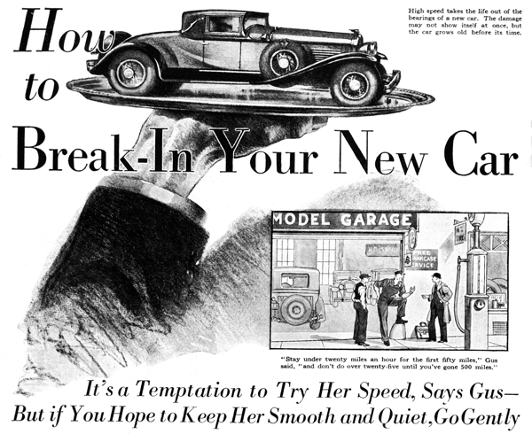
"Have I got to swear out a writ of habeas corpus to get my car. Mr. Wilson?" smiled young Webb, the town's newest lawyer, as he poked his head in the door of the Model Garage.
"You can habeas the corpus right now, far as I'm concerned," growled Gus Wilson, veteran auto mechanic, as he wiped the perspiration from his face. "But by rights, I really ought to call in the coroner and have him hold an inquest over that particular corpus. Honest, Webb, I've done the best I could short of completely rebuilding it. It's running now, but I'm not guaranteeing it. Better get a new boat before that one falls to pieces and leaves you sitting in the road!"
"That's precisely what I'm going to do," Webb chuckled as he climbed into his ancient car. "I've placed the order already. Going to take delivery month after next, the day before I get married, and we're going on our honeymoon in the new car."
"Why the delay?" Gus asked. "Can't they make delivery before that?"
"Certainly they can," Webb replied, "any time I say. But I thought it would be nice to have a brand-new car to start the trip." "That's bum dope," grunted Gus. "First place you ought to drive a new car real slow for the first thousand miles, and that would be a nuisance on a tour. Besides, little troubles may develop in a new car during the first thousand miles. Anything wrong in the assembly or adjustment usually shows up then. Better get the car as soon as you can and work it in before you start the trip."
"You've made out a prima facie case, Gus," Webb admitted. "I'll tell the agent I want the car now."
Two weeks later the young lawyer drove up in a brand-new coupe. "Well, gentlemen of the jury, what's your verdict?" he grinned.
"Looks good - now," Gus commented. "I hope you'll keep it that way."
"Status quo, as it were," agreed Webb. "That's what I want to do if you'll show me how. First off, I'll issue a restraining order against jamming the throttle against the floor boards to see how fast she'll go. "Why is it so necessary to drive a car easy at the start. Don't the parts fit?"
"Certainly they do," Gus replied. "It isn't that at all. It's a matter of surfaces. The walls of the cylinders or the bearings on the crank shaft, for instance, look smooth and polished, but if you could see 'em under a microscope, you'd be surprised how rough they really are - full of little ridges and valleys and pits."
"But I thought the oil kept the surfaces from touching each other." Webb interrupted.
"Theoretically it should," Gus explained, "but actually it doesn't. If you don't believe it, connect an electric doorbell in series with a battery, touch one of the wires to the crankcase, and let the other rub against the exposed end of the crank shaft while the motor is running. You'll find the bell will ring almost as steadily as if the wires were hitched to each other. The crank shaft is spinning in bearings supposed to be flooded with oil, yet the bell rings - proving there's a real metal-to-metal contact at some point.
"What do you suppose happens when the tiny metal ridges on the shaft bump into the microscopic rough spots on the hearing surfaces?" Gus asked.
"They commit assault and battery, I suppose," suggested Webb.
"That's exactly what they do, if - " and Gus paused significantly - "they come together at high speed. If the little ridges and points rub together at slow speed in the presence of plenty of oil, they just wear each other till there aren't any ridges left. But when they slam together at high speed they tear loose and leave the surface rougher than before. It takes the life right out of the bearings. The damage may not show right away, but the car will grow old before its time."
"How slow ought I to drive?" Webb asked. "I'd stay under twenty miles an hour for the first fifty miles or so," Gus advised. "Then don't do over twenty-five until you've reached the 500-mile mark, and not over thirty till you've passed 1,000 miles. And no quick getaways. Be gentle. Let the clutch in easy, don't jam on the brakes, and don't do any rip snorting up the hills in second speed."
"I can see where I get a chance to enjoy the scenery for a while," Webb laughed. "What's the rest of the bill of particulars?" "Drain the crankcase and put in new oil at the end of 250 miles, "he added. "Even if the car has an oil filter it's worthwhile, because until the piston rings get worked in, raw gasoline gets past them into the crankcase. Have the rear wheels tightened at the end of 500 miles. Then get 'em properly seated and you won't have any more trouble. Let 'em stay loose and you're liable to bust an axle when you least expect it.
"One thing we ought to do right now is add about a pint of oil to the gasoline in the tank. I'll give a little extra lubrication to the cylinder walls and piston rings while they're holding evenly after the brake lining has had a chance to wear in.
"That's about all, outside of the usual precautions about keeping the car greased and oiled," Gus concluded. "After that first thousand miles, though, when you first start burning up the road. It pays not to keep the car traveling at high speed for long stretches at a time. About every mile or so take your foot off the throttle for a few seconds - just long enough to let the car slow down to normal speed. That'll give the oil film on the cylinder walls a chance to renew itself.
"If you stayed in this shop awhile you'd soon see how many sets of piston rings I have to replace, how many scored cylinder walls have to be honed or reground, how many connecting rods get loose or burn out - just because dumb-bell owners step on it while their cars are brand-new!"
END

