August 1929

DOLLARS YOUR CAR CAN SAVE YOU
by Martin Bunn
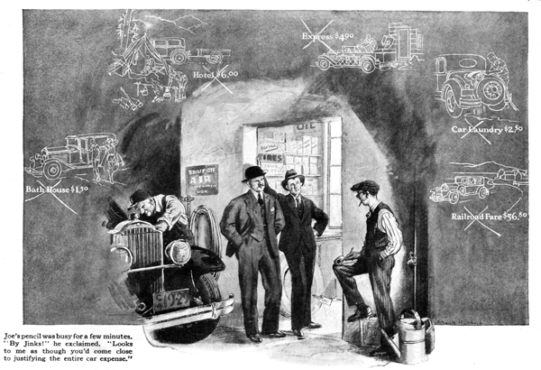
An argument between two customers that threatened to develop into a regular fight was in progress just outside the Model Garage. Gus Wilson stood it about as long as he could.
"Hey! You guys outside there!" he shouted, banging on the side of a convenient pail with a monkey wrench to emphasize his remarks. "Isn't it hot enough around here without you two spilling all that extra hot air? Joe, see if you can't shoo 'em away."
Joe Clark, Gus's partner in operating the Model Garage, and the bookkeeping member of the firm, went to the rescue.
"What's it all about?" he interrupted as, pencil in hand, he confronted the two argumentative gentlemen.
"Ted, here is shooting off a lot of bunk about how his car doesn't cost him anything to run," said one of them.
"But it isn't bunk, Mac," protested the other. "I know what I'm talking about. Don't I pay the bills?"
"Just arguing won't get you anywhere," said Joe. "Why not do a little figuring and see how it comes out in black and white on paper? If I understand you right Ted, here, is convinced that his car doesn't cost him anything to run, while you, Mac, claim that's a lot of applesauce and that your car is running you straight to the poorhouse. Is that the sense of it?"
"You've got it," Ted agreed.
"But, Joe," Mac protested, "Ted can't possibly be right. You can't spend money and have it, too, you know. That's -"
"Just a minute, Mac," Joe broke in.
"Let's settle this thing on paper not with chin music. You've both got the same kind of car and you got 'em about the same time, so we ought to get sour pretty interesting figures out of this.
Let's get Mac's story on paper first. How do you figure our car's making your pocketbook so lump?"
"It's as plain as the nose on my face," Mac asserted subconsciously scratching that rather prominent feature. "I drive about six thousand miles a year, and you've told me before that it costs at least eight cents a mile to operate a car like mine. That makes four hundred and eighty dollars right there."
"All right, I've got that down," said Joe as he noted the figure on a piece of paper. "Anything else you can charge against the car?"
"Lots," grumbled Mac. "Every time we go out for a ride on Sunday we invite some people to go with us, and I get stuck for dinner for the crowd. Every time I drive to a show in the city there's a parking charge added to the cost of the tickets. Because we've got the car we don't have to take the last train home and that means e go to some restaurant instead of raiding the ice box after we get home.
"Then we wouldn't belong to the country club if we didn't have a car to go back and forth. So what I spend at the club ought to be charged against the car - and, believe me, it's plenty!
'That car doesn't do anything else but take us to places where we can spend money!"
"H'mm," grunted Joe. "You seem to make out a case. What have you got to say, Ted, for your side of the argument?"
"Well," Ted began. "I drive about as many miles as Mac does, so I guess the four-hundred-and-eighty-dollar figure fits me, too, but the car saves money in lots of ways."
"As for instance?" questioned Joe, jiggling his pencil.
"On vacations, for one thing," Ted explained. "If you want to put down some figures, you can start with exactly fifty-six dollars and eighty cents railroad fare we saved last summer. That's what the tickets for the wife the two kids, and myself would have cost on my vacation. Then you can put down at least four dollars more that e saved on expressage by carrying our baggage in the car. Also, because we had the car and didn't have to hang around the hotel all the time, we were satisfied with a cheaper hotel farther from the beach. That saved at least twenty dollars on the hotel bill. And we found a beach where we could conveniently get into our bathing suits in the car. Every time we did it we saved just one-fifty in bath house fees. Figure all that up for a two weeks' vacation! This year we're going motor camping for our vacation and we'll save still more."
"That's nearly a fifth of your car expense already offset by saving," Joe commented.
"How do you account for the rest?"
"It's kind of hard to give definite figures," Ted said slowly. "It's principally in getting our fun out of the car instead of spending money on more expensive amusements. Nearly every clear Sunday we go off on a picnic in the car. That doesn't cost us anything but the food, and the wife says it's cheaper to get up a picnic than to cook Sunday dinner. Then, since we've got the picnic to look forward to on Sunday, we don't bother to go to the movies on Saturday night as we used to before we got the car. The savings that way ought to come to quite a respectable total during the course of a year.
"Before we got the car I used to hang out with a bunch of fellows from the office Saturday afternoon. Usually we went to a matinee, or shot some pool or something, and what with one thing and another I generally spent at least three or four dollars. Now I head for home right after the office closes, have a bite to eat at home, and we go for a ride, or, if the wife is busy, I spend the afternoon washing and polishing the car."
Joe's pencil was busy for a few minutes. "By Jinks!" he exclaimed. "Looks to me as though you'd come pretty close to justifying the entire car expense."
"If I haven't," Ted grinned, "you can put down a little something for doctor's bills saved. I've noticed that we don't have to call in the doctor quite so often now that we spend more time outdoors."
"Well," observed Joe, "far as I can see, you're both right in this argument. Each one of you is looking at it from a different viewpoint. It only goes to show that a car will help you to spend money if you're inclined that way or it will help you to save money if you'll let it!"
Have you a motor car problem that needs solving? Let Gus and Joe answer it.
END

