September 1928

WHY "FIX" A BRAND- NEW CAR?
by Martin Bunn
Gus Gives a Know-It-All Driver
a Few Hints Concerning His Automobile
That Are Worth Anybody's Reading
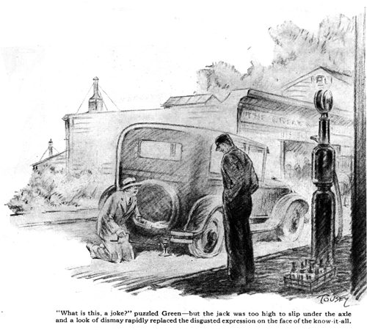
"Isn't it funny," observed Joe Clark, "that just as soon as a fellow gets to know a little about automobiles, right away he thinks he knows it all."
Gus Wilson, his partner, working on a motor outside of their Model Garage, grunted, "Know-it-alls give me a pain," he growled.
"Then," grinned Joe, "you're due for a severe pain. Here comes the biggest know-it-all in town, Archibald D. Green!"
A larger and shiningly new sedan stopped with a crunching of gravel and a fat young man climbed jauntily out. "Hello, old-timers!" he called. "Just thought I'd let you feast your eyes on my new boat. Some class, eh? And believe me, those factory men don't know anything. It took me two or three hours to get it running good. The carburetor wasn't set just right. I had to go over the ignition system - even the brakes were set wrong!"
Green, thumbs hooked in his vest, strutted around like a pouter pigeon.
"It's a good looking bus, al right," observed Gus with a twinkle in his eye, "and I guess you can show 'em up when it comes to fixing an automobile."
"Surest thing you know," Green agreed, nearly snapping the buttons on his vest, "Nothing can happen to a car that I don't know how to fix and fix right."
"Kind of fancy yourself as an auto mechanic, don't you?" Gus growled, "Why I'll bet you I can fix your car with my bare hands and without busting any part, so you'll have to holler for help."
"Huh!" Green snorted. "Here's a good cigar that says you can't!"
"All right," said Gus, "Just suppose you're out on a lonely road and a tire goes flat." He screwed the valve out of one of the rear tires and it collapsed.
"What the heck is this, a joke?" puzzled Green, "If you just wanted to see me change a tire, why didn't you say so in the first place?"
Disgustedly, he got out his jack and attempted to put it under the rear axle, but the top of the jack was at least an inch too high to slip under. The collapse of the big tire coupled with the small diameter of the wheel let the axle down too far. A look of dismay rapidly replaced Green's disgusted expression.
"You're sure some swell auto mechanic if you let a little thing like that stump you," grinned Gus derisively, "Hand me that cigar and I'll show you a few ways to raise your car.
"Now," said Gus as he clipped the end from the cigar Green handed him, "what's the matter with digging a hole for the base of the jack? And there's certainly nothing to stop you from placing the spare tire in front of the flat and driving the flat up on top of it. Then you can slip your jack under. If you haven't any spare along, you can run the car up on a piece of wood.
"And just a minute," called Gus as Green was about to climb into his car. "You said you had to adjust the brakes. What was the matter with 'em?"
"Nothing much," Green replied. "The car didn't seem to stop as quick as I thought it should with four wheel brakes, so I just tightened 'em up."
"I thought so," grunted Gus, "See what happened when you stopped here." He pointed out where both wheels on one side had locked and slid a few inches in the gravel although the wheels on the opposite side had left any mark.
"When the four-wheel brakes on one side are too tight, you are all set for some extra fancy skidding.
"If you want to get the brakes even, you've got to jack up both rear wheels at the same time and have somebody put on the brakes while you test to make sure that both brakes take hold at the same time. If you haven't anyone to help you, rig up some blocks of wood and use your jack to push the brake pedal down a little at a time.
"And," Gus continued, "you can pull on a husky spring balance hooked into the spokes near the rim to match the effect of one brake with the other. That is a pretty accurate method.
"Then when you have the rear brakes right, remove one jack and raise a front wheel and test it. The front brakes should take hold a little after the rear ones and they shouldn't hold on tight. If they lock before the rear ones, you are mighty bold to get into a dangerous skid. After you have one front brake right, you can transfer the other jack to the front and match the other front brake."
"Why not just shorten the brake rods by turning the chassis?" suggested Green.
"Whatever you do, don't do that!" Gus replied most emphatically. "Don't ever monkey with the length of the brake rod. Changing their length throws the leverage of the whole system out of whack so that you'll have to push a whole lot harder on the brake pedal to get the same amount of braking effect."
"Can you fix 'em for me this morning?" asked Green, sheepishly.
"Soon as I finish this job I'll get at it - by the way, didn't I hear you say you had adjusted the carburetor?"
"You did," Green admitted.
"Then," grinned Gus, "I'll fix that too!"
END

