October 1928

A PIECE OF STRING FIXES AN AUTO
by Martin Bunn
Gus and Joe Hire a Wizard Who Doesn't Bat an Eye
at a Dead Battery or Broken Steering Arm.
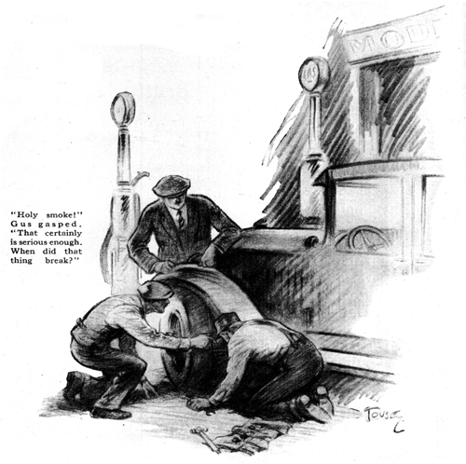
"I wonder how "Spare Parts" Harbison made out with that queer little mechanic you talked him into taking on his automobile trip?" Joe Clark observed.
"Must have worked so well that "Spare Parts" extended his trip to cover a lot more territory," replied Gus, who was Joe's partner in the Model Garage. "I wish they'd come back. We need another man right along. I'm thinking and that little Alec McGregor ought to fill the bill." "Maybe he will come back." argued Joe, "but I can't figure out how you know he's so good. You've never seen him do even one job." "Just wait and you'll see, said Gus confidently. "Guess I won't leave to wait long," Joe chuckled as he saw a car drive up in front of the garage. "Here they are." "That certainly was one small trip, Gus," said Harbison enthusiastically after the greetings were over. "Never had to worry about the car. Alec, here is the real stuff. And the funniest thing about it was that we didn't have to use a single one of the spare parts we took."
"What! No trouble at all?" exclaimed Gus in mock surprise. "Sure we had trouble. Lots of it!" Harbison replied. "Never had so many fool things happen on our trip. Bet Alec here is a regular wizard on that stuff. Nothing went wrong for the first week. Then one morning Alec suddenly began sniffing the air like a hound dog. Alec, you'd better explain what was wrong: I don't quite understand myself."
"Wasn't much," said Alec modestly. "I smelled scorched paint as we stopped and found the motor was boiling like a steam engine. Funny part of it was we could hear the steam gurgling around inside the cylinders but when I poked open the filter cup on the radiator with a stick so's not to get scalded with the steam, nothing came out I figured the top water pipe must be stopped up some place and I took it off after the motor cooled a bit. It was all clear so I took off the thermostat. A piece of wood-don't know where it came from-had worked up in back of the valve and when the valve closed after we'd put the car away the night before, it had jammed it tight shut."
"I wouldn't have found that trouble in a million years," admitted Harbison. "It probably wouldn't happen once in a million years," Gus commented. "You did well to find it so quick, Alec. Great!" "The next trouble we had was sort of freakish too, Harbison replied. "We had to stop over night at a little inn up in the mountains and the next morning we found the storage battery store closed. Alec found that the starter switch had partially shorted and drained every speck of juice out of the battery. There wasn't enough left to start the motor even with the crank. It looked like we'd be stuck until we could get another battery sent in because there wasn't a battery charger or even any electric light current in the place and we couldn't find any door bell batteries. And there wasn't any other car to give us a tow to the nearest service station. But that didn't scare Alec. He noticed that there was quite a steep down grade in the road a couple of hundred feet from the inn. So we got behind the car and pushed it to the top of the grade.
"Alec threw it in high gear and after we picked up speed down the hill he let in the clutch. We were going fast enough so that the generator cut in and the needle moved over to charge. Just before we got to the bottom of the grade Alec threw the ignition switch and the motor started as nice as you please. You can bet we didn't let it stop again for several hours."
"Good work, Alec!" Gus approved. "But what would you have done if there hadn't been any grade to coast down?"
"I guess we'd have been stuck," Alec promptly admitted. "We had no trouble after that for nearly another week." Harbison continued, "and then came the queerest one of all. A tiny green worm succeeded in stopping this big heavy car. Tell 'em how it happened, Alec. "I guess the worm didn't intend to do it, " Alec grinned. "he just made a mistake. Anyhow we were rolling along at a good clip when the motor coughed a couple of times and then quit cold. It sounded to us like we'd run out of gas, but the tank gage showed more than half full even when I rocked the car to make sure that the gage was working. So I tickled the carburetor, but it wouldn't flood so I thought the pipe between the carburetor and the vacuum tank must be clogged and I took it off. I could blow through it easy enough. Then I turned on the shut-off valve at the bottom of the vacuum tank and gas began to gargle out like water does from a small necked bottle when you turn it upside down. That meant the vent pipe must be clogged up and sure enough, when I took it off the gasoline ran fine, so I blew through the curved vent pipe and a little green worm popped out and hit me right in the eye!"
"Maybe he thought it was a knot hole in a tree," laughed Gus. "You've certainly had some queer troubles. I'm glad nothing more serious happened." "Serious!" echoed Harbison. "Just you come over here and take a look if you want to see serious trouble." He rumbled in, turned the steering wheel of his car a trifle and pointed to the end of the steering arm. "Holy smoke," Gus gasped as he studied the string winding around the end of the steering arm and the drag link. When did it break?" "About two hours ago," replied Harbison, "I was driving along admiring the scenery when all of a sudden we hit a deep hole in the road and right after that I noticed that the steering wheel just turned in my hands without doing anything. I jammed on the brakes just in time to keep from going into the ditch. I thought we'd have to call for a service wagon, but Alec found a piece of heavy cord beside the road, cut some short pieces and looped together and then bound them on as you see. You can bet we just crawled the rest of the way!" "It's remarkable what you can do with just a piece of string if you know how," Gus observed. "That ends your trip till we can get a new steering arm." "That doesn't worry me," said Harbison. "This was the end of the trip anyway, and I won't be going on another one for several months." "Then you won't need Alec anymore," Gus said and he turned to the little mechanic, "Alec, we can use you right along if you'd like to work for us."
What do you say?" "Well, Chief," replied Alec, grinning from ear to ear, "I've been kind of a rolling stone, but a rolling stone gathers no moss, so I guess I'll stick around and gather a little - I sort of like the looks of this outfit!"
END

