March 1928

WHEN YOU BUY A CAR
by Martin Bunn
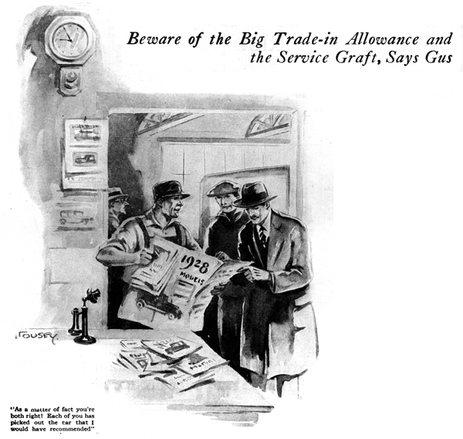
"What's the matter with your car?" Gus Wilson asked his partner Joe Clark as the latter arrived this morning on foot. "I could answer a lot easier if you'd ask what isn't the matter with it," Joe grumbled as he hung his hat and overcoat on the door of the tiny office in the Model Garage. "I'm afraid the time has come when I've got to dig into the old bank roll and get me a new car."
"It's about time," Gus chuckled. "I've been wondering how much longer you were going to keep that old wreck."
"I could fix it up easy enough, if I wanted to," retorted Joe.
"Sure you could," Gus agreed. "No car ever gets so old that it can't be put in good running order - if you're willing to spend money; but there comes a time when its parts begin to lay down one after another and it doesn't pay to try to fix it. You've had your money's worth out of your car; now you'd better turn it over to the junk man. What kind of a car are you thinking of buying?"
"Whoever will give me the largest allowance on the old bus gets my order," replied Joe. "You say all cars are almost alike, so I'm going to shop around and see how much money I can save."
"And probably get stung doing it," predicted Gus. "I declare, Joe, you certainly don't show much sense sometimes. When did I ever say that all cars are exactly alike? What I said was that any modern car will give good service - and that's all I meant. Some cars are much better buys from a price point of view than others. And you'll generally get the biggest allowance offers from the dealers who sell the worst bargains.
"The dealer who has the hardest time selling his cars usually is the most liberal with trade-in allowances. Besides some manufacturers put a fictitious list price on their models just so the dealers can make bigger allowances. The thing to do is pick your car first and then find the dealer who'll give you the best allowance. Hello! What's that? - "
Gus broke off suddenly as the front door of the garage closed with a violent sound. "I tell you you're cuckoo!" growled an angry voice from the shop. "That car's a lemon if there ever was one!"
"G'wiz! You don't know what you're talking about!" came another equally heated voice.
"More grief!" whispered Gus, after peeping out the office window. "It's my cousin from up Winchester way. Another morning shot to pieces! Hello folks!" he called out as he snapped the last buckle on his overalls and stepped out into view. "What's all the row about?"
"Well, you see it's this way, Gus," began one of the two as he fished a bundle of automobile catalogues and circular out of his pocket. "Ben and I have decided to buy new cars this spring and I've been trying to get Ben to take my advice but he's so darn pig-headed he won't do it."
"Pig-headed, am I!" exclaimed Ben. "Maybe I am - because I know I'm right –but your dome sure is made of solid concrete - "
"That's no way to start a visit," interrupted Gus, "but I suppose the argument is what bought you here, so let's go in the office and get it settled.
"I gather," he continued when they had settled themselves around the table with the literature spread out before them, "that you've each chosen a different make. What cars are you thinking of buying?"
"I could pretty near have guessed right on both of you," Gus smiled after they had belligerently announced their choices. "You still working in the test room at the Manly works, Hank" he inquired, turning to the man who was wearing the flannel shirt.
"You bet," Hank replied, "I'm foreman now." "And you, Ben, I suppose, are still the leading legal light of Winchester?" "I'm still practicing law," Ben corrected him.
"Have it your own way," grinned Gus. "Anyway, each of you is an expert in one particular line. But you've driven all the way down here just to get my opinion on a line that neither of you is expert in - automobiles.
"The car you've picked, Hank, is fast. It's got lots of pep on the hills. It doesn't ride any too easy unless you fit it with shock absorbers and keep them adjusted just right. The motor will give good service if it gets just the proper care and there are a number of other things about the car that require touching up every now and then if you want good service. But, balancing the advantages against the disadvantages, I'd say it was a mighty fine car."
Hank grinned triumphantly, "Told you so!" he snickered.
"On the other hand," Gus went on, "the car you're going to buy, Ben, is not so good. It isn't much as a hill climber. It's sluggish on the pick-up. It needs overhauling perhaps a little more often then other cars in the same price class. And it needs quite a lot of servicing. Judged strictly on merits as a car, I'd say it was inferior to a number of others I could name."
"Humph!" muttered Ben. "Then I suppose you'll say I ought to follow Hank's advice eh?" "Not at all, said Gus. "The quality of a car - any car - is only a part of the story - and sometimes a mighty small part at that."
"As a matter of fact you fellows could have saved yourselves the trip down here. You're both right! Each of you has picked out the car that I could have recommended."
"I don't see how that can be," argued Hank. "You've practically told Ben he's picked a lemon and yet you tell him to buy it. What's the big idea?"
"Well," said Gus, "the point is, I know you two birds. You're a bug on machinery, Hank. You'd take care of a car as well there wouldn't be a chance for any real trouble and if you do have a breakdown you'll fix it yourself. Chances are after you've done bought your car you'll never go near the dealer again."
"Now, Ben, you're a lawyer. You don't give a whang-doodle about anything mechanical. You don't know what goes on under the hood of a car and you probably don't care. All you want is a good looking bus that will stay on the job and get you from place to place without worry."
"But why shouldn't I take Hank's advice?" questioned Ben.
"I've good reason. Ben," Gus replied. "The dealer who handles the car Hank favors is, as I happen to know, a slick article. He'd stick you for a wad of money every time you poked your nose in his door looking for a little service. That doesn't make the slightest difference to Hank, because he'll never have occasion to go near him. The second reason is that the dealer who handles the car you've picked out would sooner go out of business than take advantage of anybody. Maybe his car isn't quite so good, but he'll keep it on the job for you and that's what counts!"
"When you're buying a car," Gus summed up, "don't let a high trade-in offer stampede you into buying a car you really don't want. Pick your car solely on the best of mechanical merit if you expect to do all the work on it yourself; but if you expect to let somebody else do the work for you, choose the car that is represented by a dealer who is older and willing to give you better service."
END

