January 1928

DEATH HIDES IN YOUR GARAGE
by Martin Bunn
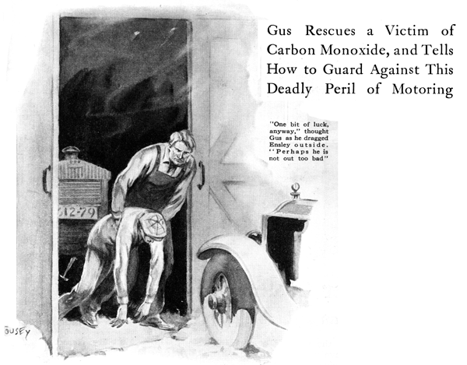
"Hey, Joe!" Gus Wilson shouted to his partner in the Model Garage. "What do you think this is, a cold storage plant? My fingers are so cold I can't tell whether I've got a hold of monkey wrench or a screwdriver! It's your turn to manicure the furnace this week. Get busy before I turn into a lump of ice."
Joe poked his head out of the office. "Gosh!" he exclaimed. "It sure is cold out here. I'll tend to it right away." And he headed for the heating plant in the pitlike cellar.
The comforting rumble of the furnace grate reassured Gus, and he picked up his tools to resume work, but just then the telephone rang insistently.
"Drat it!" the veteran motor car mechanic grumbled as he clamped a greasy hand around the receiver and pressed it to his ear.
"Hello, is that you, Gus?" inquired a faint voice.
"Right here, John, what can I do for you this cold morning?" said Gus, his frown giving way to a smile as he recognized the voice of John Ensley, a young fellow who had recently started out for himself in the trucking business. Ensley apparently was speaking from his "office," which consisted of a broken-down desk and a telephone instrument in one corner of his tiny garage.
"There's something wrong with my engine, Gus," Ensley explained. "I had an awful time getting it started and now after it's been run only a little while it's boiling to beat the band. I thought maybe the water was frozen at the bottom of the radiator, so I've been running it to get it thawed out, but I just felt the radiator and it's fairly warm right down to the bottom, but it still keeps boiling. What - would you -er-"
The voice trailed off as though the speaker were moving away from the phone, and Gus could only hear the gentle rumbling of the truck motor.
Gus waited a few moments. "Hello!" he called, but there was no answer. A startled expression suddenly came over his face.
"By Golly!" he gasped. It's got him!" And with that cryptic remark Gus slammed the receiver into the hook and tore out of the office as though seven devils were after him.
"Door stuck again?" Joe Clark called casually. He had come up from the furnace in time to see Gus struggling to open the frozen door.
"Shut up and help me," Gus snarled. Their combined weight broke the ice and Gus dashed quickly toward his car.
"But what's all the hurry about?" Joe demanded. Gus's reply, if he made any, was drowned in the roar of the motor. He shoved the lever into first and a shower of sparks flew from the tire chains on the concrete floor. The car shot out of the garage, skidded on the ice, straightened out, and roared down the road.
Joe watched the departing car in amazement. "Holy smoke!" he gasped. "The old boy's certainly gone nutty."
The distance to Ensley's was close to three miles over a rutty ice-covered road. In four minutes, Gus roared into Ensley's driveway, slammed on the emergency brake, leaped from his car before it stopped sliding and raced toward the closed garage door.
He swung it open at once and a vast cloud of blue vapor welled out behind it.
Gus darted around the rear of the big truck and there, slumped down beside the old desk, lay Ensley unconscious. Gus's hunch had been right.
"One bit of luck anyway." Thought Gus as he dragged Ensley outside. "His face was right close to that hole in the wall and maybe the air coming in diluted the carbon monoxide from the exhaust of the truck enough so that he isn't knocked out too bad."
Evidently no one was home in Ensley's house, for there was no response to Gus's call for help, but he was able to carry the victim through the kitchen door. He placed him on a couch beside an open window and proceeded to apply the usual first aid for suffocation.
Perspiration stood on Gus's forehead before Ensley stirred feebly and opened his eyes. "Where am I? What're you doing here?" he murmured.
"You came darn near not being here at all, you crazy dumb-bell!" snorted Gus. "You haven't any more sense than a billy goat! Don't you know better than to run a motor with the garage doors closed? You stay quiet now while I go out and shut off that truck motor."
"Was it still boiling?" Ensley asked weakly when Gus returned.
"Like a teakettle." Gus replied. "What else do you expect when all the blades have been busted off the water pump? The pump must have frozen last night, and when you started it, the ice just naturally sheared off the blades.
"If you feel up to the mark this afternoon, run down to the garage and I'll put in a new pump impeller. Got a lot of work to do - I'll be running along back to the garage now."
END

