August 1928

SPARE PARTS YOU SHOULD CARRY
by Martin Bunn
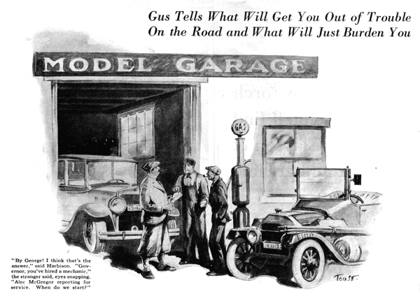
"Nuts," observed Joe Clark as he came out of the office with a letter in his hand, "are the life of the auto business."
Gus Wilson, his partner is the Model Garage, poked his head out from under the car he was repairing.
"What kind?" he grumbled. "The ones that hold the cars together or the ones that ride in 'em?"
"The ones that ride, of course," laughed Joe. "How's a letter from the worst auto nut in this section. Can you guess who?"
"Easy!" Gus grunted, "That'll be Samuel P. Harbison - old "Spare Parts' Harbison! What's eating him now?" "He's going on a long tour," Joe began, "and - "
"Don't tell me any more," interrupted Gus. "I can guess the rest, too. He's worked up a list of spare parts as long as your arms and wants to drop in and waste my time arguing about what else to take."
And Gus was right, for in a few minutes Harbison appeared. His list was not so long as Gus had predicted, but it was long enough and Gus thoughtfully nodded his head in approval as he checked over the first few items.'
"Spark plugs, sizzle patches, blow out shoes, friction tape, insulated wire, headlights bulbs, tail light bulbs." Gus paused. "Those ought to be in the tool box of every car that goes touring," he observed "Now let's see what else you are going to take. 'Spark coil with condenser' - there's a spare part nobody carries, and yet when either the condenser or coil goes bad, there you stay until you get a new part or go hours on the end of a tow line.
"Fan belt, extra piston, piston rings, can of water, can of oil, can of gas,' "Gus read. "Holy jumping spark plugs!" he gasped. "Where on earth are you going - across the Sahara Desert?"
"Not quite that far, Gus "replied Harbison a trifle sheepishly, "Only up around New England and then out to Buffalo by way of Albany and Schenectady."
"You couldn't get more than a few miles from a gasoline station on that route if you tried," snorted Gus. "I guess, Mr. Harbison, you're off on the wrong foot. There's no sense trying to carry a spare for every part that might break. You might just as well tow a spare car."
"But I hate to take a chance," protested Harbison.
"Every time you climb into your car, you take a chance anyway," scoffed Gus. "And besides, what good would parts like a connecting rod and timing chain do you? If they break while the motor is running there's going to be a lot of other damage. Very likely the crank case and the piston will get smashed if the connecting rod lets go, and the timing chain case plus a couple of sprockets normally are ruined when the timing chain parts company.
"What you ought to do," continued Gus, pausing to glance at an ancient car that had drawn up in front of the garage, "is to forget about the breakdown that might happen once in a million times and concentrate on the troubles that happen a lot oftener, particularly the ones that there's no way of fixing up enough to get to the nearest service station."
"Sounds logical enough to you, Gus," sighed Harbison. "I must be a queer case. I'm keen on keeping the car in perfect mechanical condition and I haven't the mechanical ability to do it. I know the theory of the thing, but my fingers are all thumbs. I can't even change a spark plug without barking my knuckles."
While Harbison had been talking the owner of the ancient bus had quietly strolled over.
"Howdy folks," he began. "any chance for a real good safe mechanic to pick up a few dollars around here?"
"That depends on what you can do," said Gus as his keen eyes studied the man.
"I can fix anything that rolls on wheels," he asserted with a confident grin.
"All right," Gus replied and pointed to Harbison's car. "Take the carburetor out and close it."
Harbison started forward to protest, but Gus motioned him to watch what happened.
The wiry little mechanic opened his roll of tools on the running board of Harbison's car and Gus noted with satisfaction that the few tools it contained were high grade and in perfect shape. The man started the motor and tried in every way to make the carburetor misbehave, but he did not succeed.
"No job, chief," he said. "The carburetor isn't dirty, so there's no sense cleaning it. Got anything else?"
"Humph," grunted Gus sarcastically, "All right, let it go. The party that owns that car is going on a long trip." Check over the tools and what spare parts he has and see if he needs anything."
The newcomer set to at once and Harbison turned to Gus, puzzled, "Why all the funny business with my car" he asked.
"Keep your shirt on," advised Gus, "I've got an idea. This fellow is a wandering auto mechanic, but he's as neat as a pin and his own car appears to be mighty well kept.
"Meanwhile," Gus continued, "remember that the most frequent breakdown on the road is a puncture or a blow-out. If your tires are in good shape the chances are almost a million to one you won't have more than a single flat tire at a time, and a five-minute tube vulcanizing outfit in the tool kit is handy after the day's run to fix the puncture or blowout.
"After the tires, the ignition system is where you have the most trouble. Ignition breakdowns are a cinch to fix once you find 'em - the trick is to find 'em. Anyway you're carrying a spare end and condenser, plus wire and spark plugs. You ought to be able to patch up most any breakdown at least enough to get to the nearest service station."
"There you go again," grumbled Harbison, "something that I've got a whole lot of mechancal ingenuity. I haven't. If I can't take along enough parts so I can just put in whatever breaks, I'll be out of luck and that's all there is to it." The wandering mechanic had by this time poked his nose into every compartment of Harbison's car.
"Say, chief," he drawled, "the owner of that car don't need a thing. He's got everything but a tow rope."
"What do you say to that, Mr. Harbison?" asked Gus, turning to the wealthy motorist. "I don't see that it proves anything," Harbison replied stubbornly. "Just because I've got enough parts and tools to suit a mechanic is no proof I've got enough for myself, considering that I'm not a mechanic."
"There," said Gus, "why not add a mechanic, store that's what you need most?"
"Why - er - by George! I believe that's the answer," said Harbison, brightening. "Funny I didn't think of it before."
"Governor, you've hired a mechanic!" the stranger said, his black eyes snapping under their bushy brows, "Alex McGregor reporting for service! When do we start?"
Harbison looked at Gus uncertainly, "I'll vouch for him," laughed the latter. "He uses his head and he's honest. He finds out what's the matter before he starts to fix it and he doesn't fake jobs for himself."
"On that bank, you're hired, Alex," agreed Harbison, "Gus, I've a notion that's what you intended all along!"
END

