November 1927
DRIVING-DOZING-DEATH!

by Martin Bunn
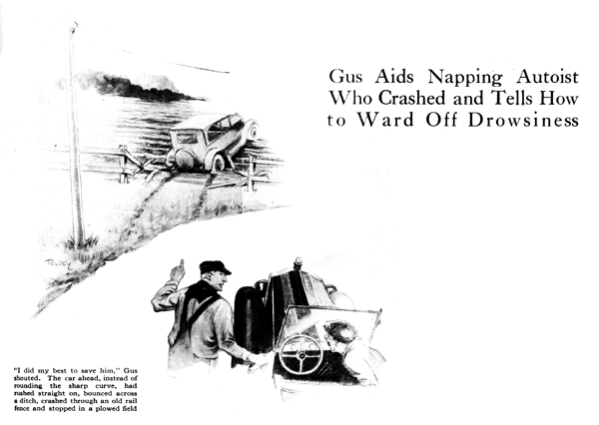
Bill," said Gus Wilson to the youngster who did odd jobs around the Model Garage, "Joe and I have to go down to the bank this morning. If anybody wants any repair work done tell 'em we'll be back in an hour.
"Come on, Joe, let's go," the veteran auto mechanic called to his partner as he climbed into his car and stepped on the starter pedal.
It was still quite early and only one car was in sight, far ahead, down the smooth concrete road.
"Gee!" exclaimed Joe. "What a swell day this is! Always plenty of pep in the air this time of year. Show me what the old bus can do!"
"Just spoiling for trouble, aren't you," growled Gus with a twinkle in his eye. "All right. Here goes - hold on to your hat!"
He slouched down in his seat and took a firm, two-fisted grip on the steering wheel. The motor suddenly broke out in a staccato, singing roar and the wind began to whistle past their ears. The car ahead was squarely in the middle of the road, which, while smooth enough, was none too wide. But the driver refused to pull over so Gus had to take his foot off the accelerator.
"That duck must be deaf," snorted Joe, "Or maybe he's just one of those confounded road hogs. That's right, keep tooting at him, "he shouted as Gus suddenly sat up straight with his gaze intent on the driver ahead and working the horn as if his life depended on it.
"For the love of Pete!" Gus shouted despairingly. "He's going to smash on this next turn sure as fate! I've done my best to save him. There he goes!"
The car ahead, instead of rounding the sharp curve they were approaching, kept straight ahead, bounced across a shallow ditch, crashed through an old rail fence and was now coming to a stop over the ridges of a fresh-plowed field.
As soon as Gus got his car safely parked beside the road, he and Joe ran toward the other car. The driver stood gazing at it bewildered.
"What happened? Who hit me?" he muttered.
Gus reached over and twisted the steering wheel back and forth. The front wheels responded perfectly.
"You ought to thank your lucky stars it wasn't any worse," he rasped. "Don't you know better than to fall asleep while you're driving a car?"
"Asleep?" gasped the victim. "Why I didn't think it was possible for anyone driving all night and it was pretty cold. This morning the sun warmed me and I did begin to feel drowsy, but I only shut my eyes for a second or two to rest them."
"Humph!" Gus grunted. "Pretty long second. You must have dropped off down the road quite a piece, because you paid no attention to my horn. If you'd slammed into that telegraph pole I'd probably be telephoning the hospital or maybe the coroner right now!"
"Gosh, it sure was a close shave," the driver mumbled tremblingly as Gus continued examining the car.
"Nothing important is damaged as far as I can see," Gus announced at length.
"Of course your headlights are smashed up but I think the running gear is all right. I'll see if I can get it back on the road."
He pressed the starter pedal and the motor responded at once. Throwing it into reverse he let in the clutch very gently and the car slowly started backward. As the front wheels climbed a ridge left by the plow, there was a sharp snap and the front of the car, on the driver's side, sagged.
"That last hump must have been the straw that broke the camel's back," observed Gus as he climbed out and went around to the front of the car. "Your luck is still with you, though; the spring is broken off behind the axle pad, so it won't be much trouble to brace it up. We'll jack up the frame far enough to lash a couple of pieces of that broken fence rail in between the axle and the frame. Then you can drive it back to the Model Garage. I think we've got a spring in stock that will fit."
"Why should it be any easier to fix because it's broken back of the axle instead of in front?" the owner inquired.
"The axle is held in line by the front half of the spring," replied Gus, "and if it breaks at that point, there is nothing to keep it from swinging back under the car as far as the shackle at the rear end of the spring will let it. Of course you can lash the axle to the frame fore and aft with rope to keep it in place, but it's a lot more trouble.
"Now," Gus continued after he had propped up the axle, "do you think you can stay awake long enough to drive about a mile up the road to the Model Garage? You'd better take a nap until we can get back and fix up that spring."
"I hate to lose the time," protested the owner, but he agreed, climbed in and drove off.
"How did you know he was asleep?"
Joe asked as the garage-men resumed their interrupted trip.
"I didn't know positively," answered Gus, "but it seemed funny that he didn't pay any attention to my horn.
Some fellows are always looking for a race and hate to let you pass them, but I knew he wasn't in that class because he didn't speed up and he didn't look around, as he naturally would, to see what kind of a car was coming up behind. And besides his head was so far forward that it looked queer."
"What gets me," observed Joe wonderingly, "is how you had time to reason out all that Sherlock Holmes stuff. Why, it couldn't have been more than a few seconds from the time you first blew your horn till the crash. How did you dope it out so quick?"
The veteran smiled. "Blessed if I know," he said, "unless it's because I've been driving so long. Quick thinking and being able to figure out the right thing to do in an emergency are things that you can get only by a whole lot of driving. No instructor can teach it to you.
And as for that sleep stuff, I'm always on the watch for it. I nearly got killed myself years ago by dozing off while driving.
"Of course there's no way of getting accurate figures, but most people have no idea what a large number of accidents are due to the driver falling asleep. Most of the fellows who fall asleep while they're driving and get into an accident either don't realize what happened or if they do they are ashamed to admit it.
"Sleep is a mighty queer business anyway," Gus went on. "Sometimes when you want to go to sleep you can't, and then when you ought not to, you do."
"But why," asked Joe, "should a fellow who has trouble in getting to sleep even when he's in bed be likely to go to sleep when he's driving a car?"
"I didn't say that," replied Gus. "The fact that he doesn't sleep well nights has nothing to do with it. It all depends on how easily he is affected by monotonous sights and sounds.
When you're driving along a straight road for miles and miles the steady hum of the motor combined with the comfortable position and the lack of physical motion seems to lull your senses into a drowsy state. Of course in heavy traffic where you are constantly forced to apply the brake, shift gears and steer the car, you may get tired but you won't get sleepy.
"If you want to find out how hard it is to keep awake some time," Gus went on, "just ask one of the fellows who did sentry duty during the World War. Even the certainty of facing a firing squad in the morning if they fell asleep wasn't enough to keep some of them awake, and if I remember correctly Charlie Lindbergh claimed that he was more afraid of going to sleep than anything else on his hop across the ocean."
Back at the garage an hour later, they found the victim of the sleep accident curled up on the front seat, snoring peacefully.
"Might as well let him snooze while we work," Gus suggested, but the pounding soon woke the sleeper and he climbed out to watch.
"You can bet I won't go to sleep at the wheel again," he said.
"How are you going to prevent it - by giving up driving?" Gus asked as he pulled the end of the new spring into line.
"Certainly not!" replied the owner peevishly, "I haven't got cold feet yet, I'll just remember not to go sleep, that's all."
"Banana oil!" snorted Gus. "Will power will help, of course, but it's a whole lot better to adopt some definite way of overcoming the sleepiness. About the best I know of is one that a salesman friend of mind works when that sleepy feeling creeps over him. He pulls up at the side of the road out of the way of the traffic and deliberately goes to sleep for ten or fifteen minutes.
"Then I know another fellow that gets out and runs up and down the road a bit. The exercise, he says, starts the blood circulating and seems to break the hypnotic spell brought on by the steady hum of the motor."
"If you're going to stop anyway," suggested Joe, " why not park at a hot dog stand and eat one while you're waking up again?"
"Humph!" growled Gus. "That ought to work - indigestion will keep anybody awake!"
END

