May 1927

ARE YOU A THROTTLE HOPPER?

by Martin Bunn
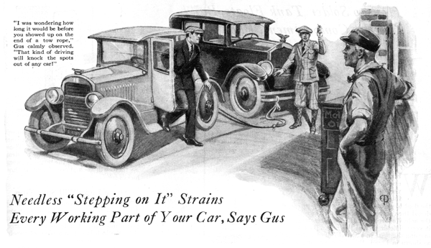
Percival Stebbins jammed the throttle down to the floorboards and vigorously thumbed the horn button preparatory to making his usual wild dash up Marley Hill. He waved his hand disdainfully to the driver of a spindly little coupe as he flashed by.
At each curve of the steep and dangerous grade, Stebbins snapped his foot off the throttle pedal just in time to lurch around the turn without skidding off the road, and then down would go the throttle again almost before the big sedan had time to straighten out.
The husky chap at the wheel of the coupe dubiously shook his head.
"That little guy is going to get busted wide open taking chances like that," he muttered to himself. "And like as not when a piece of the landscape hands him a swift left hook, he'll pass out cold - maybe with two or three poor birds to keep him company."
O'Rourke, known to his friends as "Spuds," continued up the hill at a reasonable pace, his huge hands manipulating the flimsy steering wheel with considerable skill. Almost at the top he came upon Stebbins parked by the roadside.
"What's the matter, kid, are you down for the count?" he called.
"It looks that way," admitted Stebbins glumly, as he closed the hood. "She was coming up in fine shape, then I heard something snap and the motor began to roar, but the car slowed down."
"Must of got hit below the belt somewheres," suggested
Spuds. "Maybe it's a case of bad wind. Them big guys is always like that. I've put a lot of big stiffs to sleep in my time, myself, on account of no staying power."
Stebbins ruffled up like a wet hen, "This is a good car, I want you to understand. It's got lots of staying power, only something's gone wrong, that's all!"
"I'll say it has," Spuds grinned. "It'll stay right here unless you do something about it. Maybe a dash of water'll put some steam in the old boy again, and a little fanning wouldn't do any harm. Seems kind of warm to me. Got a tow rope? Gus's joint is only a couple of rounds from here - I'll tow you."
"What - with that?" gasped Stebbins. "Why you couldn't budge this boat!"
"You gimme a tow rope and I'll show you that a lightweight can bring home the bacon if he's trained right," Spuds suggested good-humoredly.
Stebbins shrugged his thin shoulders. "I never had any use for a tow rope before," he said.
"Get out your chains, then. Maybe I got something to piece out with." Spuds opened the back compartment of his car and fished out some short lengths of sash cord which he proceeded to tie on the ends of the tire chains. Stebbins was still attempting to tie a knot when Spuds had finished lashing the other end to his rear bumper.
"What are you trying to tie it there for?" Spuds demanded. "You can't tow a car by the radiator cap, you chump! Tie it on the bumper. Now you keep your foot handy to the brake and watch out you don't go into a clinch with the back of this bus if I have to stop sudden."
Spuds, being an ex-pugilist, knew when to hit hard and when to pull his blows, and consequently he eased his car ahead until the slack was almost out of the rope. Then he stepped on it a bit, and the slight jerk was sufficient to start the big car moving.
Gus Wilson was leaning against the door of the Model Garage as they drove up, waiting for Joe Clark, his partner, to return with some parts for a job he was working on.
"I was wondering how long it would be before you showed up on the end of a tow rope." Gus calmly observed. "Is that so!" snapped Stebbins. "May I ask how you doped that out?"
"Sure," Gus replied. "You're what I call a 'throttle hopper,' a driver who takes a lot of pleasure in stepping on it to see how fast the car will pick up, and then lets the pedal clear up when the car gets going too fast. Sort of a feast or famine business all the time. That kind of driving will knock the spots out of any car."
"Looks to me as though you've broken the propeller shaft," he went on, inspecting the car. "Twisted it right off. It's a shame, too, because when parts like that break it's sure proof that you've been treating the bus rough. You can be glad it wasn't the crankshaft of the motor or something else that would run to a lot of money."
"You ought to go easy on the throttle the way I do," Spuds chimed in. "There ain't no sense in socking the gas to it. Ease it on gentlelike and give the motor a chance to get the car going. Light footwork on the gas and brake pays big unless your aiming to make Gus, here, rich. Me, I handle a car like it was a lightweight in the ring with me, giving a sparring exhibition at one of them charity affairs."
"Hold on a minute," Gus interrupted. "It's a god thing for you that the drive shaft let go when it did. If it hadn't, you'd probably have gone right off the road at the next curve. Just look at this!"
Stebbins and Spuds went around to the front where Gus was examining the steering gear.
"One more yank on the steering wheel while the car was traveling fast would have snapped the ball right out of the socket in the drag link. Look - the cotter pin's out and the adjusting nut has worked loose. If that had happened, you'd have lost control of the car completely."
"I noticed that there seemed to be a lot of play in the steering wheel," said Stebbins. "I was going to speak to you about it the next time I stopped in here."
"It's lucky for you there is a next time," grumbled Gus. "It's all right to take a chance and run a car with a tire that is near blowing out if you drive slow, and there's a lot of other things that can break on a car without doing any more damage than to leave you stranded. But if anything goes wrong with the steering gear and you don't get all smashed up, you're luckier than most."
Gus was warming to his subject. "And the steering gear isn't the only part that suffers when you're a throttle hoper. The differential gears will show a lot of wear from using too much power while you're going around curves. The universal joints, I'll bet, are worn loose, and loose universal joints put just so much extra strain on the drive shaft.
Stebbins smiled sheepishly. "Maybe you're right," he admitted. "Hereafter I'm going to treat this car like a crate of eggs - unless somebody tries to pass me on a hill!"
END

