February 1927

WHAT'S WRONG WITH MARKIN'S CAR?

by Martin Bunn

Even New Cars May Have Mysterious Troubles – Can you Tell?
Here's Another Chance to Test Your Auto Knowledge
and Win a Cash Prize .
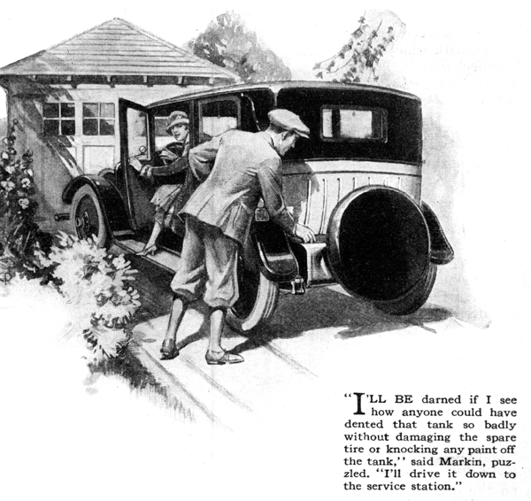
"There!" said Mrs. Markin triumphantly as she pulled on the emergency brake and shut off the ignition. "Your nasty remarks about women drivers don't apply to me at any rate. I didn't have a single accident all day!"
Frank Markin, waiting anxiously for his wife's return with the brand-new car, breathed a sigh of relief as she turned into the driveway beside the house.
"Good work, Mary," he admitted. "Are you sure you didn't so much as scrape fenders with anybody?"
He walked around the car, inspecting it with a critical eye and then stopped suddenly with his gaze riveted on the gasoline tank. "So you didn't have any accidents?" he exclaimed. "Then what put that big dent in the gasoline tank? You're not going to tell me it dented itself, I hope."
"Oh!" gasped Mary, "I didn't do that! I know I didn't back into anybody, and I'm sure nobody ran into me. It must have been done while I was in the stores."
"Humph!" grunted Markin, obviously puzzled. "I'll be darned if I see how anyone could have dented that tank so badly without damaging the spare tire or knocking any paint off the tank.
And there doesn't seem to be any particular spot on the tank that looks as if it had been hit. I'll drive it down to the service station.
"The foreman of the service station, after one glance at the apparently dented tank, inspected it with unusual care. "I know what did that, but it's the first time I've seen it happen in a dog's age," he finally announced. Let's have a look at the filler cap."
He unscrewed the cap on the gasoline tank and examined it minutely.
"The vent hole wasn't drilled all the way through," he explained, "and the air couldn't get in to replace the gasoline that was being drawn out by the vacuum in the manifold. There must have been a little, leaking in around the threads so that the vacuum created in the gasoline tank was relieved between the fillings of the vacuum tank, otherwise the motor would have stalled. As it was, the vacuum ran high enough so that the air pressure outside pushed in the side of the tank. Run her in and we'll fit a new tank. It's our fault, of course."
Markin did as directed, relieved to know that it wasn't going to cost him anything. "It wasn't a smash-up, after all," he told his wife cheerfully when he reached home.
Their plans for the evening included dinner at their friends, the Barkers. They had promised to be there before seven, and it was nearly six now. So they started out immediately. Markin drove slowly and carefully for five miles, until the snail's pace began to make Mrs. Markin fidgety.
"If you keep poking along like this we'll never get there," she worried.
"All right then, we won't!" retorted Markin. "I'm not going to ruin the car by driving it fast. You can bet on that. Lots of cars are spoiled just by driving hard the first few hundred miles, I want you to understand that I know how to handle an automobile," he finished loftily.
But hardly had he finished speaking when the regular explosions of the motor stopped completely and the car coasted to a standstill.
"Now you're giving the motor a rest so it won't be overstrained, I suppose," Mrs. Markin couldn't resist remarking as her husband climbed out and raised the hood.
"I am not," snapped Markin. "It quit on me, and from the sudden way that motor ceased firing it must be a wire that's come loose somewhere. Don't worry, I'll find it in a jiffy."
However, a casual inspection failed to reveal any disconnected wires, so Markin got out the new tool kit and systematically applied the pliers to one connection after another until he had tested them all. Every one appeared to be perfectly tight. "That's funny," he said. "There's nothing wrong with the connections as far as I can see. I wonder if something has happened to the timer? Ah, now I've found it. The spring that holds the contacts together is broken. And I haven't a spare one."
"Standing there looking glum won't fix it," suggested Mrs. Markin.
"Here, take this safety pin and see if you can't hold it together somehow."
"This is an automobile - not the baby's clothes," growled her husband. "Still I might be able to head up a spring that will work till I can get a new one. Give it to me and I'll see what I can do."
He worked steadily a few minutes, then; "I've got it!" he exclaimed jubilantly.
The motor started at once when he stepped on the self-starter, and ran smoothly, although it did miss a bit when he speeded up to twenty-five miles an hour.
Auto troubles seem to run in streaks. The Markins must have been in the midst of a particularly unlucky streak, for they had gone only a few miles when the motor abruptly stopped.
"I suppose that confounded safety pin has slipped," he grumbled as he raised the hood. "But it seems to still on the job. The contact works fine. Turn on the ignition switch again while I see if the current is going through the contacts all right. Lots of juice here, apparently," he went on. "It even makes a fat spark at the contacts. The distributor looks perfect, and certainly all the spark plugs couldn't have gone dead at exactly the same time. I guess it must be in the carburetor this time - maybe a chunk of dirt stuck in the needle valve."
Markin cleaned out the carburetor, taking care to do a thoroughly complete job, for he had experienced a somewhat similar trouble with his old car. It did no good; the motor refused to fire. He tried the compression and found it excellent. Then in desperation he went over the ignition system again, including the removal and inspection of each spark plug.
"Ouch!" he exclaimed involuntarily as he got a severe shock. He had carelessly held the distributor in one hand, working the contact points with the other. "There's some kick in that spark coil - I felt it shoot clear up my arm!"
Finally he threw down his tools in disgust. "Aw, rate!" he grunted. "You wait here while I go telephone for help...
END

