December 1927

"YOUR CAR NEED NEVER FREEZE"

by Martin Bunn
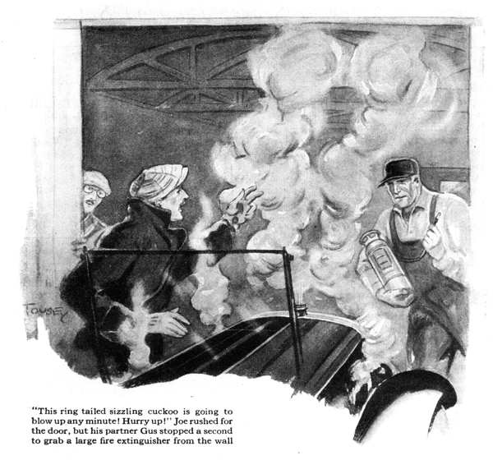
"Got plenty of alcohol in your radiator?" Joe Clark inquired of his customer as he cranked the gasoline pump in front of the Model Garage. "Pretty cold today - better let me test it, anyway."
"You keep away from that radiator," Tom Madden objected. "No more expensive alcohol for me! I've got a trick worth two of that. You won't see me wasting any more money on alcohol for any automobile radiator. And what I'm using won't boil away or evaporate like alcohol."
Gus Wilson, Joe's partner in the Model Garage, drove up in his car just in time to overhear Madden's statement.
"So you've worked out something real new," said the veteran auto mechanic. "How long have you been using it?"
"Nearly two weeks now, replied Madden. "It sure works fine. Maybe I'll tell you what it is some day if you're real good!" he called back as he drove off.
Joe was impressed. "Must be good if he can get by with it in this weather," he exclaimed. "It's been cold enough to freeze a brass monkey all this week. What do you suppose it is?"
"I don't suppose - I know - didn't I smell it?" Gus grunted. "He only thinks he's found something new. I'll bet he'll be singing out of the other side of his mouth before long!"
"But what is he using?" Joe asked as Gus opened the big garage doors.
"Humph!" growled Gus, "it's a good thing you aren't as dumb as you seem sometimes. You must have a cold if you couldn't smell what he had in the radiator."
It was two days later that Gus, at work on a car, and Joe, engaged on the books in the office, were startled by a tremendous clatter outside the garage followed by a flow of distinctly forceful language.
"Hey! Open your dod-gasted door and let me in, will you?" roared an impatient voice. "This ring-tailed sizzling cuckoo is going to blow up any minute! Hurry up!"
Joe rushed for the door, but Gus stopped a second to grab a large fire extinguisher from the wall.
"It's Madden back again," muttered Gus, and as Joe swung the door open Madden was dimly visible through a cloud of blue smoke that smelled over-poweringly of kerosene. Just then the motor gave a peculiar squeaking grunt and stalled.
"That marvelous new antifreeze solution isn't so good after all, is it?" observed Gus with a sarcastic smile, as he replaced the fire extinguisher, now that the motor had stopped and the danger of a fire was past.
"You said it," admitted Madden glumly. "Kerosene may be good for lamps, but it sure is punk as a radiator filler in place of water. Just look at this car! The upper hose connection busted and now the dinged stuff is all over the place. What made it work so rotten all of a sudden? It's worked fine up to now."
"You must have been doing some hill climbing," suggested Gus, and the other nodded in assent.
"Kerosene is no good to cool a motor when it's really working hard," said Gus. "It doesn't carry away the heat as water does. Besides, kerosene rots rubber double quick - especially when it's hot. The boiling point of kerosene is way higher than is good for the ordinary auto motor. Kerosene is all right if you only drive slow for short trips. Lots of fellows use it if they only drive down to the station and back or to the factory where they work - sort of light taxi service you might say."
"Doesn't it rot the hose connections when you use it like that?" Madden asked.
"Sure it does," replied Gus, "but if you put in new hose connections right at the beginning of winter and smear the inside of the hose with thick shellac and leave the radiator empty overnight so the shellac gets a chance to set, usually the hose connections will last out the winter.
"You want to remember not to use any radiator cover with kerosene in the radiator. All the cooling surface you've got is none too much, because the kerosene doesn't soak up the heat from the cylinders and carry it to the radiator more than about half as well as water."
"Don't worry!" interrupted Madden. "No more kerosene for me! Get busy and fix whatever made the motor stick and put in new hose connections. Then I'll be a good little boy and fill it up with alcohol as Joe suggested."
"Fixing the motor may be easier than you think," Gus said with a smile. He stepped in the car and the motor turned over and started at the first pressure on the starter pedal.
"Well I'll be blasted!" gasped Madden. "What did you do, hypnotize it, Gus?"
"I didn't have to," Gus answered as he shut off the motor and rummaged under the front seat for the starting crank. He turned the motor over several times to test the compression and then put the crank away."
"When a motor sticks like that from overheating," he explained, "It's because the piston has kept expanding until it won't slide up and down in the cylinder any more. Generally the cylinder walls get burned a bit but if the motor is just running idle as yours was, as soon as the pistons cool off they'll slide again, although sometimes they practically weld themselves to the cylinder walls and you're in for a fat repair bill.
"The compression seems all right," Gus continued, "so it's a safe bet that none of the rings broke, and if the burned streaks don't start it to pumping oil and fouling the plugs no damage has been done."
"That's something to be thankful for," agreed Madden, "but all the same I hate to go back to alcohol. It's such a blamed nuisance. Isn't there something else I can use to keep the radiator from freezing? You never know how much alcohol you've got. Every time the motor gets good and hot going up a hill a lot of alcohol boils away and the same thing happens even on level going whenever there's a warm day in winter."
"That's true enough," Gus agreed. "Of course alcohol has its disadvantages. The low boiling point is one of them. On the other hand it is much better than the calcium chloride preparations because alcohol doesn't cause any corrosion, but why don't you use glycerine? I know it costs a lot more to fill your radiator with the proper mixture of glycerine and water when you start using it, but it really is cheaper in the end, because you can use the same glycerine year after year if you're careful. The glycerine in my radiator is three years old."
"Three years old!" exclaimed Madden I great surprise. "But doesn't it evaporate or get sour or something? If the motor gets hot doesn't it boil away?"
"You couldn't lose a drop by evaporation or boiling if you wanted to, "Gus replied.
"The only thing you've got to be mighty careful about is leaks in the cooling system.
It wouldn't pay to use glycerine if the hose connections dribbled water or the pump packing gland leaked a drop now and then. You've got to have them absolutely tight. Glycerine doesn't evaporate at all in the ordinary sense, and it boils way above 212 degrees, so if the motor overheats, the water boils away and leaves the glycerine right in the radiator.
"There's one point you want to watch out for. You may lose some glycerine if the motor boils so hard that the steam bubbles raise the level of the solution in the radiator high enough to force a lot of it out the overflow pipe. You can presume that by slipping a piece of rubber hose on the end of the overflow pipe and tying the other end into an old tin can fastened beside the motor near the radiator. Then if steam blows off any of the solution, it will be caught in the can and you can dump it back in the radiator."
"Sounds good," agreed Madden. "Where do you get the glycerine?"
"You can buy it at the drug store," Gus told him, "but it will cost quite a bit, because the glycerine they sell in drug stores is a lot purer than you need. Several brands of a lower period glycerin, refined especially for automobiles, are for sale now. We carry a good supply. Want to try it?"
"I know the answer to that one," laughed Madden. "It's yes! And even if the car does smell like an old lamp from that confounded kerosene. I'll know I'm not going to get another shower bath from it!"
END

