April 1927

WHEN YOUR WIFE LEARNS TO DRIVE

by Martin Bunn
Gus Gives Some Pointers for the Woman Motorist
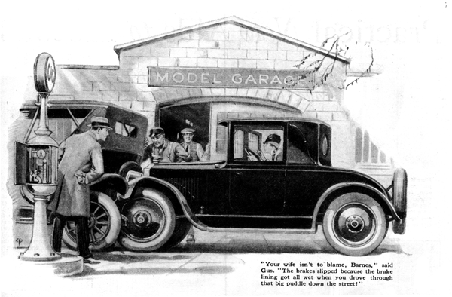
"Now I suppose we'll have a little peace and quiet around here," Gus Wilson grumbled to his partner, Joe Clark, as the latter finally stopped hammering on the fender of his flivver. A truck had side-swiped Joe's car on the way to the Model Garage that morning.
"Aw, quit beefing!" snapped Joe. "It's got to be fixed sometime, hasn't it?"
But Gus was doomed to disappointment, for the next moment the two garage men were startled by the sound of a crash, followed by the tinkling noise of broken glass.
Dropping their tools, they rushed for the door. Directly in front of the garage a car had rammed into the rear of another car parked at the side of the road. The force of the collision had been sufficient to smash both headlights and wreck the spare tire rack on the parked car.
"Now you've done it! Didn't I tell you to put on the brake?" the owner of the car was shouting, hopping about excitedly.
His wife was still sitting behind the wheel. "But I did put on the brake as hard as I could, Dick," she protested. "It just didn't hold!"
Gus, who had been examining the brakes, now walked around to the front. "Your wife isn't to blame, Barnes," he asserted positively. "The brakes did slip because the brake lining got all wet when you drove through that big mud puddle down the street, and when the brake lining is wet it doesn't hold near so well as when it's dry."
"Sure, I know it doesn't." admitted Barnes, "but that only means you've got to press a bit harder on the pedal. It's no use," he growled, shrugging his shoulders.
"She'll never learn how to drive a car in a thousand years! It makes no difference what I tell her, she does exactly the opposite."
"Is that so!" snapped his wife, who by this time had recovered somewhat from the shock of the accident. "If I can't drive, whose fault is it? You just keep nagging at me until I get so fussed I don't know what I'm doing!"
"Seems to me it isn't all your fault at any rate, Mrs. Barnes," suggested Gus mildly, in an attempt to stop the family scrap that threatened to develop. "In the first place, I notice that you haven't any cushion at your back and as you are not so tall as your husband, you can't reach the pedals properly or push them hard enough.
"Then it's always bad dope for a man to try to teach his own wife how to drive. No wife likes to play the dumb bell before her husband, so she won't admit she doesn't understand everything he tells her the first time. She makes mistakes. He becomes impatient and sarcastic and the war is on. Besides, just because a man happens to be a good driver himself is no guarantee that he can teach anybody else. It's much better to get somebody who has made a study of teaching auto driving to give you regular lessons."
"There!" exclaimed Mrs. Barnes triumphantly, "That's just the trouble, Dick. You never were cut out to be a teacher, that's certain."
"Well, you may be right, at that," admitted Barnes. "Whom can I get to teach her, anyhow? Can you do it?"
"Nothing doing!" said Gus emphatically. "I'm a mechanic, not a teacher, I can suggest someone, but first I'd like to point out a few ideas that may help you."
"Believe me, we'll be grateful," said Barnes. "A few more days like this and we'd have ended in the divorce court."
"To begin with," said Gus, addressing Mrs. Barnes, "make sure that your driving position is right. I told you about a cushion to put you near enough to the pedals. And you ought to have clips put on the pedals to keep your feet from sliding off. Your pedals seem to be narrower than on most makes. Back away from the other car, now, so I can see if the steering gear is damaged."
Mrs. Barnes started the motor and threw in the reverse gear. Gus watched carefully, and noted that the clutch grabbed badly, although the pedal was let in with great care.
"That clutch needs touching up," he said. "It takes hold too rough, and a rough clutch is a strain on a new driver. The steering gear doesn't work any too easily either, and both the brake and clutch pedals seems to bind badly. Easy controls help a man driver, but they are an absolute necessity for a woman, unless she is a regular Amazon.
"Most women, of course, aren't so strong as men. Learning how to drive a car is hard on both the muscles and the nerves, especially the nerves; and a woman, being kind of high strung, gets to the point of nervous exhaustion pretty quick. Accidents happen when drivers get tired, so you want to watch out that you don't keep at it too long, at first.
"Here's another point. A woman driver mustn't expect that just because she's a woman, men drivers are going to give her the right of way on all occasions.
"Most men give a woman the right of way when they meet her on foot, but they're not so polite when they're driving a car. The rules of the road apply to all drivers whether they wear pants or skirts, and the woman who doesn't realize that is likely to find herself in a smash up.
"Here's another thing that will help anybody - man or woman - to learn how to drive. Master one thing at a time. Learn how to steer and get the rules of the road fixed in your mind so you turn the wheel the right way without having to think about it. Learn how to apply the brakes next. It's a whole lot more important to know how to stop a car than it is to start it. After that you can practice gear shifting, and when you get that far you'll realize how important it is to get steering so pat that it is instinctive.
While your brain is occupied with figuring out the right way to go through the motions of gear shifting, the steering has to go on just the same.
"Learning how to back up is a point that many otherwise good drivers neglect. Whoever is teaching you how to drive ought to take you out on a road where there isn't any traffic, to teach the gear shifting; and don't kick if he makes you back up a whole lot. Practice is the only way you can get to know how to handle the steering wheel when the car is going backward.
"Most women don't want to know anything about what goes on underneath the hood or the floor boards, but you ought at least to learn how to change a tire without help. And you should know enough about the oiling system to tell whether the motor needs oil or not. Also, you ought to know how to read the gasoline gage and the radiator thermometer."
Joe Clark, who had been busy with another customer, strolled over at that moment.
"Here comes a teacher for you," smiled Gus. "Joe is a swell teacher - even if he does clash gears once in a while!"
END

