July 1926

HOW TO FOIL THE AUTO THIEF
by Martin Bunn
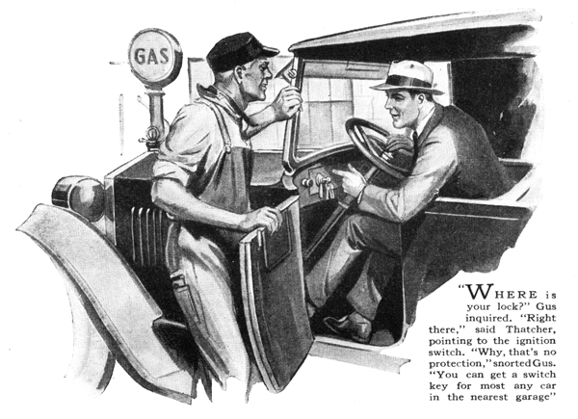
"Got your car back again, I see," said Gus Wilson as George Thatcher drove up to the Model Garage.
"Yeah, what's left of it," replied Thatcher in a glum voice. "Those crooks sure did shoot this bus all to pieces in the two weeks they had it. Nothing works right. And just look at the scratches and dents in the body!"
"Maybe it isn't so bad," said the veteran mechanic hopefully, as he raised the hood and inspected the power plant.
"How come you didn't lock it the day it was stolen?"
"How did you know it wasn't locked?" demanded Thatcher.
"Humph!" growled Gus, "Nearly all stolen cars weren't locked. What's the good of locks if you don't use 'em? Pretty soon the insurance companies are going to make extra low rates on what they call coincidental locks; the kind that throw on automatically when you turn off the ignition to stop the motor."
"Don't worry! I won't forget again," said Thatcher positively. "I've had my lesson. After this I'm going to lock her up every time I get out,--even if it's only to step into a store for a pack of cigarettes."
"That's the right idea," Gus encouraged as he got out his tool kit and began adjusting the carburetor. "After a while it will become second nature to turn the key in the lock when you get out and it's a cinch no crook will take your car - unless you leave it out all night or something like that. No lock is any good if the crooks have plenty of time to work on it. If they can't pick the lock or break it, they just come along with a tow car acting like it was a regular trouble call, hoist up the front end and take your car to some place where they can have all the time in the world to break up the lock.
"Where is your lock, anyway?" he inquired, examining the steering wheel and transmission.
"Right there," said Thatcher, pointing to the ignition switch.
"You don't mean to say that's the only lock you've got!" snorted Gus disgustedly. "Why, that's no protection.
You can get a switch key for most any car in the nearest garage. We keep quite a stock of them. And it's no trick at all for the crook to connect up a piece of wire around the switch. Ignition locks on the timer itself are enclosed in steel so the crook can't get at the terminals to wire around it."
"I never thought of that," Thatcher admitted with a sheepish expression.
"Well, what would you call a good lock?"
"Best thing I know of is a steering wheel lock that disconnects the wheel so that it turns free when you throw the lock on," replied Gus. "A transmission lock is good, but it won't stop crooks from towing your car away. All they have to do is to park their car in front of yours and, when no one is looking, hook on a tow rope and drive off, with one of the gang sitting in your car to do the steering."
"You'd better fit one like that after you get done with the rest of the repairs," said Thatcher. "Or can't you fix up some kind of a secret lock on the ignition or the gasoline line that the crook won't know about?"
"Sure I can," Gus replied, provided I put it where you can work it without making any queer motions with your hands when you stop and get out. That's because crooks often hang around where cars are being parked, and if they spot you lifting up the hood or anything like that they are sure to get on to what you are doing. Then what good is the secret lock?"
"They must have been laying for me all right," observed Thatcher. "The week before the car was stolen, they got away with a brand new spare tire, and I had it locked on, too."
"With one of those dog chains and a twenty-five-cent padlock, I suppose," said Gus sarcastically. "You've got to have a mighty husky chain and padlock to foil the crook who has a powerful bolt cutter in his car. He just cuts the chain like so much cheese and walks off with your tire as easy as can be. The best dope I know is not to keep a new tire on the spare tire rack. Always have your oldest tire on the rack. Nobody would bother to swipe an old shoe."
"That's a good tip," said Thatcher. "What about those secret locks?
Wouldn't it be a good idea to have one in addition to the lock wheel?"
"They're good all right - sometimes," Gus grinned at Joe Clark, his partner who had just strolled out of the office. "Tell Thatcher about the one that fooled you, Joe."
"That was one on me all right," admitted Joe. "Gus was away and I went out with the tow car on a telephone trouble call from a man who said he was stuck. And he sure was stuck. The gasoline wouldn't flow from the main tank. I nearly busted a lung trying to blow the dirt out of the pipe. Then I got out the tire pump, but that didn't work either, so I hitched on the tow rope and pulled the car all the way here to the garage. The owner went down the street to do some errands and while he was away I discovered that there was a secret shut-off valve in the gas pipe under the seat that had jarred closed. It was a second-hand car, and the owner didn't even know that confounded valve was there! I only charged him half price, because it was half my fault."
"By jinks!" said Thatcher enthusiastically, "I am going to put something like that on this bus right away."
"Don't do it," advised Gus. "Even with the gas shut off, your car will run quite a ways on the gasoline in the vacuum tank, and if the crook can get out of sight he can stop and find the trouble easy enough.
"You go into the office with Joe now while I straighten out a few more little kinks here and pick out the kind of a lock wheel for you. We'll have to order it anyway. I'd suggest that you choose one of the kind that swings up out of the way when you get in and out of the car."
"All right," agreed Thatcher. "And while I am about it, I guess I'll get a good padlock and chain for the spare."
"I can show you something better than that," suggested Joe. "Put one of these locks on in place of the bolt that holds the spare tire on the rack. It's a lot better than the padlock and chain combination, because there's no way of cutting it with a bolt cutter, and besides that it can't rattle around and chip off all the paint."
"And how about a padlock for the tool box, too?" Thatcher inquired.
"We have them in all sizes and prices," said Joe as he pulled out a board with a lot of samples fastened to it. "Some of these are low priced, but a high-grade padlock is well worthwhile. It's stronger, almost impossible to pick, and it won't rust up and stick so you can't unlock it."
"Sort of like locking up the barn after the horse is stolen," grinned Thatcher.
"Only in this case I've got the 'horse' back and don't want to lose him again!"
END

