December 1926

WHAT'S WRONG WITH SPRATT'S CAR?
by Martin Bunn
See If You Can Figure Out What Happened -
Here's a Chance to Test Your Auto Knowledge
and Win a Prize
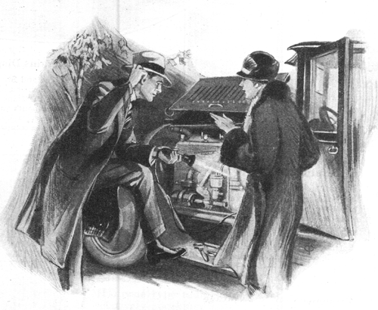
Henry Spratt jiggled the spark lever up and down in a vain effort to make the top of the hill on high.
"We shouldn't have to shift into second on a grade like that," he grumbled as he pulled over to the side of the road and stopped the car.
"I told you, you were crazy to buy a secondhand car and start right out on a long tour with it," replied Mrs. Spratt.
"You might know something would happen."
Henry untangled his long frame from beneath the steering wheel. "Don't start crabbing so soon," he said. "I know what's the matter now. The spark is no good because the contact breaker points need cleaning. Just watch me and you'll see how the job ought to be done."
"I hope you're right, Henry," sighed Mrs. Spratt.
"Is that what's been making the engine miss so much? I thought when the engine missed it was always the spark plugs needed cleaning. You told me that yourself."
"It depends on how it misses," Henry asserted loftily. "If the miss is regular and keeps time with the revolutions of the engine, it's always a spark plug; but if it skips at random you can't blame any one spark plug. There's only one pair of points that make contact for all the cylinders, and if they get rough the motor is likely to miss in any cylinder.
"See, here's the trouble. I was right. The current has burned a hole in the stationary contact and all the metal out of the hole has piled up in a cone-shaped point on the other contact."
"What are you going to do about it?" questioned Mrs. Spratt, "You certainly can't cut off that point and put it back in the hole where it belongs."
"Certainly not," Henry admitted. "But I can use this file to get rid of the hump on one contact, and I can file off enough of the other to get it smooth and flat again. The secret of this job is to get each contact rounded just a trifle so that when the two come together they'll touch in the middle instead of at the edge."
Henry proved he was right, for now the motor ran without a skip. "They hummed along at good speed for several miles. Then -
"My goodness!" exclaimed Mrs. Spratt. "My feet are burning up. Are you sure the motor isn't on fire, Henry?"
"It is kind of warm," agreed Henry, "I'll stop and see what's the matter."
As soon as the car came to a standstill a gentle hissing noise became audible and wisps of steam floated up from underneath the radiator. Henry shut the motor off, "The fan belt seems to be all right and the radiator isn't leaking anywhere," he observed, puzzled. "I know there's plenty of water in the radiator - Ah!
Here's the trouble! Look at that upper hose connection. See how the rubber is all swelled out? It's getting rotten and I'll bet the inside layers of rubber have swelled, too, and closed up the passage. I'll drain the radiator far enough to get the water level below where that bum hose is. Then I can take off the hose connection and cut out the extra rubber."
Again Henry proved he was right. He made the repair quickly.
"I hope nothing else happens," said Mrs. Spratt a bit more hopefully.
"Knock on wood and trust in me." Henry suggested.
"I'll keep the old bus running unless the wheels fall off or - Confound it! She's missing again! Now what's the trouble? Acts like the mixture is too thick."
"Oh, dear!" wailed Mrs. Spratt. "You will never get it fixed now. It's as dark as pitch."
"Humph!" growled Henry. "Don't you think I can set the carburetor in the dark? Just watch me!"
Henry soon had the hood up. As soon as he turned the knob to cut down the gas supply the idling motor picked up speed and ran quite steadily. "There you are! All set again," he said as he settled his long frame behind the steering wheel.
The car ran fairly well for several miles and then on a steep hill the motor refused to pull except in first speed. In fact they barely made the top of the hill even in first.
The missing and weak, uneven running became more pronounced until finally the motor quit firing completely and the car rolled to a standstill.
"I didn't stop it," snapped Henry peevishly, in answer to the unspoken question in his wife's eyes. "It just naturally died. Something must be wrong with the carburetor. The gasoline is dripping out of it to beat the band. That means the float is on the blink or dirt has jammed the float valve.
"There!" he exclaimed after he had taken off the float bowl. "What did I tell you? Look at all the dirt in the bottom of the bowl. After it's cleaned out it ought to run as fine as silk."
Henry was doomed to disappointment, however, for although the motor started, it promptly stopped again to the accompaniment of a gurgling, strangling noise. A second later gasoline started to flow out of the lower air intake of the carburetor in a stream.
He groaned, grabbed a wrench and attacked the carburetor again. The second cleaning did no more good than the first.
"I'm stumped," said Henry despairingly as he rested his elbows on the front fender and gazed at the motor under the feeble rays of the trouble light...
END

